# **Temple University Center for the Advancement of Teaching Logo**

# **Accessibility How-To:**

# **Word Accessibility Tool Set Up & Use**

## Setting Up Real Time Accessibility Feature

You can enable or disable the feature using the Accessibility Settings option by:

1. From the ribbon menu, open **File > Options** (PC) or **Word > Preference** (Mac)
2. Under **Accessibility,**make sure to check the option “Show me options for creating accessible documents**.”**

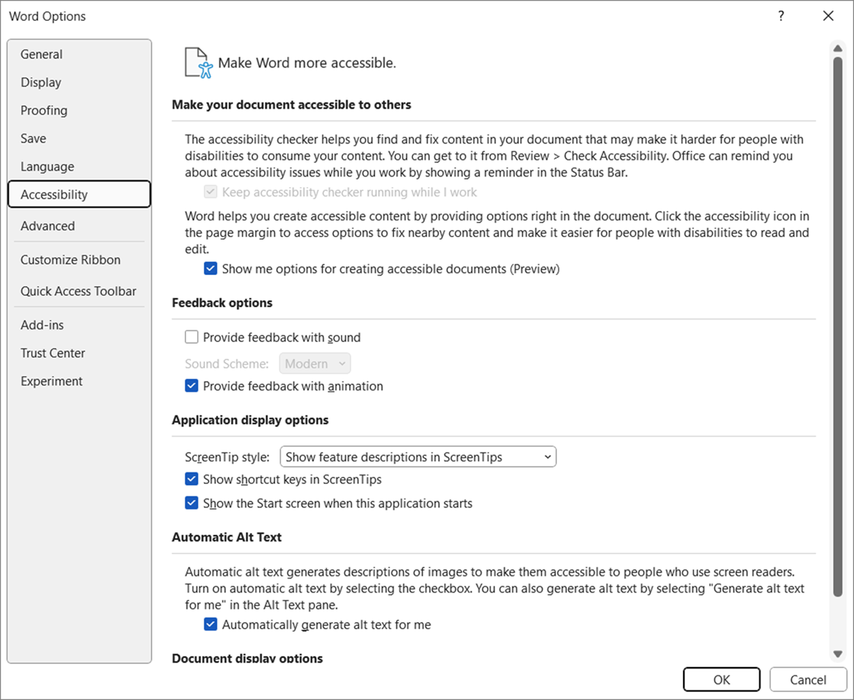Screenshot of accessibility options.

1. **​​​​​​​​​​​​​​**Select the **OK** button to update the settings.

With this setting enabled, the accessibility icon will appear next to any items in your document that need to be addressed. The accessibility icon in the screenshot below, once clicked, notifies you that the image needs alt text. It automatically opens the alt text entry box.

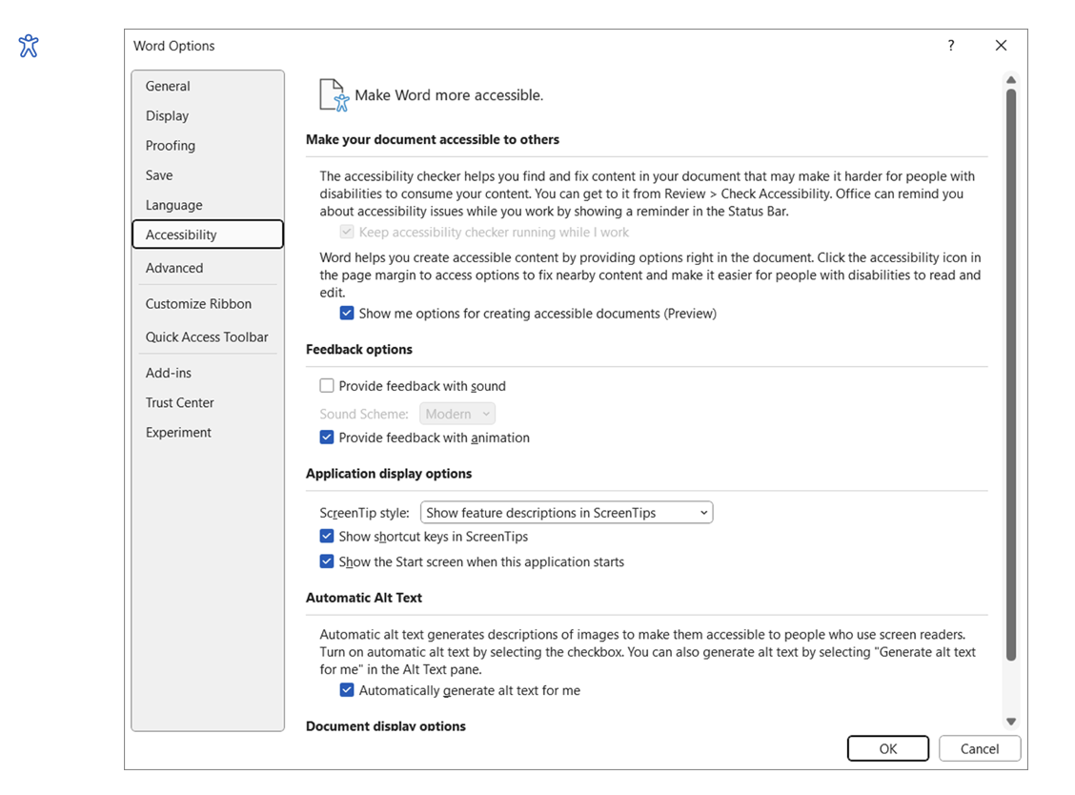

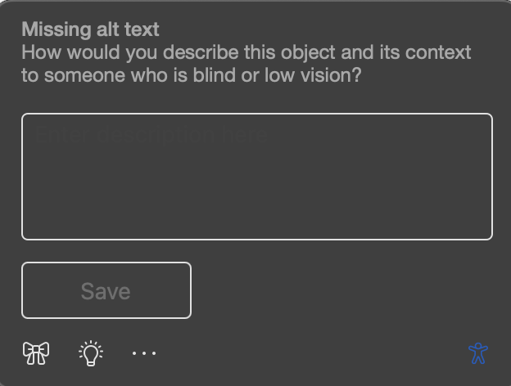

## Accessing The Accessibility Checker On Mac

To launch the Accessibility Checker, do one of the following depending on the app you are using:

In Word, Excel, and PowerPoint, select **Review** and choose **Check Accessibility**.

If you don't see the button on the toolbar, you need to add it there manually.

Select (See more items) and choose **Customize toolbar**. Then drag and drop the **Check Accessibility** button to the toolbar.

The **Accessibility**pane opens and issues are organized into **Warnings**, **Errors**, and **Tips** under **Inspection Results**.

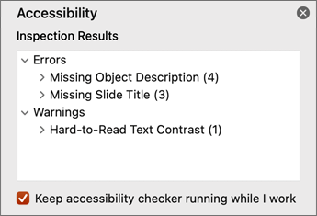

1. Review and select an issue to see all affected items and objects.
2. Select an item or object to see why you should fix the issue and the steps to take to correct it.

## Accessing The Accessibility Checker On PC

1. Select **Review**.
2. Select Check accessibility button**Check Accessibility** to open the **Accessibility**pane on the right.

NOTE: If you do not see the Accessibility Checker on the Review tab, you might be using an older version of word. Please visit [Microsoft Support](https://support.microsoft.com/en-us/office/improve-accessibility-with-the-accessibility-checker-a16f6de0-2f39-4a2b-8bd8-5ad801426c7f#picktab=windows) for more information on how to open the checker in an older version.

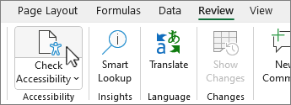

**Tip:**For Word, Excel, and PowerPoint desktops, select the lower half of the **Check Accessibility**button for more options.

1. In the **Accessibility**pane, review and address the findings under **Inspection Results**.

## Running The Accessibility Assistant

1. Select **Review** to expand menu.
2. (Mac) Click the **Check Accessibility** menu button and the **Accessibility Assistant** Pane will open.
3. (PC) Press the **A**+**1** keys to open the **Check Accessibility** dropdown menu in the Accessibility group.
4. (PC) Press **A** to select the **Check Accessibility** option and then the **Accessibility Assistant** pane will open.
5. Alternatively, press **Shift**+**F6** to navigate to the status bar. Use the **Right arrow** key to go to the **Accessibility: Investigate**button.
6. Press **Enter** to open the **Accessibility Assistant** pane.

**Note:**The **Accessibility: Investigate**button is highlighted on the status bar whenever there are accessibility issues in the document.

## Fixing Accessibility Issues

The Accessibility Assistant helps you find and fix issues in the following categories:

**Color and Contrast**: This category ensures the text is easy to read against its background.

**Media and Illustrations**: This category checks for missing alt text and other media-related issues.

**Tables**: This one looks for issues in table structure and readability.

**Document Structure**: This category ensures headings and other structural elements are used correctly.

**Document Access:**This category verifies if the document can be accessed programmatically, such as using screen readers.

### To resolve an accessibility issue:

1. Press the **Tab** key to move through categories with accessibility issues, such as hard-to-read text contrast in the **Color and Contrast**, or missing alt text in **Media and Illustrations**.
2. Press **Enter** on a category to view the issue and probable solutions. The text or image with the problem will be highlighted.
3. The drill-down pane for the issue will open, providing suggestions to fix it.
4. Use the basic navigation keys to move through the options in the drill-down pane.
5. Press **Enter** to choose an option that resolves the issue.
   * To understand the importance of resolving an issue, select the **Learning Tip**link at the bottom of each drill-down pane.
   * The summary pane at the top shows the remaining issues and the current issue being addressed.
   * If there are multiple issues of the same type, use the **Previous**or **Next** buttons in the drill-down pane to navigate the previous and the next issue.
6. Once all issues are resolved, the focus returns to the summary pane. Review and fix any remaining issues.