# **Temple University Center for the Advancement of Teaching Logo**

# **Accessibility How-To:**

# **Uploading Pre-recorded Video to Your Panopto Library**

1. Log into your Panopto account.
   1. From TUPortal
   2. From the [URL](http://video.temple.edu/): video.temple.edu
2. Use the left-hand navigation to identify the folder where this video will reside.
   1. Ensure that you have selected the correct folder first – this will be the ‘My Folder’ for this activity.

A screenshot of Panopto’s browser interface.


1. Click the ‘+ Create’ button.

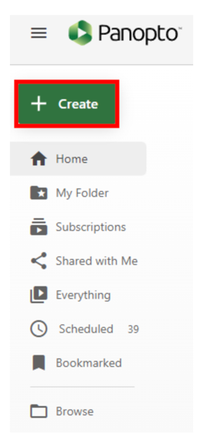

1. Select ‘Upload Media’ from the menu that appears.

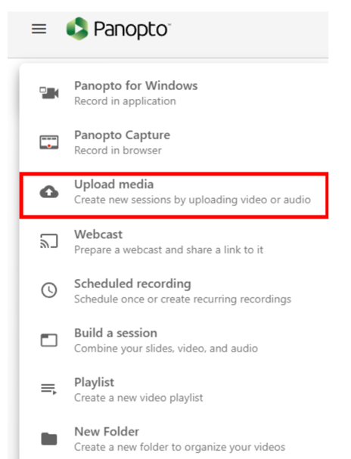

1. A window will appear. Drag and drop the video file into this window – or – click in the window to bring up the computer browser and navigate to the video file.

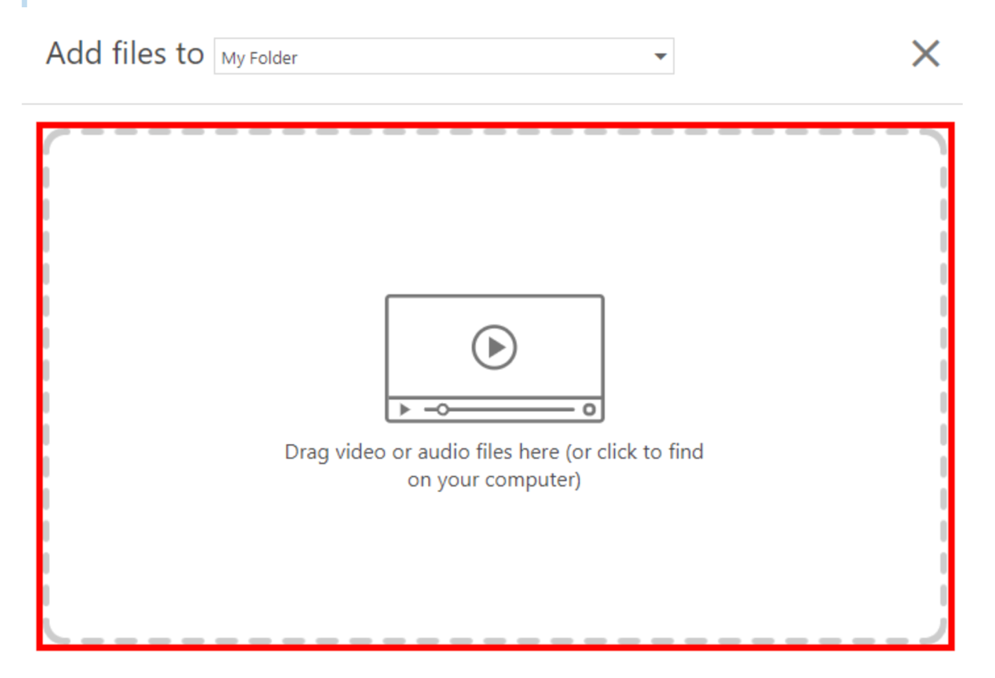.

1. A green bar below the window denotes the upload progress.
2. Your video file will now appear in your video library. You can simply double-click on it to view it or click the edit icon.

