

Accessibility How-To:

Sufficient Color Contrast
The rule for sufficient color contrast requires a 4.5:1 color contrast ratio for size 12 font (or smaller). For larger text, size 14 bold font or size 18 (or larger) font, a 3:1 color contrast ratio is required.
The ratios for sufficient color contrast can be tricky to identify with the naked eye, even with typical rather than low vision. We recommend using WebAim’s Color Contrast Checkers to ensure sufficient color contrast.

How to Use WebAim’s Color Contrast Checkers
- Navigate to WebAIM’s Contrast Checker (website)
Choose two colors using the Color Picker (shaped like an eye-dropper) to compare the foreground and background (or enter the color values in RGB hexadecimal format). There are also a few advanced options.
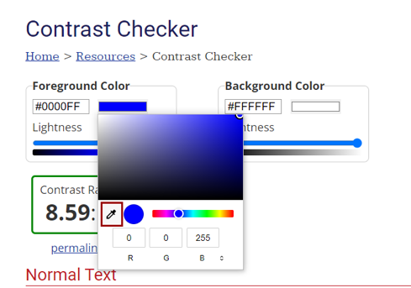
To use the Color Picker: begin with the foreground color
- Click on the square of color under the words “Color Picker” and select the eye-dropper tool. A pixelated circle, which zooms in on specific colors as you move it around, appears.
- Drag and hover over the target color and click.
- Then do the same with the Background Color (if it is not white).
The color contrast ratio will be calculated, and a pass or fail result will appear for three categories: Normal Text, Large Text, and Non-text Elements. You yourself must evaluate which category applies.
Pro: Relatively straightforward
Con: Must keep toggling between the color contrast checker website and the target slide/doc/website

How to Use WebAim’s Bookmarklet
This is a miniature version of the Color Contrast checker that will stay on top of the browser you want to evaluate. It “installs” as an app when you drag it into the bookmarks bar of your web browser. Otherwise, it works the same way.
Pro: Stays within easier reach when evaluating color contrast on a browser
Con: Involves one more step than just navigating to the website

