

Strategies for Making Complex Visual Elements Accessible
Our learning environments often feature imagery, which can be a powerful tool for learning. For example, maps are integral to political science, photos of paintings and sculptures are used in art history classes, and STEM classes present data using charts and graphs. To make our classes accessible to all, we need to provide alternative ways for students to access key information from the visuals in our courses.
For simple images, alt text is used to convey key information. However, faculty also use complex visual elements, images for which alt text alone cannot fully convey the meaningful information necessary to ensure that students with disabilities receive an equivalent learning experience. Examples include charts, infographics, maps, diagrams, dashboards, and other visuals in which meaning depends on detailed data, structure, sequence, or spatial relationships. In these cases, a longer text description or equivalent accessible alternative may be needed along with alt text.
In this guide, we will describe alternatives to alt text that render our complex visual images accessible and provide examples that illustrate how these alternatives can be implemented effectively.
This guide addresses digital content accessibility as defined by the Web Content Accessibility Guidelines (WCAG) 2.1 Level AA, the standard that applies to course materials delivered through digital platforms such as Canvas, course websites, and digital documents. The guidance here covers what you post, share, and publish online.
WCAG does not govern live classroom instruction, paper-based exams, or the accommodation arrangements that apply to those contexts. Questions about exam accommodations, including what tools or alternative formats a student may use during an in-person or paper-based assessment are handled through Disability Resources and Services (DRS). Likewise, students with documented disabilities may require accommodations beyond the WCAG standards to fully access the material. If you have questions about accommodating a specific student in a specific assessment context, DRS is the right starting point.
Table of Contents
Strategies for Making Complex Visual Elements Accessible 1
1. Long Description 3
2. Interactive Alternatives to Long Descriptions 5
3. Structured Format Alternatives to Long Descriptions 7
4. Long Descriptions and Long-Term Workflows 9
5. Complex Visual Elements and Assessments 9
6. Writing Long Descriptions Using AI 13
7. Using AI for Handwritten Notes 13
8. Discipline-Specific Resources 15
Appendix A: Long Description 17
Appendix B: Long Description and Assessment 23

Long Description
When alt text is not sufficient, the most common way to ensure accessibility is through the use of long description. Long description is a detailed explanation of the visual element that includes the information needed to understand the image's meaning or purpose. This might include the image's main purpose, relevant labels, key data or trends, relationships among elements, equivalents, structure, and spatial organization. The goal is to convey the image’s meaning and function, rather than describing every visual detail.

Tips for Long Description:
- All images require alt text, even when a long description is provided. Refer to this Guide on Alt Text if you aren’t sure how to add alt text to an image.
- A long description can be placed in various areas. Often, it is placed near the image in the body of the text, in a caption, in a figure note, or in another clearly associated location. It can also be included as an appendix or as a separate document.
- If the long description is not near the image, such as when it is included as a separate document or in an appendix, you would include a descriptive hyperlink near the image, such as “Detailed long description of the chart.”

Long Description Examples

Example 1: General Synthesis of 2-Amino-2-Imidazolidinones
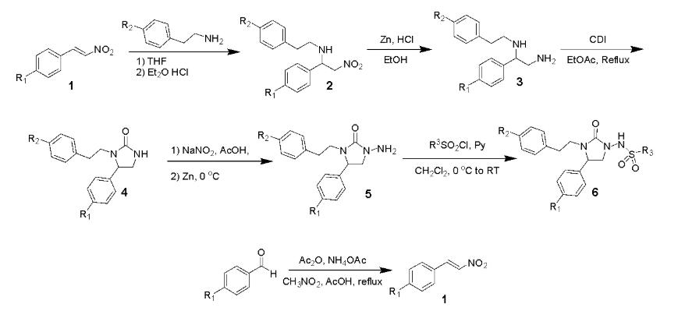
Alt Text: Multi-step reaction scheme for synthesis of substituted 2- amino-2-imidazolidinones from substituted nitroalkenes, substituted primary phenethylamines, and substituted sulfonyl chlorides precursor through intermediates 1 to 6.
Long Description of Synthesis

Example 2: Muscle Contraction Diagram
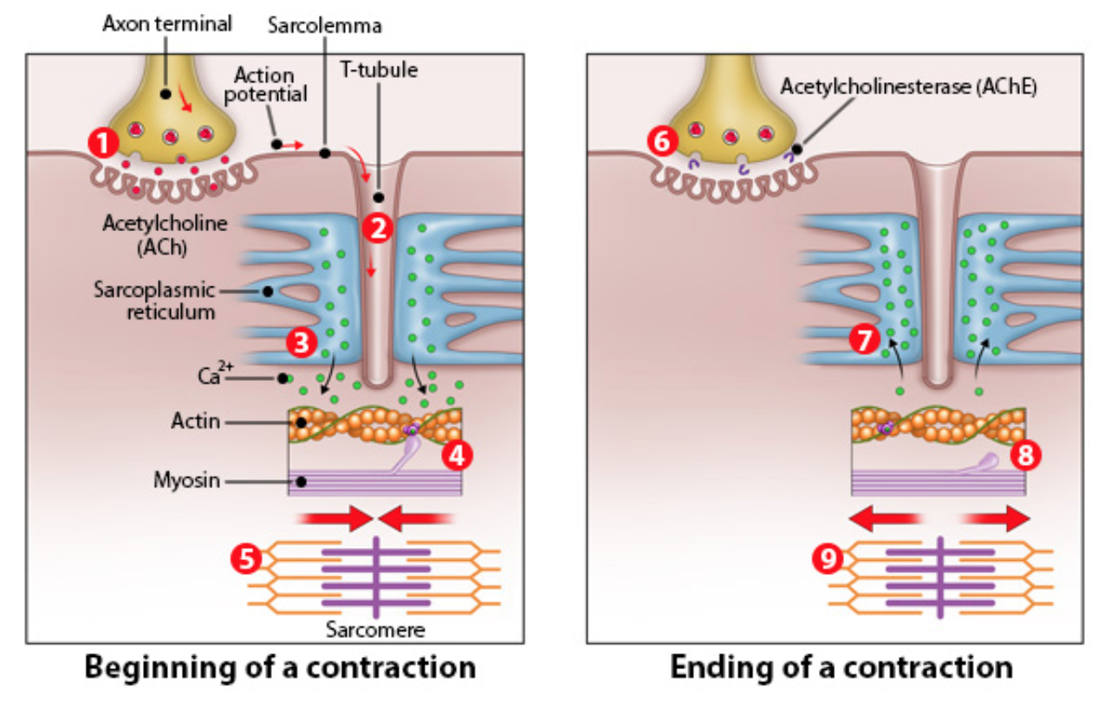
Alt Text: Two-panel diagram of skeletal muscle contraction showing the beginning and ending of a contraction.
Long Description of Muscle Contraction Diagram

Example 3: Student Weekly Activities Bar Chart
When sharing a graph or chart, one of the best ways to make it accessible is to include a link to the full data set, as in this example from Harvard University’s Digital Accessibility Services. Another option would be to provide a long description that describes the chart in detail.
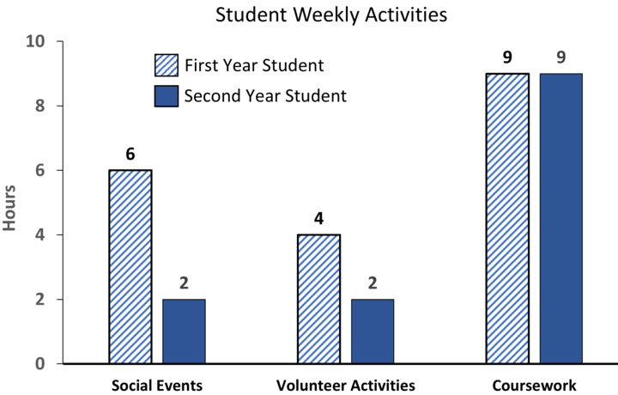
Alt Text: Bar chart of first and second year students’ weekly activities, including social events, volunteer activities, and coursework.
Detail: See full data for student weekly activities
Long Description of Student Weekly Activities

Interactive Alternatives to Long Descriptions
Long descriptions are often the right solution for complex visuals, but some images represent underlying data, functions, or processes that can be made accessible by providing an interactive alternative. This allows users to engage with the information directly rather than read about it.
Interactive alternatives work especially well when an image is essentially a visualization of something that can be calculated, queried, or explored — a graph of an equation, a reference chart encoding lookup values, a diagram that maps inputs to outputs, or a schematic that represents a formal structure.

When to Consider This Approach
Ask whether the image is primarily a visual encoding of computable or queryable information. If so, a functional alternative may serve users better than description alone.

How to Implement
- Provide alt-text for the image.
- Immediately follow the image with a note pointing to the alternative, such as: "An accessible version of this information is available via the Swamee-Jain friction factor."

A Note on Equivalence
The goal is functional equivalence: the alternative should allow a user to access the same information or perform the same task the image supports. When the image also carries pedagogical value in its form, for example, showing the shape of a relationship, clustering of curves, or visual patterns, consider whether you should also include a long description that conveys that interpretive layer, even if an interactive tool handles lookup tasks. In some cases, the way you provide access to information may not be sufficient for students whose disability affects how they engage with discipline-specific visual formats. In those cases, working with DRS to think through a specific student's full learning experience is the appropriate next step.

Example 1: The Moody Diagram
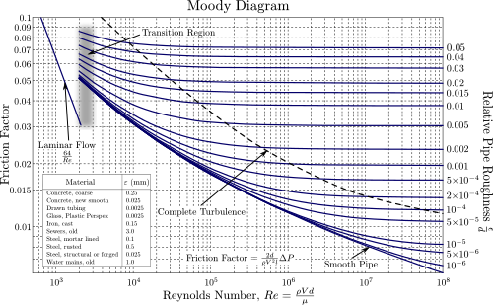
Alt Text: Moody diagram showing pipe friction factor vs. Reynolds number, with laminar flow, transition, and turbulence regions.
Moody Chart Calculator - Find the Darcy friction factor for any pipe flow condition. Enter your Reynolds number and relative roughness. The calculator solves the Colebrook-White equation and plots your result on an interactive Moody diagram.

Example 2: Fourier Series Approximation
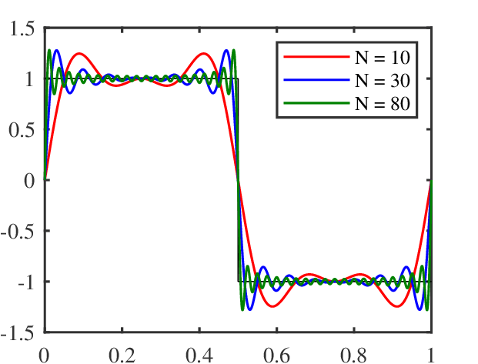
Alt Text: Graph showing Fourier series approximations of a square wave using N = 10, 30, and 80 terms, illustrating convergence to the target function and the Gibbs phenomenon near the discontinuity at x = 0.5.
For an interactive version where you can adjust the number of terms and query specific values, see this Desmos graph.

Structured Format Alternatives to Long Descriptions
Some images represent underlying data, functions, or structures that can be made accessible by providing the source code or data that generated them. This allows users to reconstruct, query, or adapt the information directly.
For certain categories of visual content, domain-specific markup languages can do something a long description cannot: they encode the structure of the content in a form that a screen reader can navigate directly. A screen reader working with MathML, for example, can step through the components of an equation; the student is navigating the content itself rather than reading a prose account of it. The good news for faculty is that you rarely have to write this markup yourself. The tools can generate the appropriate format automatically, or export to it with minimal additional steps.
Code-based alternatives work especially well when an image is the output of a computational process because the source that produced the image already contains the structural information needed for accessibility. In these cases, sharing the generative artifact gives users access to the underlying information in a form that is often more meaningful than description alone, and that benefits a broader range of students than those using screen readers.

Example 1: Mathematical Equations
In the Canvas Equation Editor, available in the Rich Content Editor, you can use LaTeX code to enter mathematical expressions such as interval notation, piecewise functions, matrices, determinants, and tables. Canvas automatically converts LaTeX to MathML behind the scenes, which allows screen readers to interpret math expressions and can support screen-reader interpretation and user control over how equations are explored. Once rendered, any user can zoom in on an equation, view the underlying LaTeX or MathML source, or adjust display settings – preferences that are user-specific and persist across sessions.

Example 2: Maps and Spatial Data Visualizations
Maps are among the most information-dense visuals faculty include in course materials. A choropleth map, a layered spatial analysis, or a georeferenced dataset rendered as an image may compress dozens or hundreds of underlying values into a color gradient or a set of overlapping polygons.
When an interactive map is carefully designed and tested for keyboard and screen-reader access, it may provide a better alternative than a static image. Tools such as Leaflet and ArcGIS Online can support more accessible map experiences, but accessibility depends on how the map is configured, labeled, and navigated. An interactive map should not be assumed to be accessible without testing.
Where an interactive map is not feasible, sharing the underlying source data is often a meaningful alternative. GeoJSON and CSV files with geographic coordinates are especially useful because they are text-based, openly documented, and compatible with a wide range of tools. Shapefiles may also be shared when relevant, though they are a multi-file GIS format rather than a plain-text one. When providing source data, include the coordinate system, a brief explanation of the key attribute fields, and enough context for users to understand what the dataset represents. A plain-text table of the main values the map is intended to convey—for example, the regional percentages underlying a choropleth—can also serve as an effective supplement.

Example 3: Musical Notation
Musical scores present a particular accessibility challenge because notation is itself a specialized symbolic language.
MusicXML is the most widely supported exchange format for structured score data. It encodes pitch, rhythm, dynamics, articulation, and other structural information in a machine-readable form and can be exported from Finale, Sibelius, MuseScore, and most other notation software. This makes it a strong alternative when an image of notation would otherwise be inaccessible.
MuseScore, which is free and open source, can both export and import MusicXML and includes documented accessibility support, particularly with NVDA on Windows and VoiceOver on macOS. Because support varies by platform and screen reader, faculty should avoid assuming the software experience will be identical for all users. LilyPond source files are another option for faculty who already use that toolchain; LilyPond input is plain text and fully describes the musical content. For shorter examples, such as a melodic motif, chord progression, or rhythmic pattern, ABC notation may also be a practical alternative that can be read and edited as plain text without specialized software.
When providing a MusicXML, LilyPond, or ABC file, include a note pointing to it directly, such as: “A MusicXML file of this excerpt is available for download below.”

Long Descriptions and Long-Term Workflows
Based upon the present accessibility standards, creating long descriptions for complex visual elements is going to be an ongoing component of instructors’ pedagogical workflow. However, that does not mean you need to write every description yourself. Peer collaboration can reduce some of the work. You and your colleagues may want to create a shared OneDrive file or Canvas site to host complex elements and their accompanying long descriptions, creating an archive of ready-made materials for future semesters. Or you may want to coordinate with other institutions and/or your professional association to build such an archive at a larger scale.
Additionally, the challenge of writing good long descriptions is also an opportunity for some of your students to practice the interpretation skills critical to your discipline. For example, students in more advanced classes could be offered extra credit to write long descriptions for materials used in introductory-level courses. You would still need to review and possibly edit the results. If you use this method, make sure to advise students that any materials they create will be used in other courses. Keep in mind that your students will likely find themselves held to the same WCAG standards in their future practice, so writing long descriptions is a skill they will need to learn.

Complex Visual Elements and Assessments
When a complex visual is part of an assessment, faculty sometimes worry that providing a long description will give away the answer and undermine the analysis students need to perform. This concern is understandable, but a well-written description should not have that effect. A long description is meant to give a student who cannot fully access the image the same opportunity to examine the relevant information that others in the class have. When used in the context of an assessment such as a quiz, exam or essay question, the description should present the content of the visual in a neutral way, without interpretation, analysis, or hints about the correct answer.
A useful way to think about it is this: describe what the image shows, not what the student should conclude from it. If the question asks students to interpret a graph, the description should report the axes, labels, measured values, and visible trends, but it should not state the interpretation the student is expected to make. If the question asks students to identify a structure or analyze a process, the description should provide the labeled components and observable features of the image, not the answer those features point to.
For faculty, this often feels most challenging when the visual itself contains the information being tested. In those cases, the accessible description should include the same details a sighted student can visually inspect, while leaving the reasoning to the student. This preserves both access and academic integrity. If, after reviewing the examples below, you are uncertain about specific approaches to assessment in your course, contact the CAT and we would be happy to support you. If your concerns relate to a specific student’s accommodations, contact DRS for further assistance.

Long Description Assessment Examples

Example 1: Lung X-ray Analysis
For this assignment, students need to analyze a lung x-ray and determine which, if any, conditions may be present.
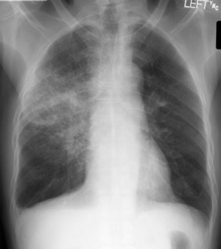
Alt Text: Posteroanterior chest X-ray of an adult with visible density differences across the two lung fields.

Long description of Lung X-Ray

Example 2: Environmental Engineering – Breakthrough Curve Analysis
Figure 1 shows breakthrough curves for a packed-bed granular activated carbon (GAC) column treating contaminated groundwater. The x-axis represents time (hours), and the y-axis represents normalized effluent concentration (C/C₀). Three curves correspond to different flow rates (Low, Medium, High).

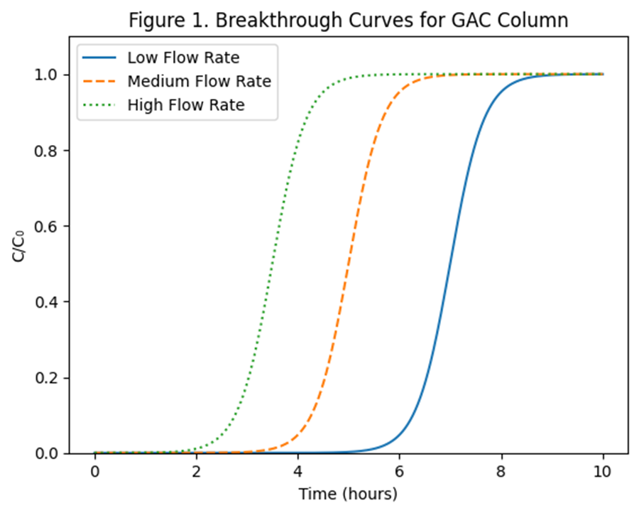
Alt Text: Three S-shaped breakthrough curves (Low, Medium, High flow rate) showing C/C₀ vs. time for a GAC column over 10 hours.
Full data table of Breakthrough Curves for GAC Column.
Scenario
The treatment plan must determine the optimal operating condition to maximize contaminant removal while minimizing carbon replacement frequency. Using Figure 1 only, answer the following questions:
- Breakthrough Timing (5 pts)
Which flow rate reaches breakthrough (C/C₀ = 0.1) first? Estimate the breakthrough time for each curve and rank them from shortest to longest operational life. Explain how the graph supports your answer.
- Mass Transfer Behavior (6 pts)
Compare the steepness of the breakthrough fronts. Which curve shows the sharpest mass transfer zone? Which shows the most gradual transition? What does this imply about adsorption efficiency and contact time? Support your answer using features of the curves.
- System Optimization (5 pts)
If the goal is to maximize total contaminant mass removed before breakthrough, which operating condition is preferable? Justify your answer based on area under the curve and curve shape.
- Early Warning Sensitivity (4 pts)
If monitoring equipment detects small increases in effluent concentration, which operating condition would provide the least warning time before full breakthrough? Explain your reasoning based on curve steepness.

Example 3: Using Mass Spectra as an Example of Data‑Dense Visualization
3. (6pts) Given the mass spectrum below, suggest an empirical formula and suggest a structure.
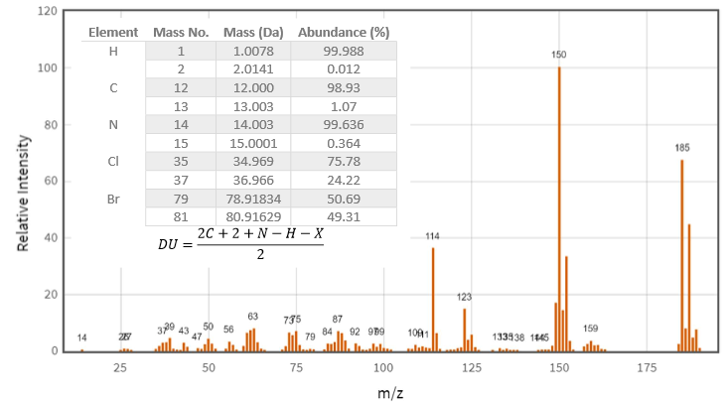
Alt Text: Mass spectrum with peaks across m/z range; a reference table of element masses and a DU formula appear over the plot.
Detailed long description of the Mass Spectrum chart

Example 4: Art History Quiz
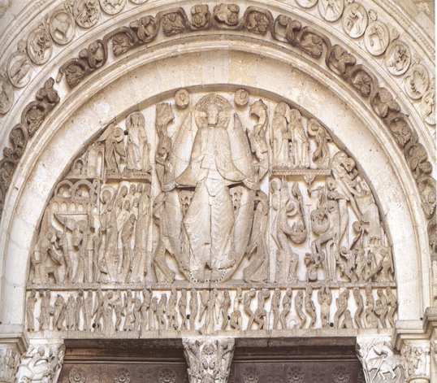
Alt Text: Stone relief carving in the tympanum above a cathedral entrance depicting a central enthroned figure surrounded by smaller figures.

Detailed long description of stone relief carving

Name the period/style that this work of art is most closely linked to.
- Classical Greece
- Classical Rome
- Romanesque Period
- Gothic into the Proto Renaissance
- Renaissance
- Renaissance (Mannerism)
- Baroque

Writing Long Descriptions Using AI
Generative AI can be very helpful in interpreting complex visual elements and writing long descriptions. When using AI to generate long descriptions, it can be helpful to include the following in your prompt:
- A brief description of the image
- The purpose of the image. Consider why you are sharing it with students, and/or what they are supposed to do with it.
- Explicit instructions for describing detail, such as “using the text in the image,” or “using the terms from the legend.”
- Explicit instructions for details you do not want included in the description, for example, “do not include details that will give away the answer to the following question…”.

At times, AI-generated image descriptions can be inaccurate or incomplete, so always check and edit them before adding them to digital content.
To learn more about writing long descriptions and using AI to support you in this process, check out the Long Description Resource from Colorado State University.

Using AI for Handwritten Notes
If you share handwritten notes with students, such as pictures of the whiteboard or notes created in Microsoft OneNote or another app, AI can help turn those images into a text document. Upload the image into the AI program of your choice and ask it to create a text document of your notes. Helpful prompts include:
Simple transcription: "Please transcribe everything written on this whiteboard exactly as it appears, preserving the layout and structure as closely as possible."
If the notes have headings, lists, or diagrams: "Please transcribe the text from this whiteboard image. Preserve any headings, lists, or organizational structure you can see. If there are diagrams or arrows, describe them briefly in brackets where they appear."
If you want a cleaned-up document: "Please transcribe the text from this whiteboard image and lightly clean it up for readability, fixing any obvious abbreviations or shorthand while keeping the content and meaning intact."
As always, you will want to review the document and make any necessary edits.

Discipline-Specific Resources

Arts
- Alt-Text and long description for Artwork with examples (note that this resource uses the term image description instead of long description)
- The Diagram Center Guide to Image Description - Helpful resources that include specific image description guidelines for a variety of image types, including art, photographs, chemistry, diagrams, graphs, mathematics, tables, and maps.

STEM and Social Sciences
- Guidelines for Preparing Accessible Mathematics Content - Guidelines published by the American Mathematical Society (AMS), European Mathematical Society (EMS), London Mathematical Society (LMS), and SIAM (Society for Industrial and Applied Mathematics)
- Mathematical Association of America Accessible Course Materials Presentation Slides
- Making Accessible Documents Using LaTeX - Notices of the American Mathematical Society
- Video Guides on PreTeXt- PreTeXt is a markup language for STEM documents that can convert into a wide variety of output formats with special attention to accessibility. These videos were created by Temple University Professor Andy Eisenberg
- PreTeXt for Instructors - Learn PreTeXt while creating accessible course materials
- American Chemical Society Inclusivity Style Guide - recommendations draw on guidelines from multiple organizations, institutions, and advocacy groups, with examples primarily from ACS publications
- Tips for Accessible Chemistry Teaching Documents - CAT resource
- RMarkdown and Accessibility- Guide created by Temple University Professor Joshua Klugman
- Making Partially Handwritten Slides Accessible - blog post outlining use of PreTeXt to address accessibility of handwritten notations on slides

Health Sciences
- Accessibility, Inclusion, and Action in Medical Education: Lived Experiences of Learners and Physicians with Disabilities - AAMC publication featuring interviews conducted with 47 students, residents, and physicians with disabilities
- Disability and Accessibility in Academic Medicine - links to AAMC web pages focused on disability and accessibility across academic medicine, in health care, and in medical education

Data Visualization
- Long Description and Alt-Text Examples for Flow Charts and Concept Maps
- Harvard University Information Technology Data Visualizations, Charts, and Graphs - guide to creating accessible charts and graphs
- State of Minnesota Tableau Design Guide for Accessibility - provides Tableau designers and developers with tips and tools for incorporating accessibility into their content

Appendix A: Long Description

Example 1: General Synthesis of 2-Amino-2-Imidazolidinones Long Description

Overview
This reaction scheme illustrates a multi-step synthetic route to sulfonamide-substituted 2-amino-2-imidazolidinone derivatives. The scheme is arranged in three rows. The top row depicts the forward synthesis from compound 1 through compound 3. The middle row continues from compound 4 through to final product 6. The bottom row shows the preparation of compound 1, the nitroalkene starting material, from a substituted aromatic aldehyde. Variable substituents are labeled R1 (on the lower aromatic ring), R2 (on the upper aromatic ring of the phenethylamine fragment), and R3 (on the sulfonyl group of the final product).

Overall Transformation Summary
- A substituted aromatic aldehyde undergoes Henry condensation/dehydration to yield nitroalkene 1.
- Aza-Michael addition of a substituted phenethylamine to 1 gives β-nitroamine 2.
- Metal-acid reduction of the nitro group in 2 gives diamine 3.
- CDI-mediated cyclization of 3 forms the 2-imidazolidinone core in 4.
- N-amination via NaNO₂/AcOH then Zn reduction installs an exocyclic amino group to give 5.
- Sulfonylation of 5 with R3SO₂Cl/pyridine delivers the final sulfonamide-imidazolidinone product 6.

Example 2: Muscle Contraction Long Description
This image is a two-panel diagram comparing the beginning of a muscle contraction on the left with the ending of a muscle contraction on the right. Each panel shows a motor neuron axon terminal above a muscle fiber membrane, with labels for the sarcolemma, T-tubule, sarcoplasmic reticulum, calcium ions, actin, myosin, and the sarcomere. Red numbered circles mark the sequence of events.
Left panel: Beginning of a contraction
This panel shows the events that trigger contraction.
- Acetylcholine is released.
At the top left, an axon terminal sits above the folded muscle membrane. Vesicles in the axon terminal release acetylcholine (ACh) into the neuromuscular junction.

- An action potential spreads along the sarcolemma and down the T-tubule.
The muscle fiber membrane, labeled sarcolemma, carries an action potential. The signal travels across the membrane and downward into a vertical T-tubule.

- Calcium is released from the sarcoplasmic reticulum.
On both sides of the T-tubule is the sarcoplasmic reticulum, shown as blue membrane sacs containing green dots. These green dots represent calcium ions, Ca2+. In this panel, calcium is released from the sarcoplasmic reticulum into the surrounding muscle cell fluid.

- Calcium enables actin and myosin interaction.
Below the calcium release, a small magnified view shows actin as an orange filament and myosin as a purple thick filament with a projecting head. Calcium allows the myosin head to interact with actin, initiating cross-bridge formation and contraction.

- The sarcomere shortens.
At the bottom, a simplified sarcomere diagram shows inward-pointing arrows. These indicate that the thin filaments slide toward the center, shortening the sarcomere and producing contraction.

Right panel: End of a contraction
This panel shows the events that stop contraction and return the muscle to a relaxed state.
- Acetylcholine is broken down.
At the top right, the neuromuscular junction is labeled acetylcholinesterase (AChE). This enzyme breaks down acetylcholine, ending the signal from the motor neuron.

- Calcium is taken back up into the sarcoplasmic reticulum.
Green calcium ions are shown moving back into the sarcoplasmic reticulum, reducing the calcium concentration around the contractile proteins.

- Actin and myosin interaction ends.
In the magnified filament view, the myosin head is no longer shown pulling on actin. With calcium removed, the contractile interaction stops.

- The sarcomere returns toward its resting length.
At the bottom, the sarcomere diagram shows arrows pointing outward. This indicates relaxation and lengthening as the muscle returns toward its resting state.

Overall meaning
The figure illustrates excitation-contraction coupling and relaxation in skeletal muscle. The left panel shows how a nerve signal leads to acetylcholine release, membrane depolarization, calcium release, interaction of actin and myosin, and sarcomere shortening. The right panel shows how acetylcholine is removed, calcium is re-sequestered into the sarcoplasmic reticulum, cross-bridge activity ends, and the sarcomere relaxes.

Example 3: Long Description of Student Weekly Activities Bar Chart
Weekly Activities for 1st and 2nd Year Students measured in hours.
- Social Events - First Year 6 hours, Second Year 2 hours.
- Volunteer Activities - First Year 4 hours, Second Year 2 hours.
- Coursework - First Year 9 hours, Second Year 9 hours.

Appendix B: Long Description and Assessment

Example 1: Long Description - Lung X-Ray
A black and white posteroanterior (PA) chest X-ray of an adult. The image is labeled "LEFT" in the upper right corner, orienting the viewer so the patient's left side appears on the right side of the image and the patient's right side appears on the left.
The trachea is visible as a dark vertical column in the upper center of the image. The spine runs vertically through the center. The clavicles and upper ribcage are visible across the top portion of the image, and ribs can be traced along both sides of the chest wall.
The left lung field (right side of image) appears largely dark with some lighter gray texture visible throughout, particularly in the mid and lower zones. The right lung field (left side of image) appears dark in the upper zone. In the mid and lower zones of the right lung field, there is increased gray-white density distributed in a diffuse, patchy pattern. This denser area is not sharply bordered and is interspersed with darker regions.
The cardiac silhouette is visible in the center-left of the image. The diaphragm is visible as a curved white line at the bottom of each lung field. The costophrenic angles are visible at the lower outer corners of both lung fields.

Example 3: Long Description - Mass Spectral Data
- Elemental Isotope Information
You may assume the molecule is composed of the following elements:
Table 1 Elemental Isotope Information
Element | Isotope Mass (Da) | Abundance (%)
H | 1.0078 | 99.988
H | 2.0141 | 0.012
C | 12.0000 | 98.93
C | 13.003 | 1.07
N | 14.003 | 99.636
N | 15.0001 | 0.364
Cl | 34.969 | 75.78
Cl | 36.966 | 24.22
Br | 78.91834 | 50.69
Br | 80.91629 | 49.31

- Mass Spectrum Data (Text Description)
- The electron‑impact mass spectrum shows the following major peaks (m/z values are rounded to the nearest integer):
- Small peaks in the region m/z 25–90, mostly with intensity less than 20%.
- A strong peak at m/z 114.
- A very strong molecular‑ion region with two peaks at:
  - m/z 150 (base peak, 100% relative intensity)
  - m/z 152, with intensity approximately 95% of the peak at 150.
- A high‑mass fragment at m/z 165 (moderate intensity).
- Smaller fragments in the 120–140 range, including peaks near 123, 133, 138, 146, and 159.

The pair of molecular‑ion peaks separated by 2 mass units (150 and 152) have nearly equal intensities.

Example 4: Long Description - Last Judgment tympanum, west portal, Cathedral of Saint-Lazare in Autun
This photograph shows a large stone carving that fills the semicircular space above the main entrance of a medieval church. This architectural space — the half-moon shaped area above a doorway — is called a tympanum. The entire surface is covered in figures and scenes that are carved in limestone and appear in shades of pale gray and tan, the same color as the limestone.
The Central Figure: At the very center and top of the composition sits one enormous figure, much larger than everyone else in the scene. This size difference is intentional — it signals that this figure is the most important person depicted. The figure sits facing forward with both arms stretched wide, wearing robes whose folds are carved as flat, decorative patterns rather than looking like real cloth draped over a real body. They sit within an almond shaped frame (a mandorla).
Left Side: To the figure's right (the viewer's left), small figures appear calm and orderly, moving toward what looks like an architectural structure — suggesting welcome and reward.
Right Side: To the figure's left (the viewer's right), the mood changes dramatically. Figures are twisted, writhing, and grabbed by strange elongated monstrous hands. The bodies look contorted and distressed.
The Bottom Strip: A narrow horizontal band runs across the bottom of the main scene. Here, tiny figures appear to be climbing out of rectangular boxes and rising upward — suggesting resurrection from the dead.
The Decorative Border: The curved arch surrounding the whole scene is filled with small circular medallions containing figures representing the months of the year and signs of the zodiac.
Overall Style: The most important thing to notice is how the figures are carved. They are not realistic — their bodies are stretched and flattened, their gestures large and exaggerated, and there is very little sense of three-dimensional space. Everything is arranged to tell a clear moral story to someone approaching the church entrance, rather than to imitate the appearance of the real world.

