# **Temple University Center for the Advancement of Teaching Logo**

# **Accessibility How-To:**

# **Panorama Accessibility Tool**

Temple has implemented Yuja’s Panorama Accessibility tool to assist in the remediation of digital content across the campus. The tool is integrated into Canvas and allows the user to correct accessibility concerns and provides alternative formats for students/users. This handout will provide a brief overview of Panorama’s integration in Canvas.

## Accessibility Score Icons

Panorama will generate Accessibility Scores for DOC, DOCX, PPT, PPTX, PDF, HTML, GIF, XLS, XLSX, ODT, ODP, ODS, RTF file types, and editable HTML pages. You will see these icons on your active Canvas courses.

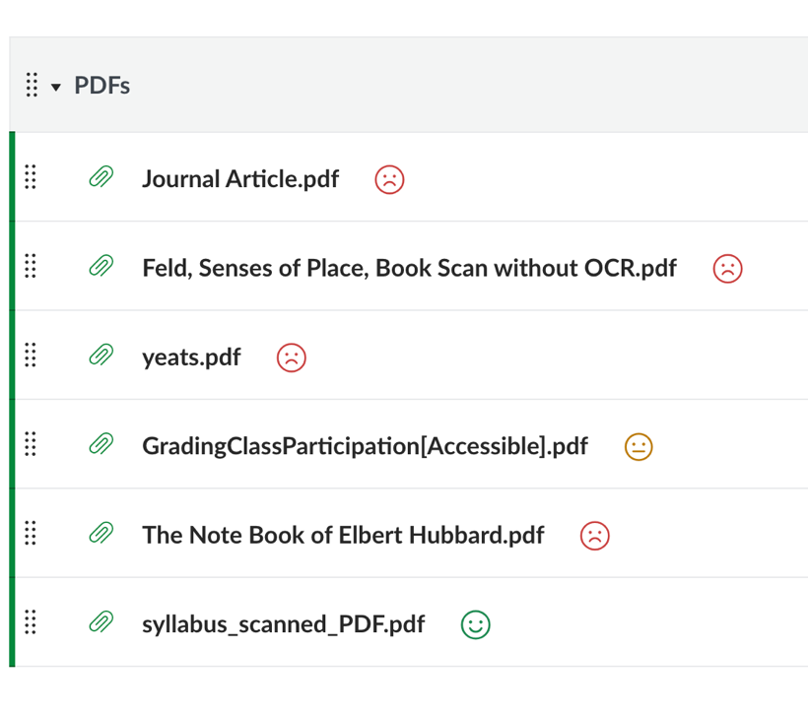

Accessibility Score icons are located next to each file type or along the top of HTML content and provide a quick at-a-glance summary of the Accessibility Score based on the icon style and color.

* The **green happy face** is for high accessibility scores.
* The **yellow neutral face** is for medium accessibility scores.
* The**red sad face** is for low accessibility scores.

For a more detailed information on a specific course content accessibility score, click the Panorama Accessibility icon next to the content item. A new window will open with a meter icon at the top. Click in the meter icon box to open the Accessibility Report pane that identifies any issues individually.

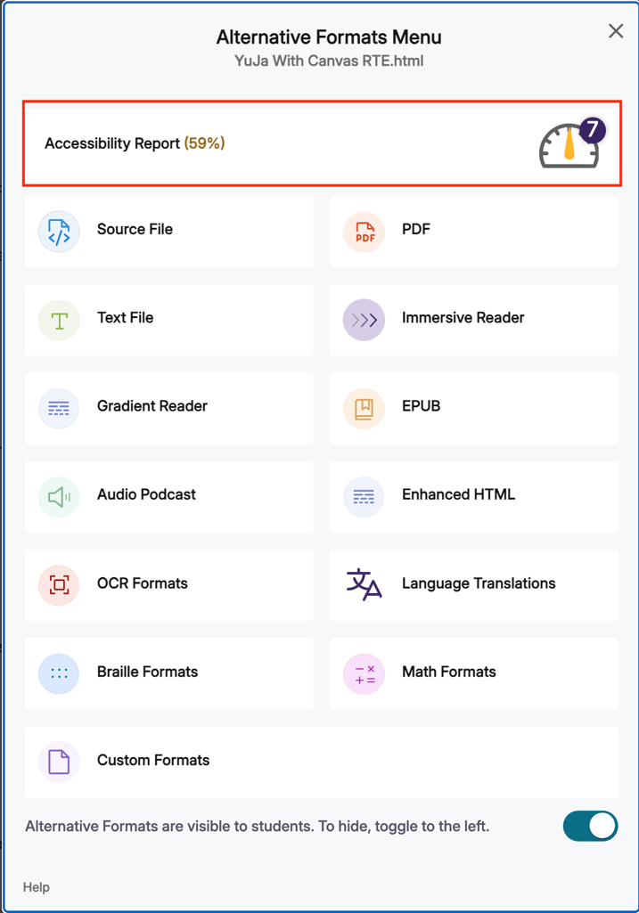

Alternatively, if you are creating content directly in the Canvas rich text editor tool, the meter icon is located just below the rich text editor window. Once it is clicked, you will see the associated Accessibility Report pane.

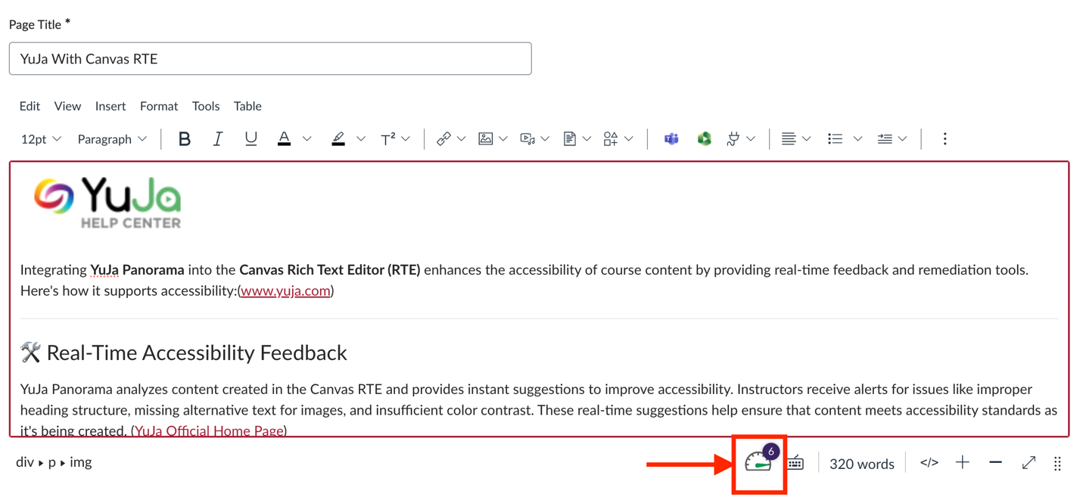

## Using the Accessibility Reports

Accessibility Reports offer a comprehensive list of accessibility issues detected within files and provide actionable options to address and resolve issues for content within the LMS.

The Accessibility Report offers two ways in which to resolve accessibility issues that have been identified under the Reviewed Issues list. Below is an overview of each method.

1. **Fix Issue (Panorama's Remediation Engine):**Manually add fixes for accessibility issues within the report and then apply those changes to your document.
2. **Replace with Alternative Format:**Replace the original document with an Alternative Format generated by Panorama.

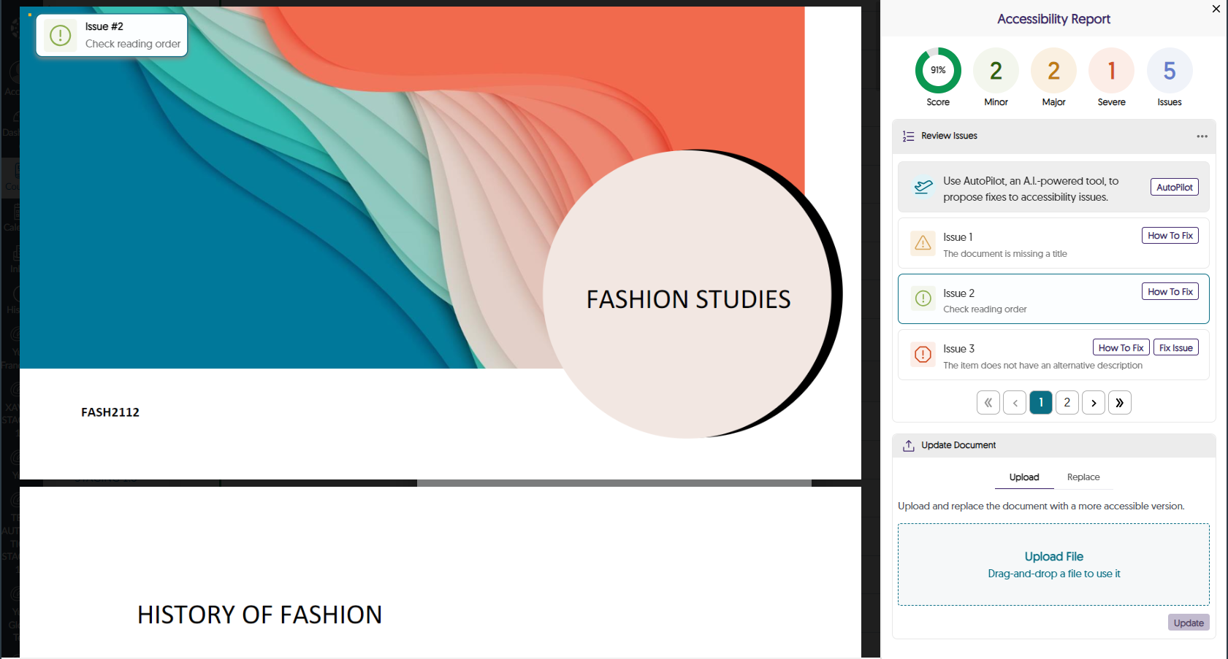

## Alternative Formats

You can provide your students easy access to alternative formats so they can select for themselves what best works for their needs. Below is the list of available Panorama Alternative Formats*:* You can also limit the formats based on course objectives - for a language learning course, you might not want the students to be able to have everything translated immediately; therefore, you would disable the ‘language translation’ option. To customize the formats available, navigate to the Panorama menu in Canvas, select Configuration > General Settings > Course Settings > Alternative Formats Menu Options. This menu allows you to toggle the Enable button for each format.

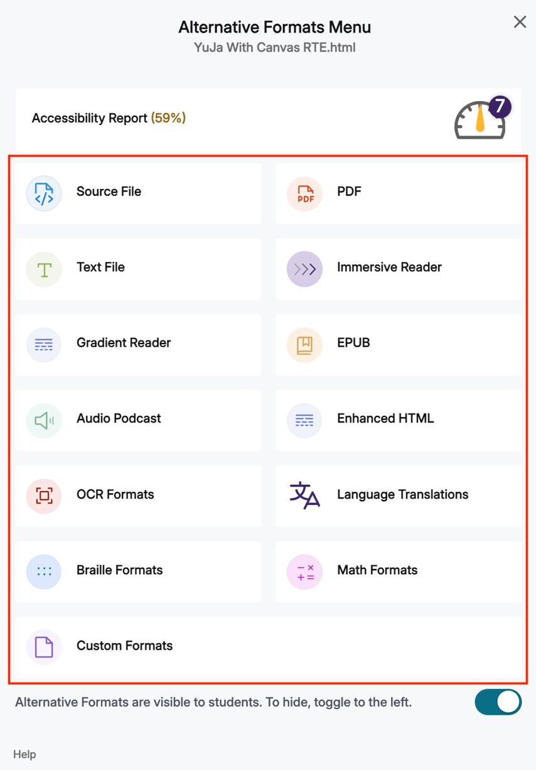

* **Source File:**View the document in its original format, suitable for download viewing.
* **PDF:**View the document in PDF format, suitable for both online and download viewing.
* **Text File:** View the document in a pure text format without any formatting styles, suitable for both online and download viewing.
* **Immersive Reader:**Allows for customizations to text preferences, grammar options, and reading preferences while following along with the audio playback.
* **Gradient Reader:**Enhances visual word recognition when reading by providing a guiding color gradient.
* **EPUB:** View the document in the eBook format, suitable for any eBook reader application.
* **Braille:** View the document in the braille grade 2 format, suitable for download viewing (a braille reader is required).
* **Audio Podcast:**Audio playback for documents, suitable for both online and download listening.
* **Enhanced HTML:**HTML documents will be displayed in a dedicated tab to customize the document's appearance using the Website Accessibility tool.
* **OCR:**Convert images with text into machine-encoded text that can be searched and read by screen readers.

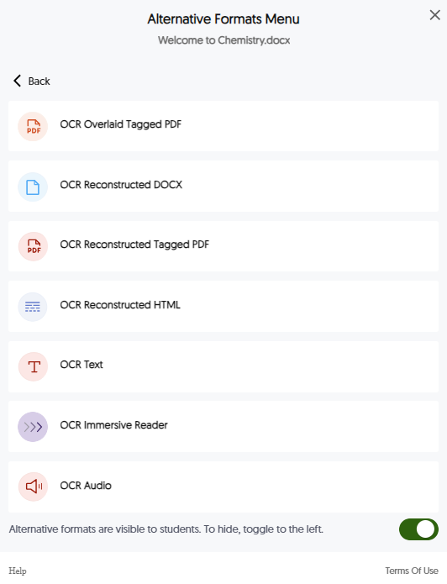

* **OCR Overlaid Tagged PDF:**Generate a tagged PDF that allows for selectable text overlaid on the original scanned document or image.
* **OCR Reconstructed DOCX:**Generate a new DOCX file from scanned documents or images. Highly recommended for PDF’s that were scanned and are being read by the screen reader as an image rather than text.
* **OCR Reconstructed Tagged PDF:**Generate a brand new tagged PDF from the scanned document or image. Highly recommended for PDF’s that were scanned and are being read by the screen reader as an image rather than text.
* **OCR Reconstructed HTML:**Generate a new HTML file from scanned documents or images.
* **OCR Text:**Recommended for those who prefer plain text, the OCR tool extracts and displays text within images and GIFs as a TXT file.
* **OCR Immersive Reader:**use the immersive reader for OCR content.
* **OCR Audio:**Extract text within images and GIFs into an MP3 text-to-speech audio player.
* **Math Formats:**Convert documents containing math equations into LaTeX, Math Text (i.e., numbers and symbols to words), or MP3 files.

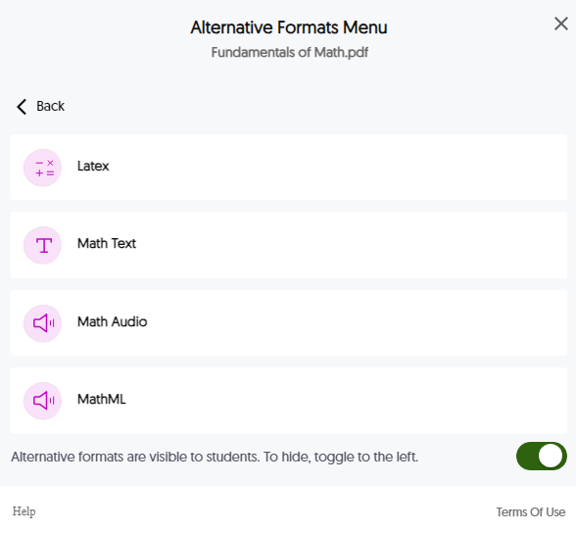

* + **Latex:**Convert documents into LaTeX document format.
  + **Math Text:**Convert documents into printed English, including numbers and symbols.
  + **Math Audio:** Convert documents to MP3.
  + **MathML:**Extract mathematical equations from documents and convert them into HTML files.
* **Language Translation:**Translate a document automatically to over 100 languages, which can be downloaded.

## Version History

Did you make your corrections and realize that you inadvertently changed or deleted something unintentionally? Panorama provides a version history so that you can go back to a previous version if need be. To access the version history for your content, select the content and open the Accessibility Report again. Scroll down the report to the **‘Update Document’ option > click the three stacked dots to the right side > select ‘Version History’ > and scroll the version you need**.

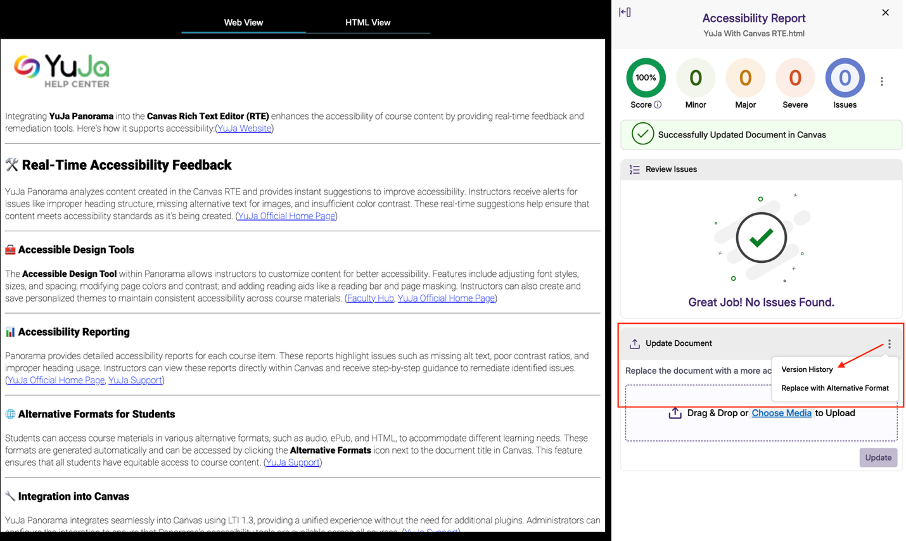

To restore the content to the earlier version, select the three stacked dots next to the version you wish to restore, select ‘Restore Version.’

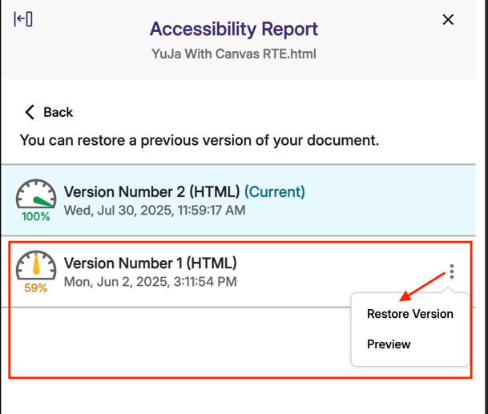

Note that restoring a version in Panorama means that Canvas will also revert to the earlier version.

If you created your content using the Canvas rich text editor window, you will not have a version history option.

## Keep Tool Limitations In Mind

Remember that Panorama is not a perfect solution to meet every single accessibility need. There are accessibility items that will need to be checked manually, such as titles for slides, accuracy of closed captions, and ensuring flashing content does not exceed the recommended threshold of 3 flashes per second. We encourage you to engage in a practice of ensuring accessibility as you create your content using the tools provided in the Microsoft bundle, but sometimes you might inherit content that you do not know if it has been created with accessibility in mind, so a checker is a nice way to have a quick look and see what, if any, remediation you should plan for as you incorporate that content.