

Accessibility How-To:

Adding Closed Captions and Audio Descriptions to Video Using Panopto

Uploading a Video to Panopto:
- Log in to Panopto and navigate to the desired folder (your personal folder is called “My Folder” and you will see it in the left-hand side navigation menu).
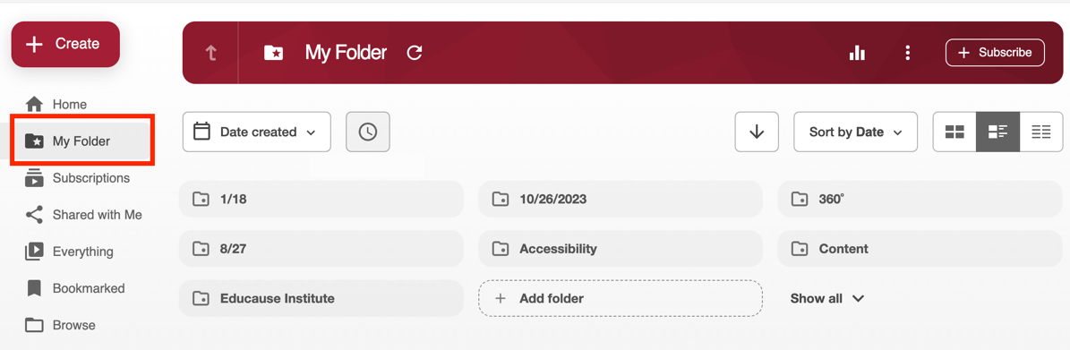
- Click '+ Create' button and select 'Upload Media' from the pop-up menu.

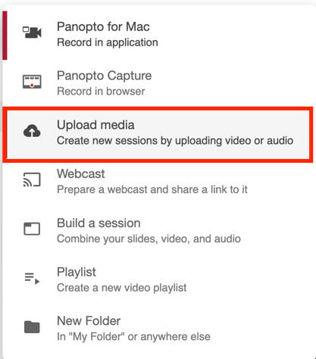

- Drag and drop your video file or browse to select it.

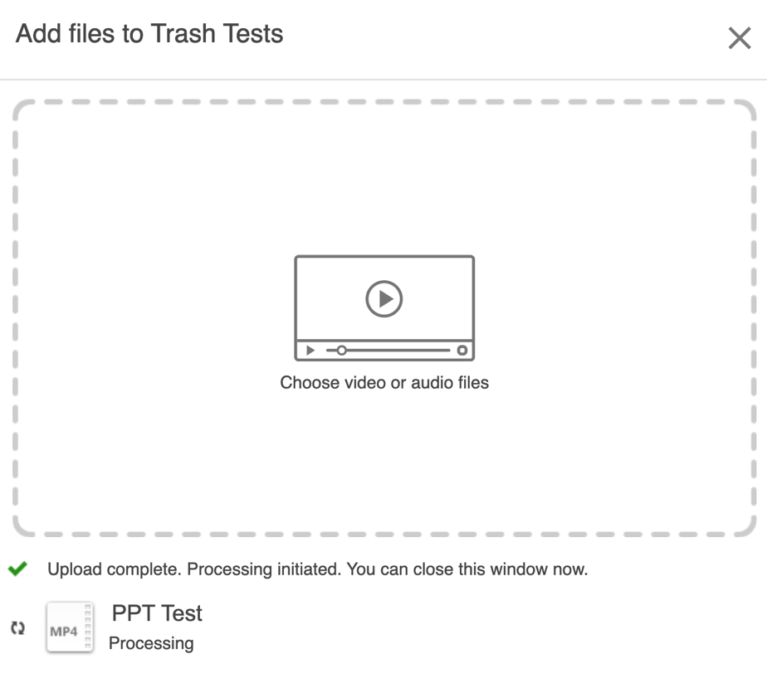

- Wait for the upload to complete – you will see a green progress bar indicating the processing time followed by a green checkmark indicating the upload ha completed. You can close this window at this time.

Note: You might need to refresh your browser window if the processing has ended but you do not see a thumbnail image of your video in your Panopto library.

Editing Auto-Captions and Adding New Captions:
- Open the video in Panopto Editor by clicking the ‘Edit’ icon that appears on the thumbnail image of the video when you hover over the thumbnail. This will open the video in Panopto’s edit window.

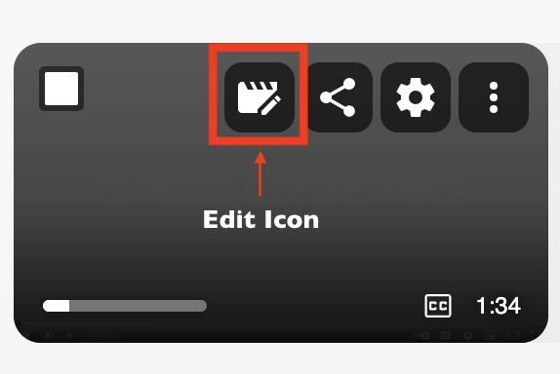

- Click the 'Captions' tab on the left side menu. This will open the closed captions edit pane. If you do not see captions in the edit pane, it could be that the video is still processing the auto-captions or there is no dialogue in the video.
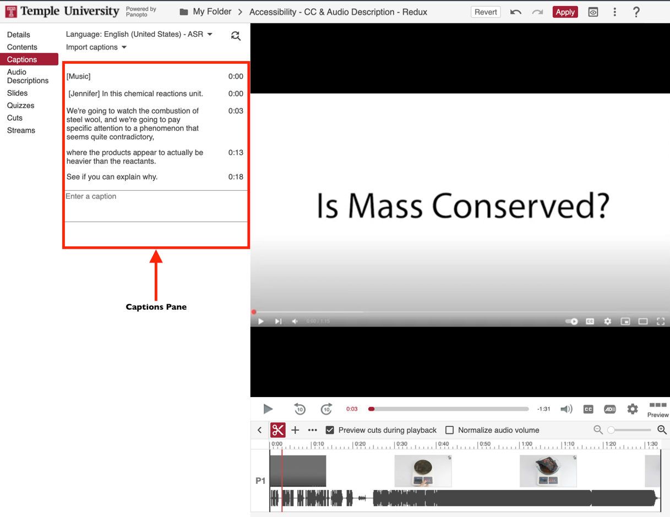
- Editing the auto-generated closed captions:
  - Click on caption text, within the captions text box, to edit text and press Enter to save.

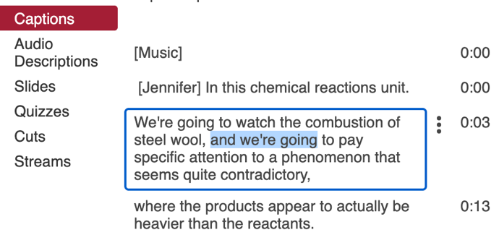

- Adding to the auto-generated closed captions:
  - Click inside of the ruler in the timeline – the lower portion of the edit window – to place your playhead where you would like the new caption to appear. You cannot scrub through the Panopto timeline.
  - Enter text into the empty caption frame at the bottom of the closed captions edit pane and press Enter to save. Your caption box will move to the appropriate placement in the sequence of other captions.
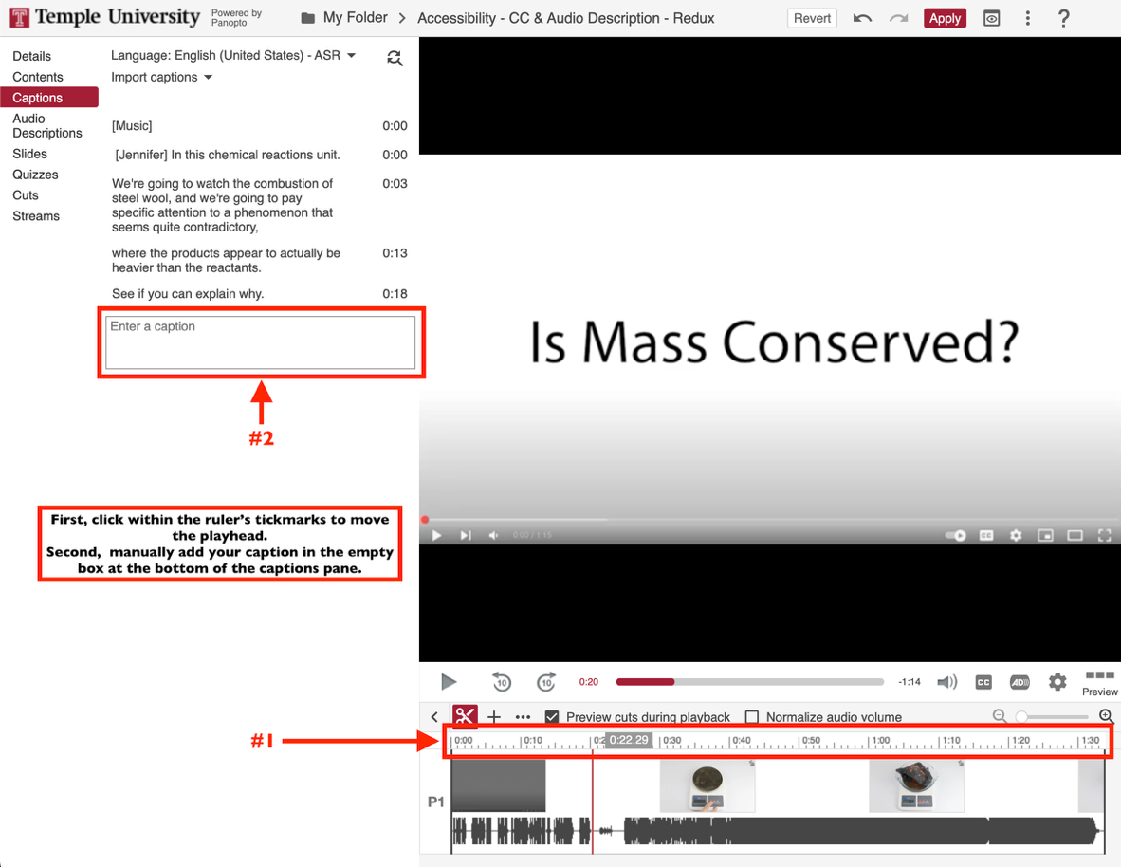
- Click 'Apply' in the upper right corner of the Panopto edit window to save all changes.
NOTE: You will need to enable the Closed Captions option, if it is not already enabled, to see the captions. Enable this by looking for the ‘CC’ button on the lower right of the viewing panel. It will be red if it is enabled.
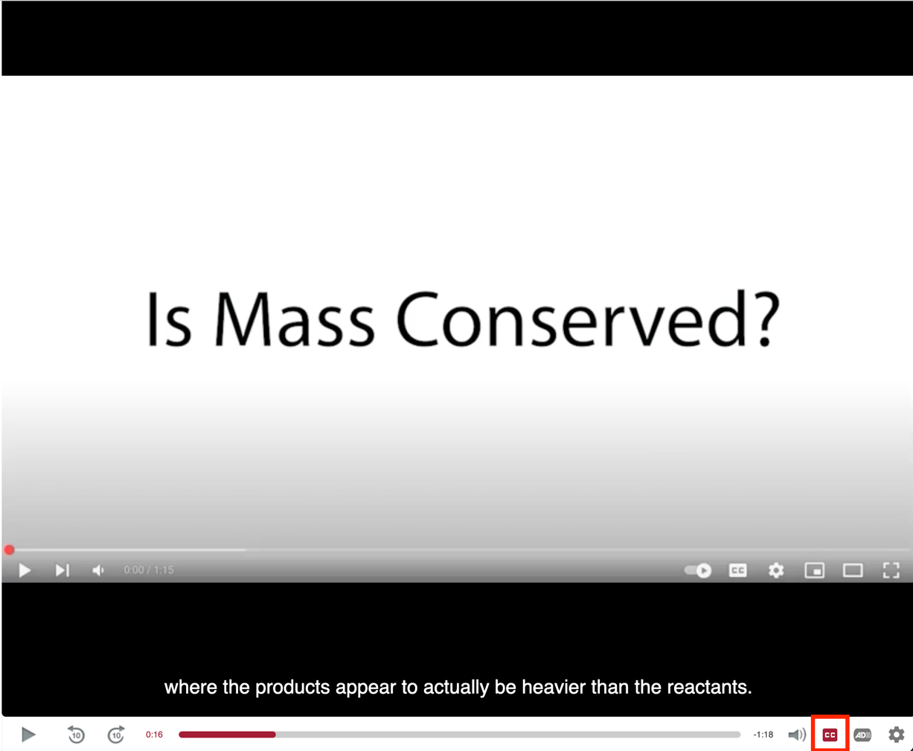

Inserting Audio Descriptions:
- Open the video in Panopto Editor by clicking the ‘Edit’ icon that appears on the thumbnail image of the video when you hover over the thumbnail. This will open the video in Panopto’s edit window.

- Click the 'Audio Descriptions' tab on the left side menu. This will open the audio descriptions edit pane.
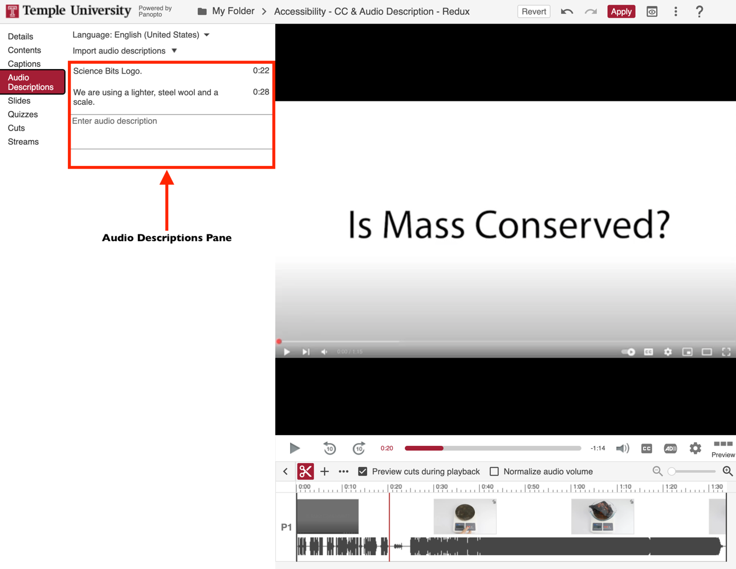
- Adding audio descriptions:
  - Click inside of the ruler in the timeline – the lower portion of the edit window – to place your playhead where you would like the new caption to appear. You cannot scrub through the Panopto timeline.
  - Enter text into the empty audio description frame at the bottom of the audio descriptions edit pane and press Enter to save. Your audio description box will move to the appropriate placement in the sequence of other audio descriptions.
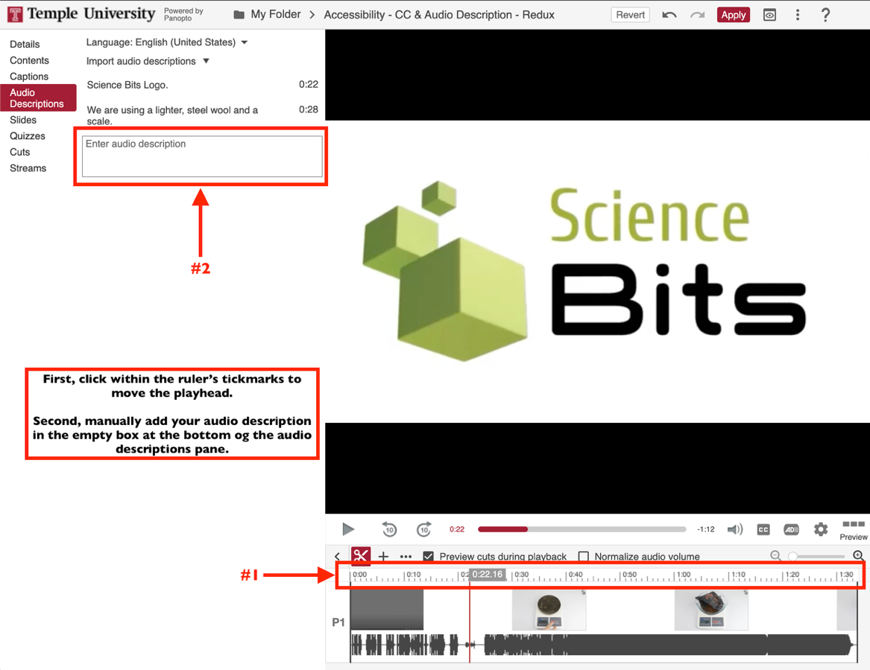
- Click 'Apply' in the upper right corner of the Panopto edit window to save all changes.
NOTE: You will need to enable the Audio Descriptions option, if it is not already enabled, to hear the audio descriptions. Enable this by looking for the ‘AD’ button on the lower right of the viewing panel. It will be red if it is enabled. It will not be visible until at least one audio description has been created.
