# **Temple University Center for the Advancement of Teaching Logo**

# **Accessibility How-To:**

# **PDF Remediation Using Panorama**

Panorama provides an accessibility checker that works for most digital content, as does Microsoft, but we want to spend time looking at the PDF remediation options in Panorama (PDF remediation is not offered in Microsoft Tools). You have already been introduced to the Panorama environment and have seen how to access the accessibility report, so we will be begin there.

To begin working on PDF remediation, please have your Canvas Course open and locate the Panorama icon next to your PDF.

1. Click the Panorama icon next to your document. This will open a new window.
2. Select ‘Accessibility Report’ from the top selection pane in that window (where you see a meter).

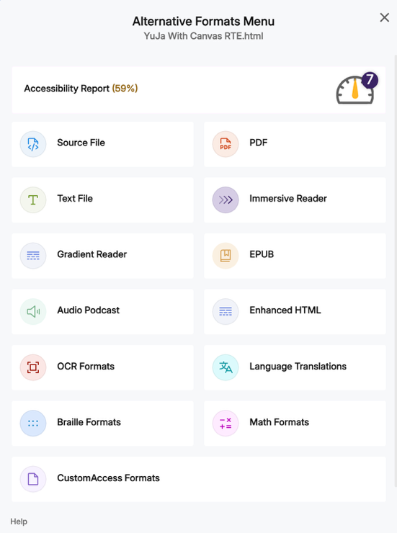

1. You can now see the ‘Accessibility Report’ in the right pane with your document in the left pane.

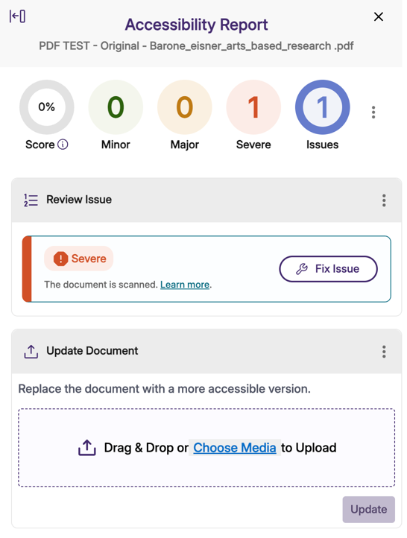Screenshot of Panorama Accessibility Report with a severe rating

1. You will note that the report states that this is a scanned document—meaning that it is being read as a picture and there are no discernible letters or words for a screen reader to announce. To correct this, you will click the ‘Fix Issue’ next to the note.
2. Clicking the ‘Fix Issue’ button will open a new window explaining the issue and providing options to remedy the issues. Select the ‘OCR Reconstructed Tagged PDF’ option. Click the ‘Add Change’ button. This will add tags to the document that do not currently exist.

NOTE: This can take some time to process.

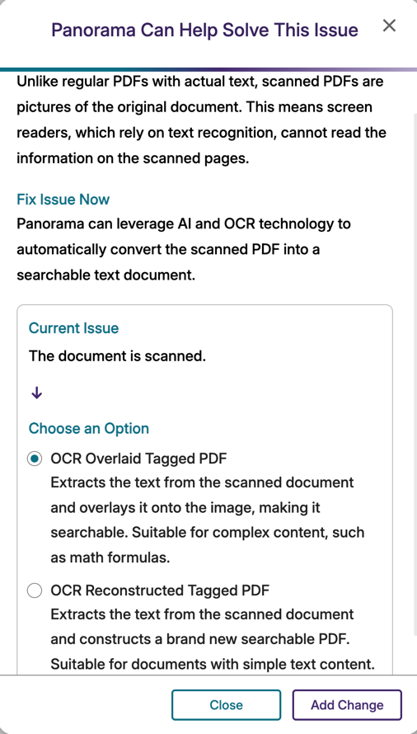Screenshot of Panorama option OCR Reconstructed Tagged PDFScreenshot highlight the Panorma Add Change icon

1. Wait for the item to process.
2. You should now see a new option in the report called ‘Structural Remediation’. Click the ‘Launch’ button.

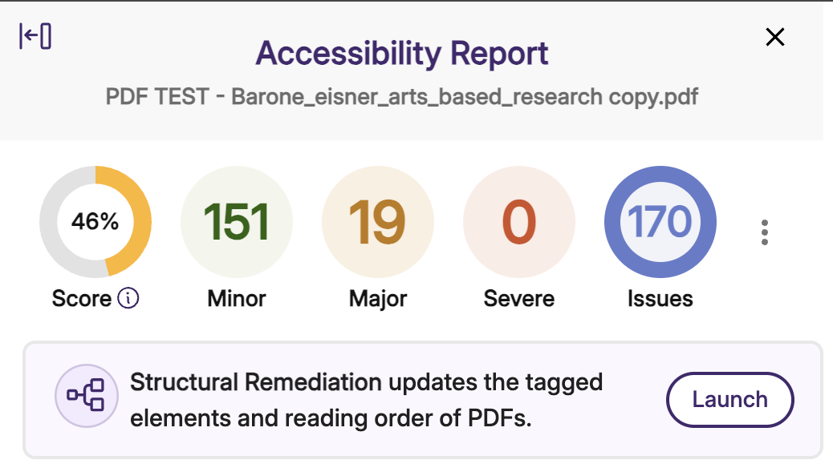Screenshot of Panorama Accessibility Report emphasizing the Structural Remidation updates Launch icon. 

1. Clicking the ‘Launch’ button will open the otherwise hidden tagging structure.

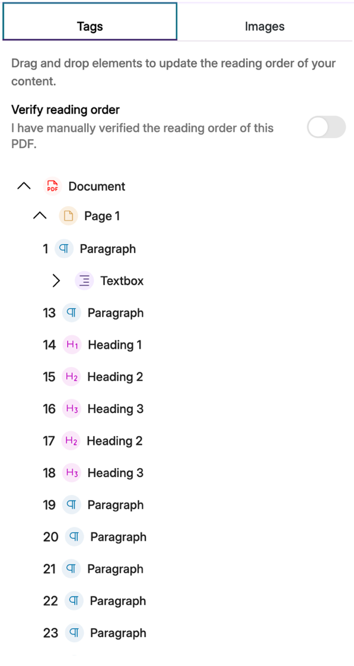

1. As you review the structure of the document in relation to the tag structure, you can click on an item in the tag structure tab to locate it in the document on the left side panel – you will see a different colored box appear around the tag element in the document as you hover above the tag element in the tag structure panel

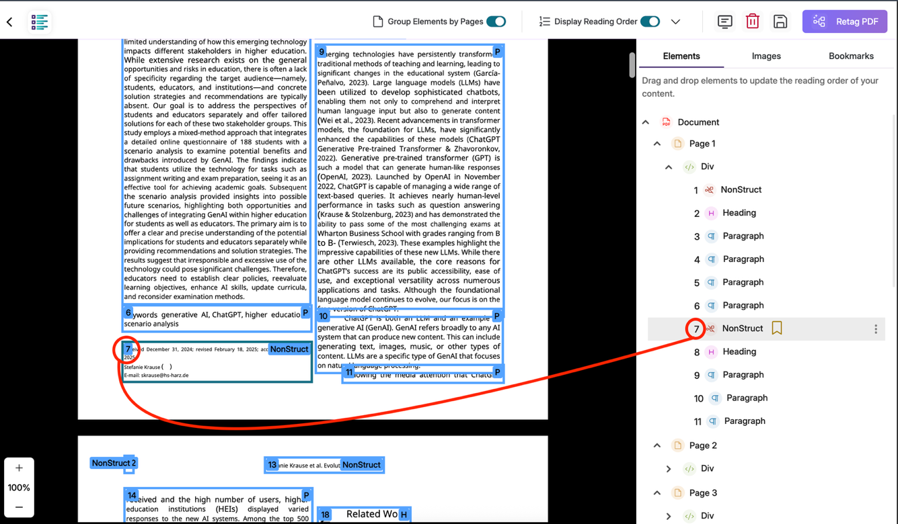

1. If you do not see the numbered boxes around the text in the document, then navigate to the upper portion of the Panorama window and select the ‘Display Reading Order’ slider to turn it on.

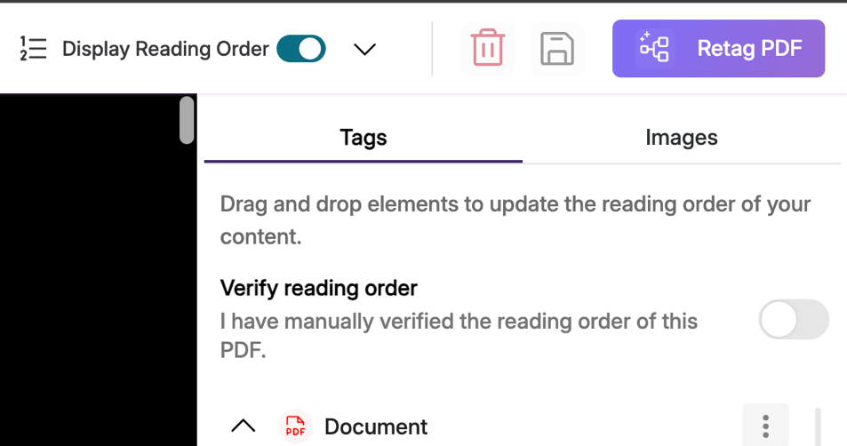Screenshot of Display Reading Order slider

1. If you feel the reading order (the tag structure) is badly out of sequence, you can try running the AI assisted tagging tool by clicking the ‘Retag PDF’ in the purple button in the upper right of the Panorama window.

Retag PDF icon

1. If you find that the tag structure is still not in the correct reading order, you can drag and drop the tag elements in the tag structure pane to reorder them. The green line in the tag structure panel will signify where you are dragging the tag to.

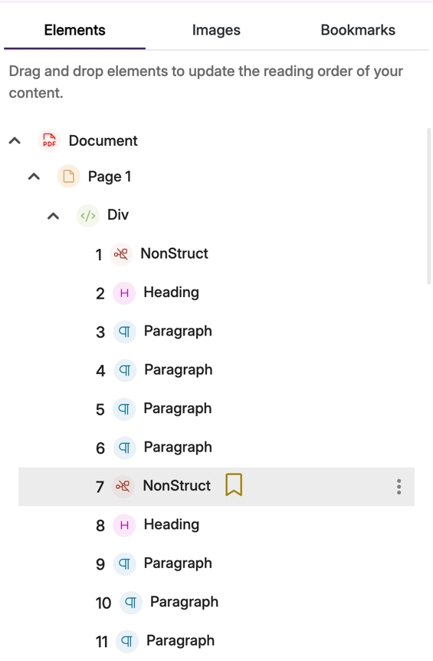

1. You can skip items that do not need to be read by selecting the three vertical dots, to the right of the tag name, and selecting edit. Change the element name by scrolling to ‘artifact’ for the screen reader to ignore it.

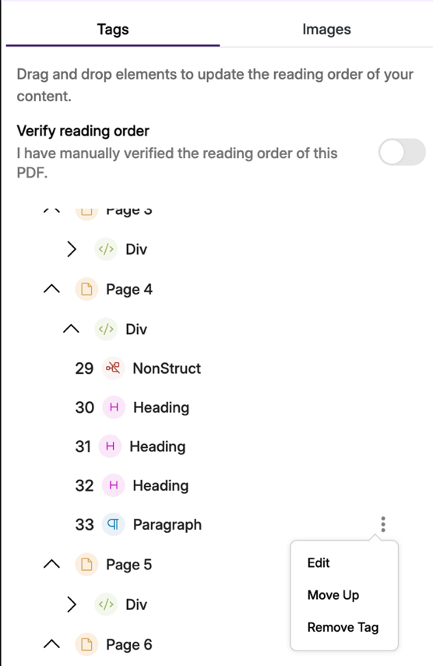 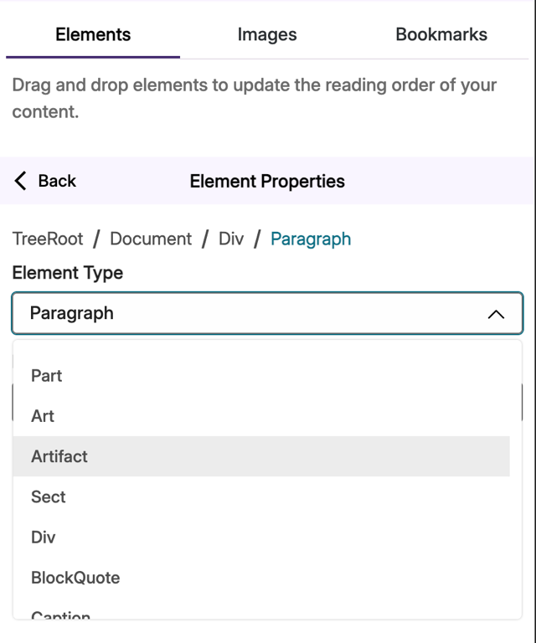Paragraph tag in PanoramaEdit option in PanoramaScreenshot showing how to change element name in Panorama

1. When satisfied with the changes, you can save the document by clicking the save icon at the top right of the Panorama window. This will replace the original version of your PDF in Canvas with the remediated version you created

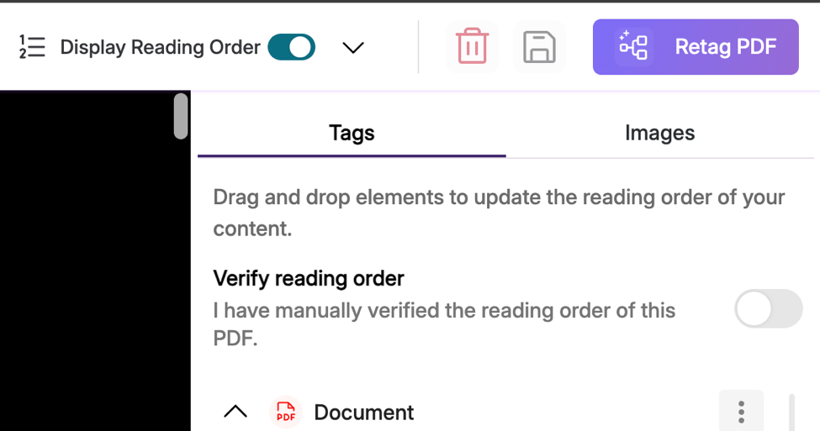Save icon 