50-Minute Lesson Plan for a Nutrition Course on Macronutrients

Ksenia Power, PhD

Assistant Professor of Instruction

Department of Health and Rehabilitation Sciences

Barnett College of Public Health

Temple University

Materials Needed:
- Slides or board
- Printed food labels or sample menus (fast food, meal prep, etc.)
- Calculators or phones
- Handout with macronutrient ranges (optional)

Lesson Breakdown (50 minutes)

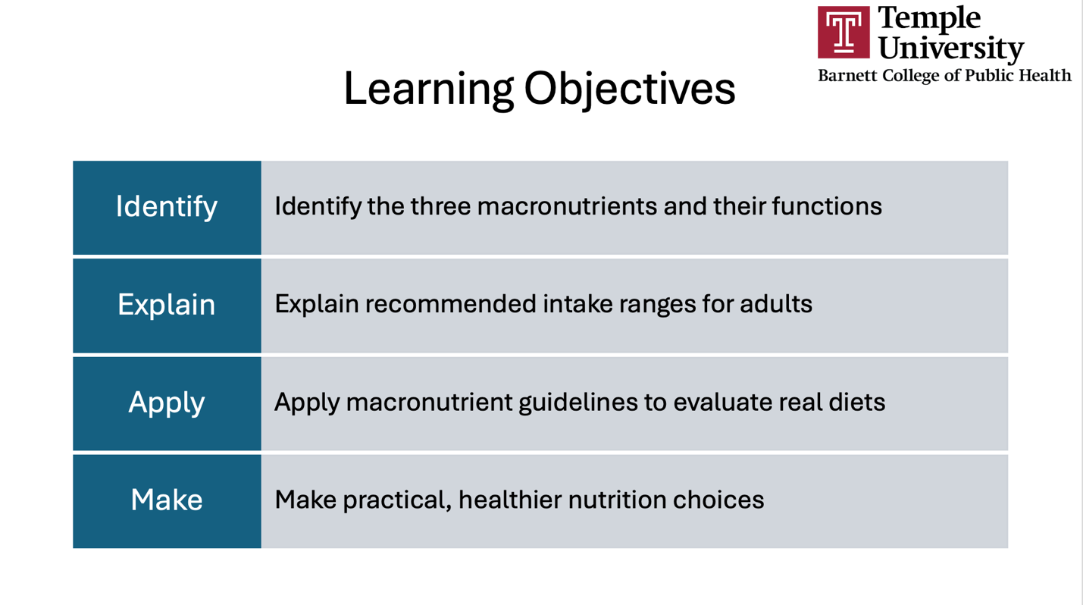

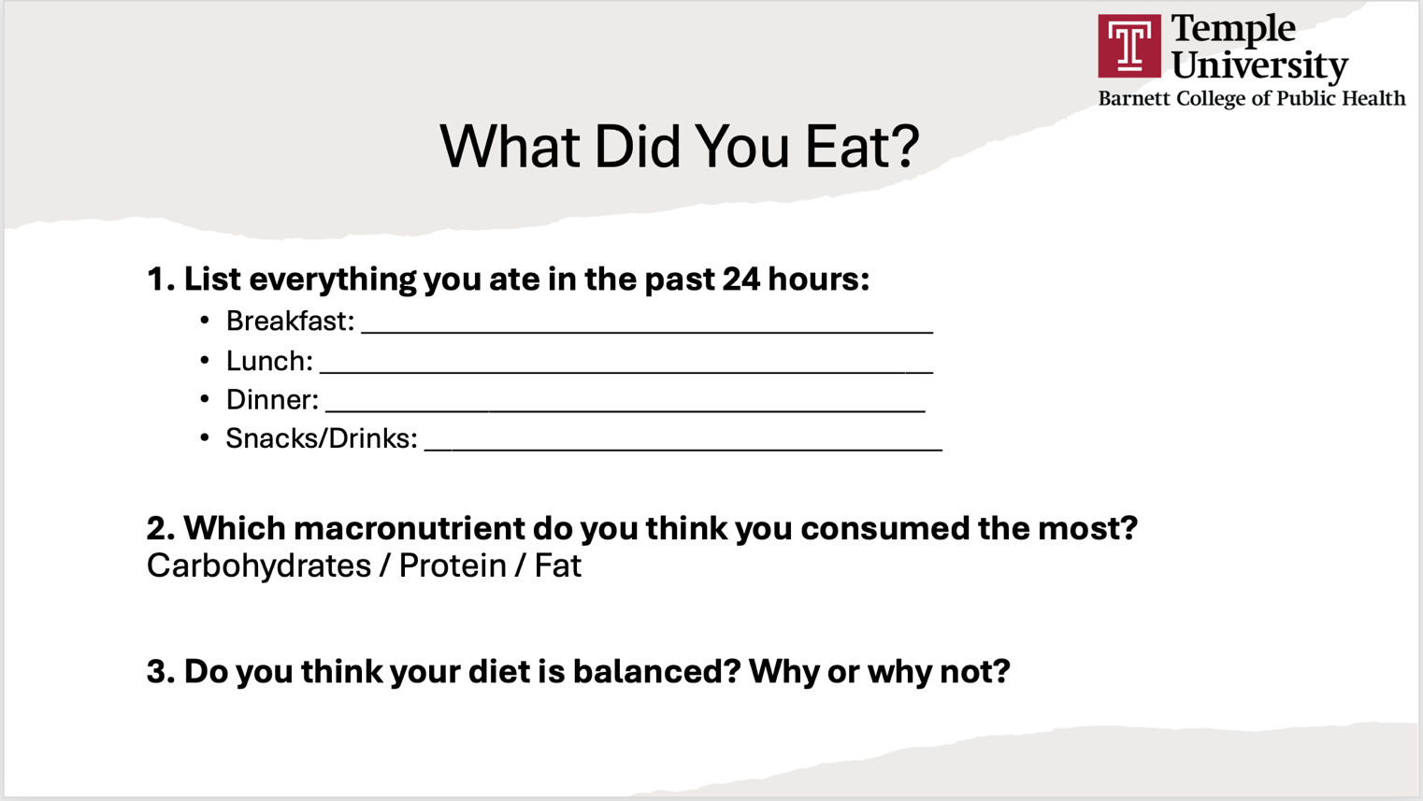
PART 1. Ice-breaker (5 minutes)

Note for the instructor: Start with a brief discussion to spark curiosity and self-awareness.
Students will use an AI platform to list everything they ate in the past 24 hours. Then, students will use follow-up prompts to ask which macronutrient they consumed the most and whether their diet was balanced. Ask students whether they agree or disagree with the AI platform’s assessment.

PART 2. Mini Lecture (15 minutes) – Macronutrients Explained
Note for the instructor: Provide an interactive overview of each macronutrient
- Ask quick questions as you present the material:
  - Examples: What do you know about carbs so far?
  - Is avocado a fat or carb?
  - What is your primary source of protein?
  - What are some non-meat protein sources?
- Use real food examples students recognize
LECTURE SAMPLE SLIDES
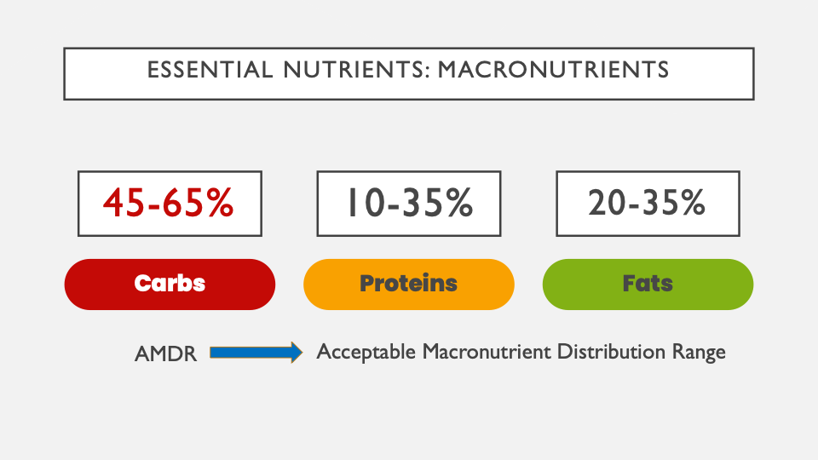

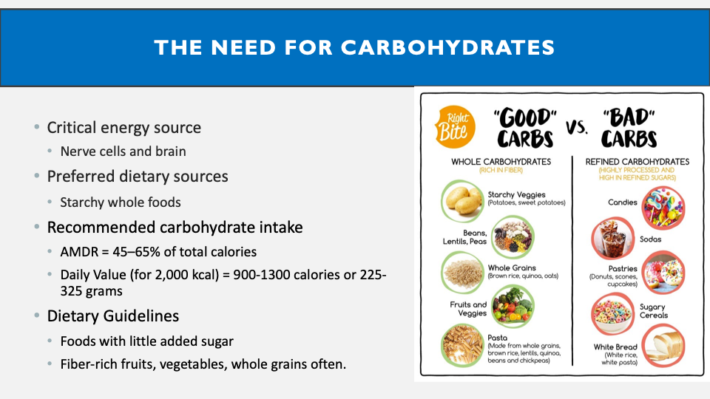

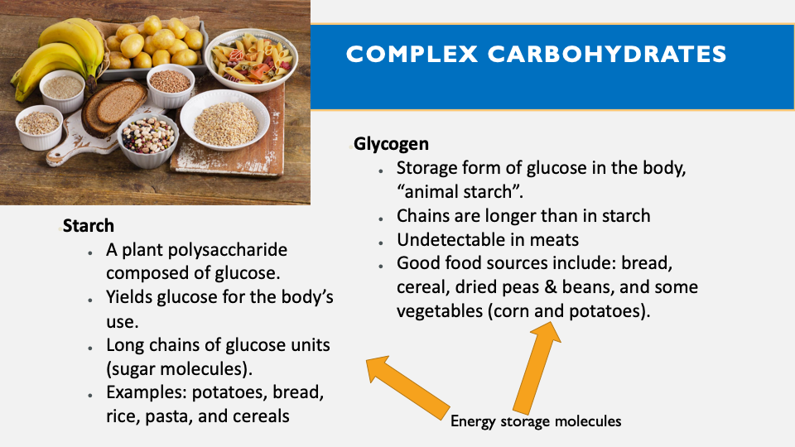
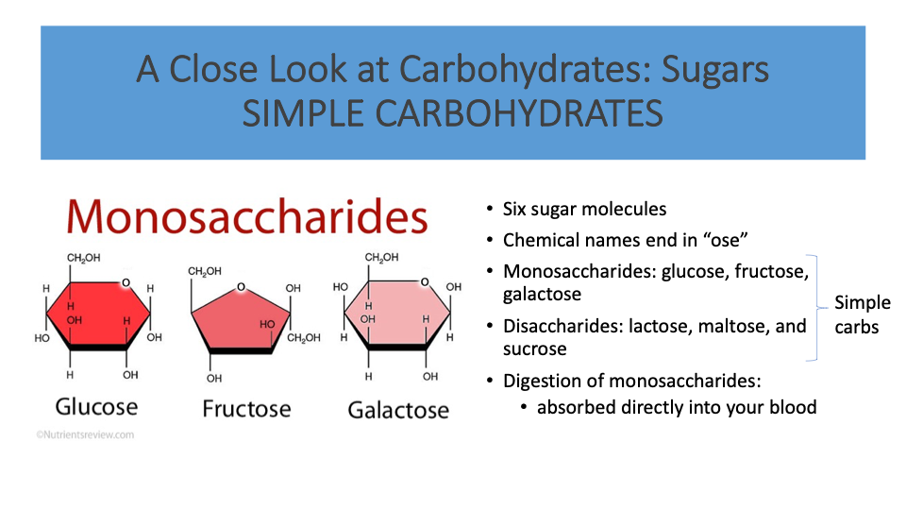

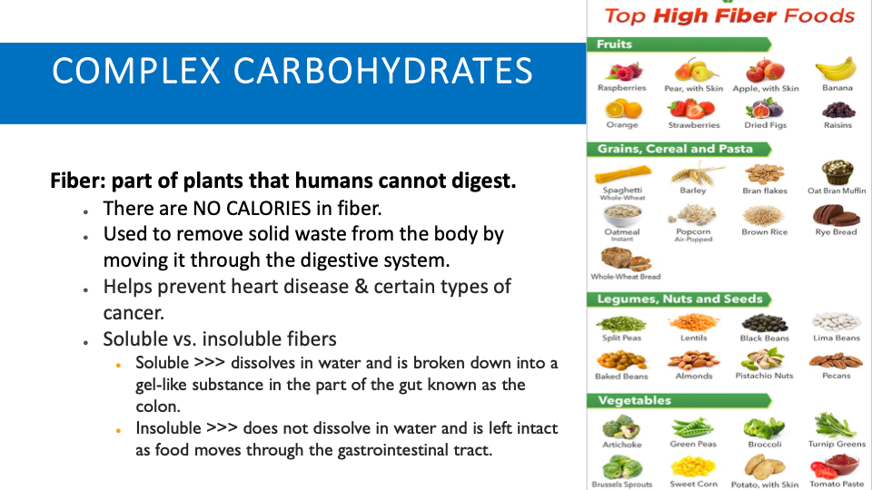
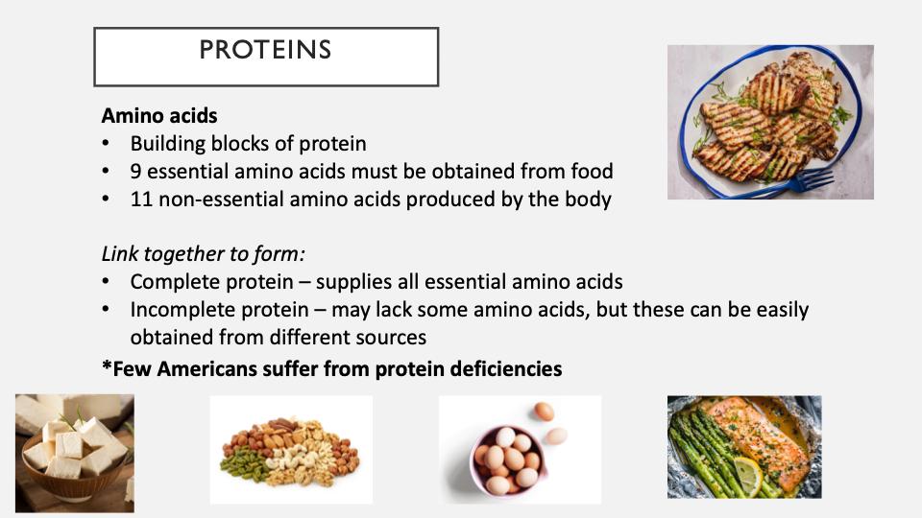

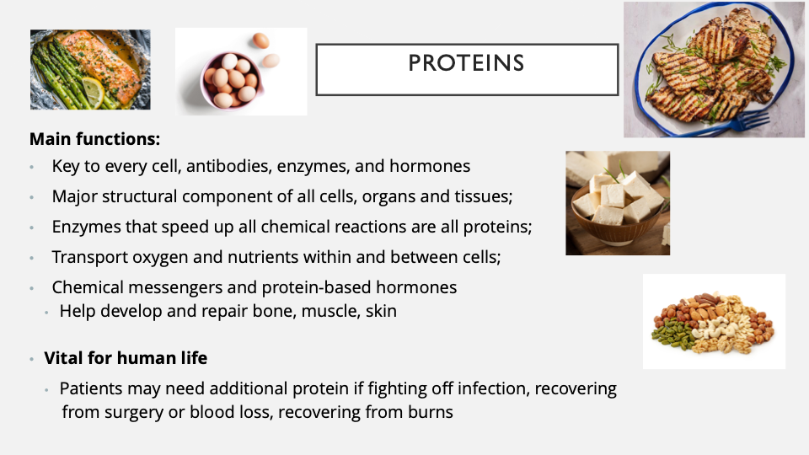
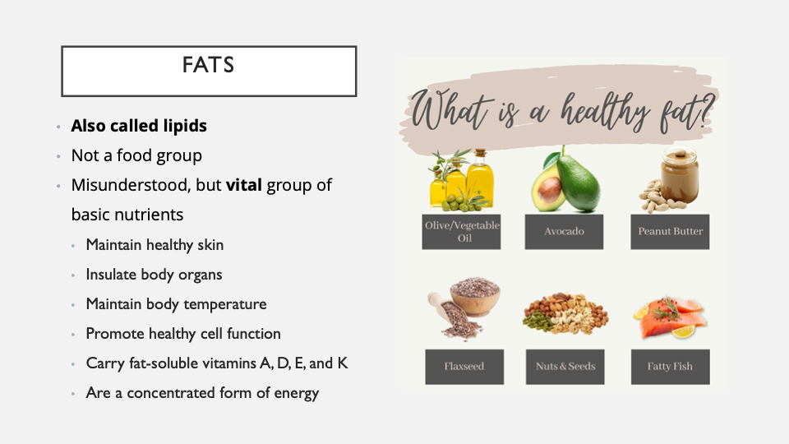

PART 3. Guided Practice (10 minutes) – “Build the Plate”
During class, walk through:
  - How many calories should come from each macronutrient
  - Convert calories → grams:
    - Carbs = 4 cal/g
    - Protein = 4 cal/g
    - Fat = 9 cal/g
Note for the instructor: students calculate alongside you

Activity Worksheet for Students

Step 1: Calculate Macronutrient Calorie Ranges
You are planning a 2,000-calorie diet.
Carbohydrates (45–65%)
- Minimum: 2,000 × 0.45 = __________ calories
- Maximum: 2,000 × 0.65 = __________ calories

Protein (10–35%)
- Minimum: 2,000 × 0.10 = __________ calories
- Maximum: 2,000 × 0.35 = __________ calories

Fat (20–35%)
- Minimum: 2,000 × 0.20 = __________ calories
- Maximum: 2,000 × 0.35 = __________ calories

Step 2: Convert Calories to Grams
(Use: Carbs = 4 cal/g, Protein = 4 cal/g, Fat = 9 cal/g)
Carbohydrates:
- Minimum: __________ ÷ 4 = __________ g
- Maximum: __________ ÷ 4 = __________ g

Protein:
- Minimum: __________ ÷ 4 = __________ g
- Maximum: __________ ÷ 4 = __________ g

Fat:
- Minimum: __________ ÷ 9 = __________ g
- Maximum: __________ ÷ 9 = __________ g

PART 4. Main Interactive Activity (15 minutes)

“Diet Detective Challenge”

Setup:
Divide students into small groups (3–4 per group)
Each group receives:
- A real-world diet scenario, such as:
  - Fast food day
  - “Healthy influencer” diet
  - Athlete meal plan
  - College student on a budget
Examples of possible scenarios:

Scenario A: Fast Food Day
- Breakfast: Donut + coffee
- Lunch: Burger, fries, soda
- Dinner: Fried chicken + mashed potatoes
- Snack: Chips

Scenario B: “Healthy Influencer”
- Smoothie bowl
- Salad with dressing
- Granola snacks
- Avocado toast

Scenario C: Athlete Plan
- Eggs + toast
- Chicken + rice
- Protein shake
- Pasta dinner

Scenario D: Busy College Student
- Skips breakfast
- Ramen for lunch
- Pizza for dinner
- Energy drink

Note for instructors: to make this activity more interactive, ask students to use an AI platform to create their own real-diet scenario for a population of their choice.

Task:
Groups must:
- Estimate total calories
- Break down macronutrients (carbs, protein, fat)
- Compare to recommended ranges
- Decide:
  - Is this diet balanced?
  - What’s too high/low?
  - How would you improve it?

Make it fun:
Ask each group to present their findings as:
- A “nutrition verdict” (e.g., “Too carb-heavy!”)
- OR a quick 1-minute “court case” defending or criticizing the diet
This aspect adds humor, debate, and critical thinking

Diet Detective Challenge Activity Worksheet for Students

Group Members:

Your Assigned Diet Scenario:
(Note for the instructor: You can use an AI platform to create a different diet scenario for each group)

Step 1: List the foods
Table 1. Form for Food Items by Meal.
Meal | Food Items
Breakfast | _____________________________
Lunch | _____________________________
Dinner | _____________________________
Snacks | _____________________________

Step 2: Estimate Macronutrients
Table 2. Form for Estimating and Evaluating Macronutrients.
Macronutrient | Estimated Amount | Too Low / Good / Too High
Carbs | __________________ | ________________________
Protein | __________________ | ________________________
Fat | __________________ | ________________________

Step 3: Analyze the Diet
- Is this diet balanced? Why or why not?

- What is the biggest problem with this diet?

- What is one strength of this diet?

Step 4: Improve the Diet
Suggest 2 realistic changes:

Step 5: Your “Nutrition Verdict”
Circle one:
- ✅ Balanced
- ⚠️ Needs Improvement
- ❌ Unbalanced

Explain your verdict:

Step 6: Class Presentation (2-3 Minutes Total)
Ask 2-3 volunteers to share:
- Your verdict
- One key issue
- One improvement


Part 5. Wrap-Up & Reflection (5 minutes)

Ask students if they have any questions at the end.

Advantages of this lesson plan
- Personal (students reflect on their own diet)
- Practical (provide real-world application)
- Interactive (incorporates group analysis + presentations)
- Engaging (diet detective activity adds energy and increases participation)

