

Accessibility How-To:

Creating Clear Structures in Documents

The structure and organization of documents ensure that students can navigate and understand the materials we provide using their preferred tools. Clear structure and consistent navigation support students who rely on screen readers to access and understand the content. This guide will show you how to use Microsoft Word’s built-in formatting features, including headings, lists, and paragraph styles, to give your document a logical flow. Instead of just making text bold or larger, which is not meaningful to a screen reader, structuring your document provides an outline that screen readers and users can navigate easily.

Headings
Headings are structural elements that:
- Organize information into clear sections.
- Enhance readability by breaking up large text blocks and making documents easier to skim.
- Assist readers in quickly finding relevant content.
- Are titles or phrases that mark the beginning of a new section within a word processing document.
- Is a text label used to define sections and subsections of content within a document.

The Hierarchy of Headings
A document’s heading structure serves as an outline, organizing content in a logical sequence that guides the reader. This heading hierarchy helps readers understand the relationships between sections of text and ensures screen readers read content in the correct order.

Heading Ranks
H1 is used for the main title of a page or document (usually only one per page).
H2 is used for major sections of content.
H3 is used for subsections within an H1 section.
H4, H5 are used for further divisions of content, but are generally less common.

Best Practices for Using Headings in Word Docs
- Use a logical hierarchy
- Only one Title heading per document
- Use descriptive, meaningful titles
- Be consistent. Use the same capitalization, color, and formatting for headings throughout your document.
- Keep headings short.
- Do not overuse headings.

Adding Headings

Steps for adding headings in Word
To add a heading style:
- Type the text you want into a Word document.
- Highlight the text you want as a heading
- On the Home tab, select Styles (or press Alt+H, then L), and then select the heading you want, such as the Heading 1 button.
- Word applies a font and color change to help make it clear that this is Heading 1 of the article. The next heading type is Heading 2.
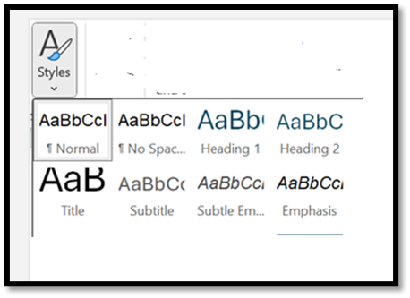

Adding a heading in a Word Document (link)

Paragraph Styles
Paragraph styles are predefined formatting settings in Word that control things like:
- Font type and size
- Line spacing and alignment
- Spacing before and after paragraphs
- Identation
Each style carries a hidden structure that helps assistive technologies navigate and make sense of the document's content.

Steps for adding paragraph styles in Word
- Select your main text
- On the Home tab, in the Styles group, click Normal

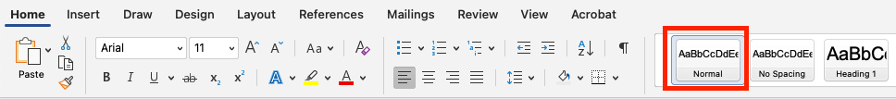

Lists
Both bulleted and numbered lists do more than just make information look tidy. When you use Word’s built-in list tools, you give your document structure and meaning that screen readers can recognize. Furthermore, lists break content into clear, concise points that improve comprehension for all readers.
When creating lists in a Word document, use the built-in list tool found on the Home tab.
