

Accessibility How-To:

Add Alt Text in Common Contexts

Google Docs & Slides
The following screenshots show Google Docs, but the same principles apply in Google Slides.

Method 1
Right-click on the image (Control + click on a Mac) and select Alt Text from the pop-up menu.
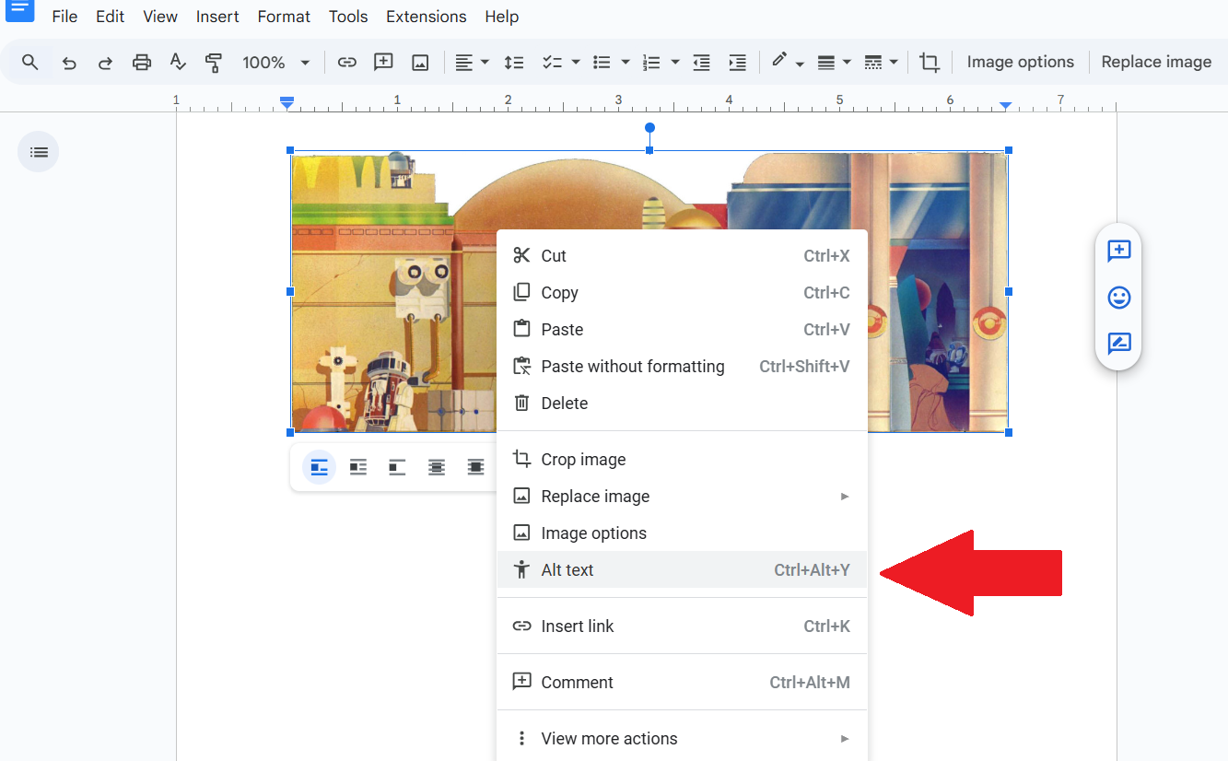

Then select Alt Text from the menu that opens up on the right side of the screen. Enter your Alt Text in the box.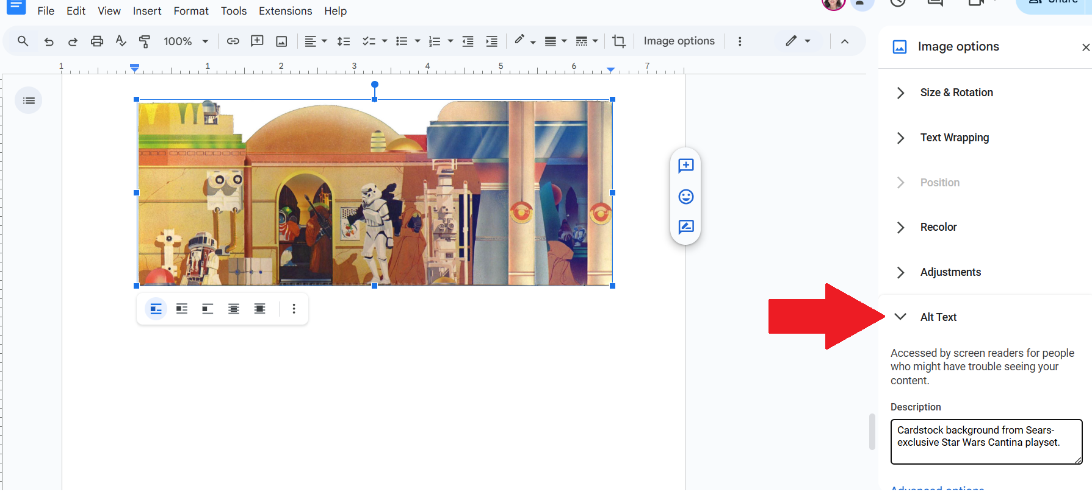

Method 2
Click on Image Options on the Menu Bar.
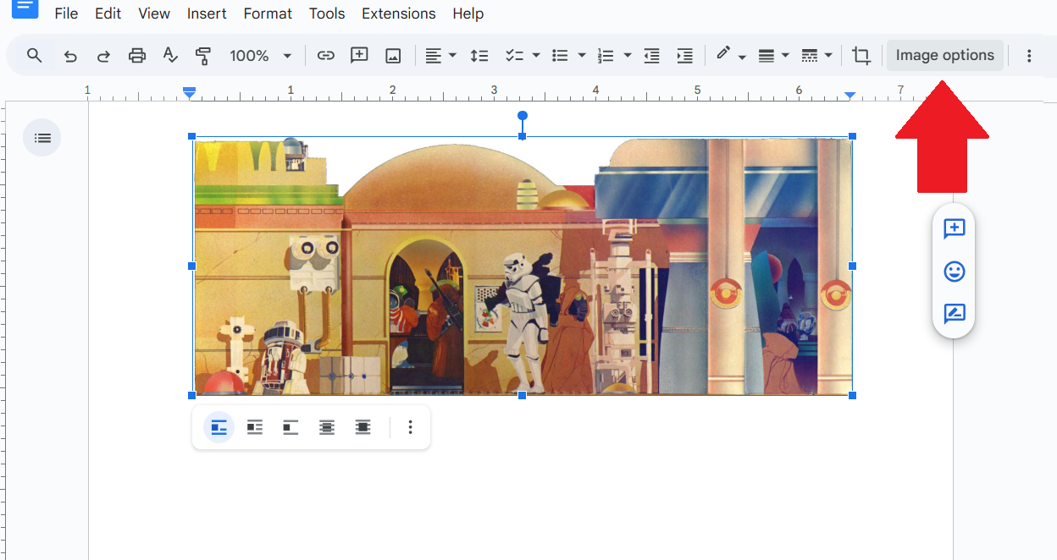
Then select Alt Text from the menu that opens up on the right side of the screen. Enter your Alt Text in the box.Method 3
Use the keys Command+Option+Y on a Mac, or Ctrl+Alt+Y on a PC. Then select Alt Text from the menu that opens up on the right side of the screen. Enter your Alt Text in the box.

Microsoft Word & PowerPoint

New Images
Microsoft products now auto-generate Alt Text. When inserting a new image in MS Word a temporary box appears just below the image allowing you to edit or approve the Alt Text.
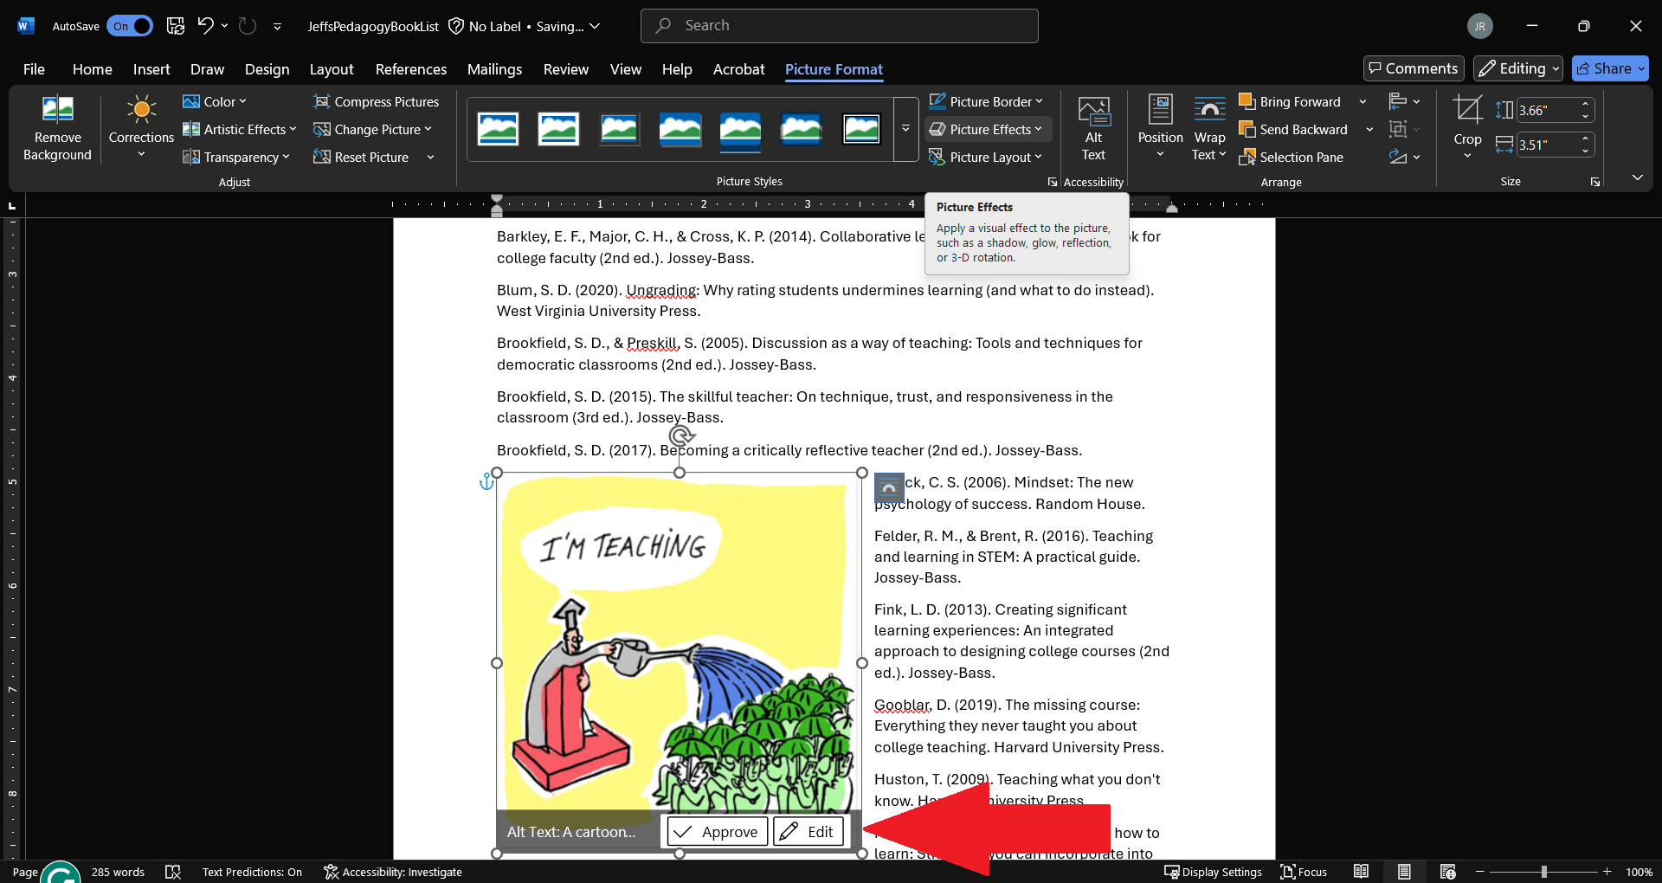

Clicking on the Edit button brings up the Alt Text panel on the right, allowing you to edit the Alt Text.
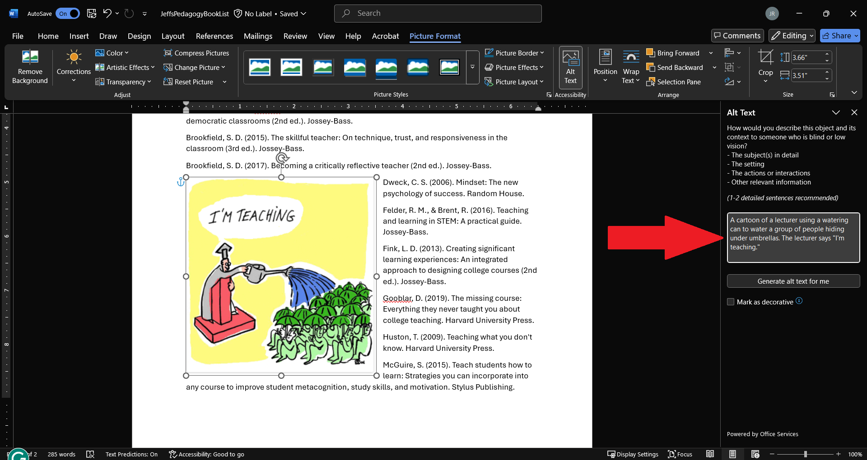

Existing Images Method 1
To review existing images for accuracy and contextual appropriateness, right click on the image (Control + click on a Mac) and select View Alt Text.
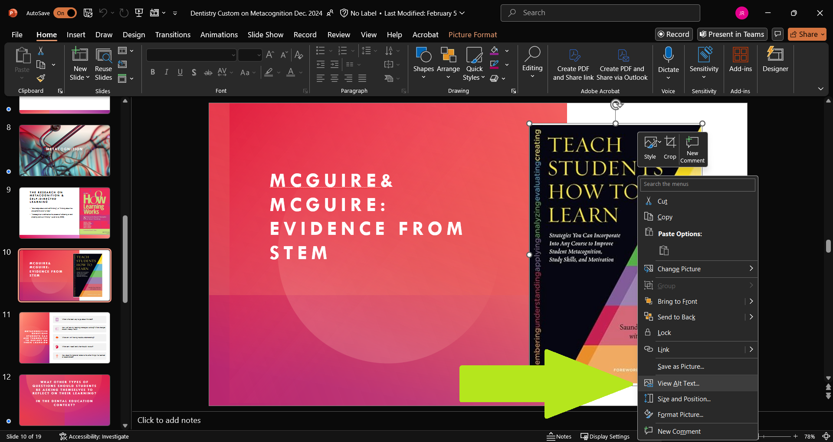

Clicking View Alt Text will bring up the Alt Text panel on the right, allowing you to edit the Alt Text.
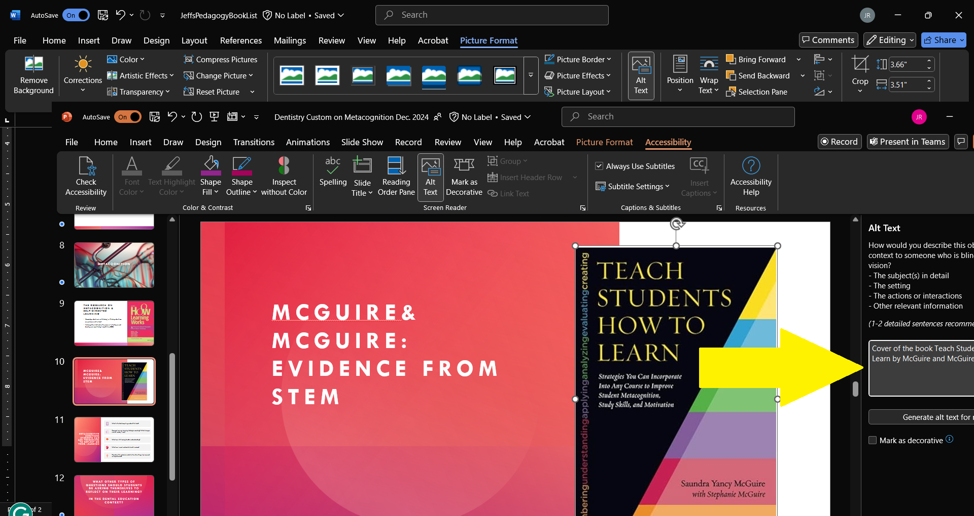

Existing Images Method 2
Selecting an image will add a Picture Format option to the menu bar.
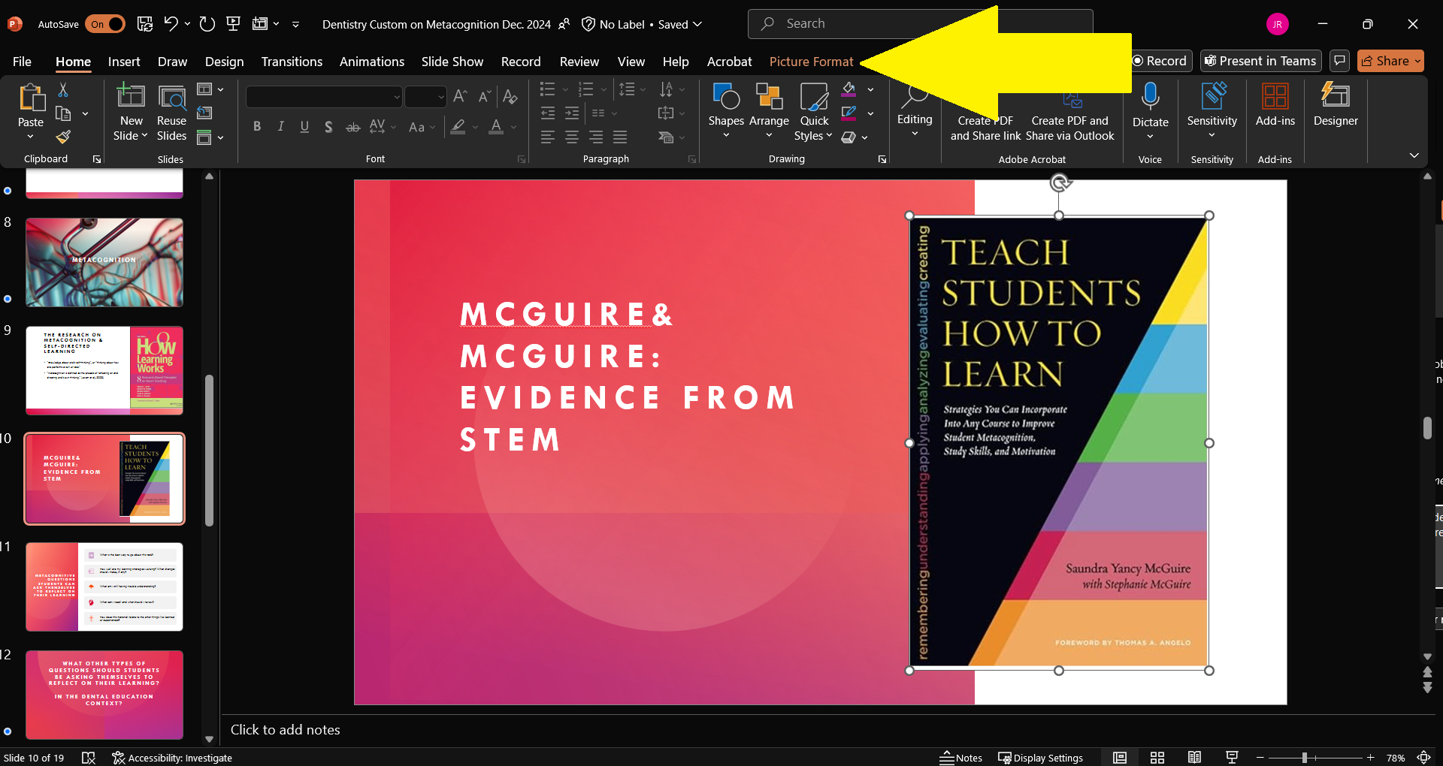

Select Alt Text from the menu bar.
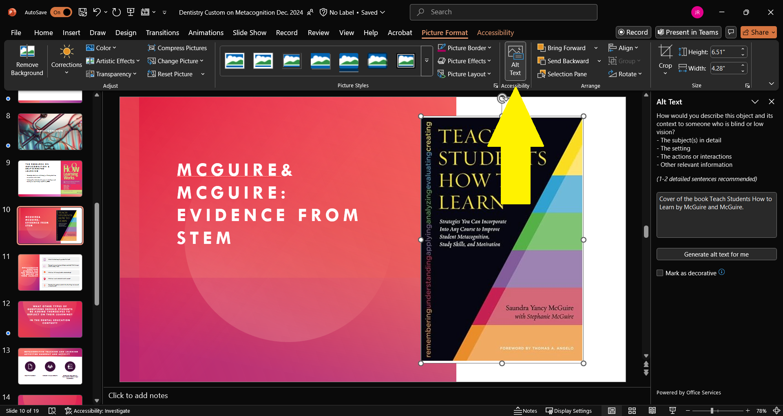

Edit Alt Text in the box to the right.

Canvas

New Images
When uploading new images you will be prompted for an alt text.
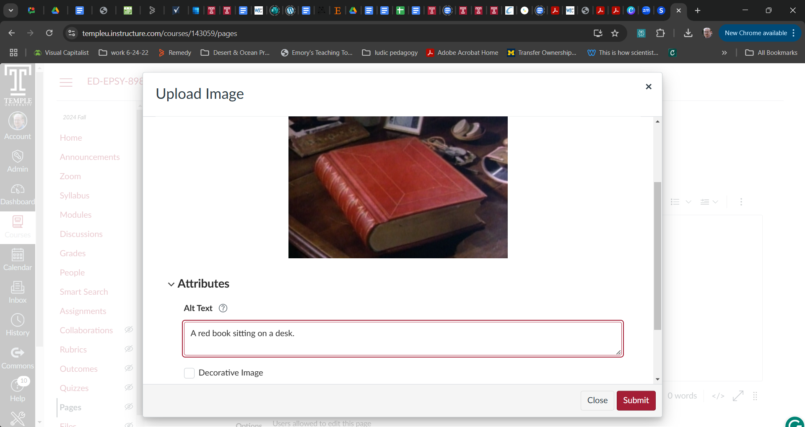

Existing Images
If you already have images uploaded to Canvas, you can add Alt Text by going into Edit Mode and using the Accessibility Checker. Look to the bottom right of the main text box for the Accessibility Checker.
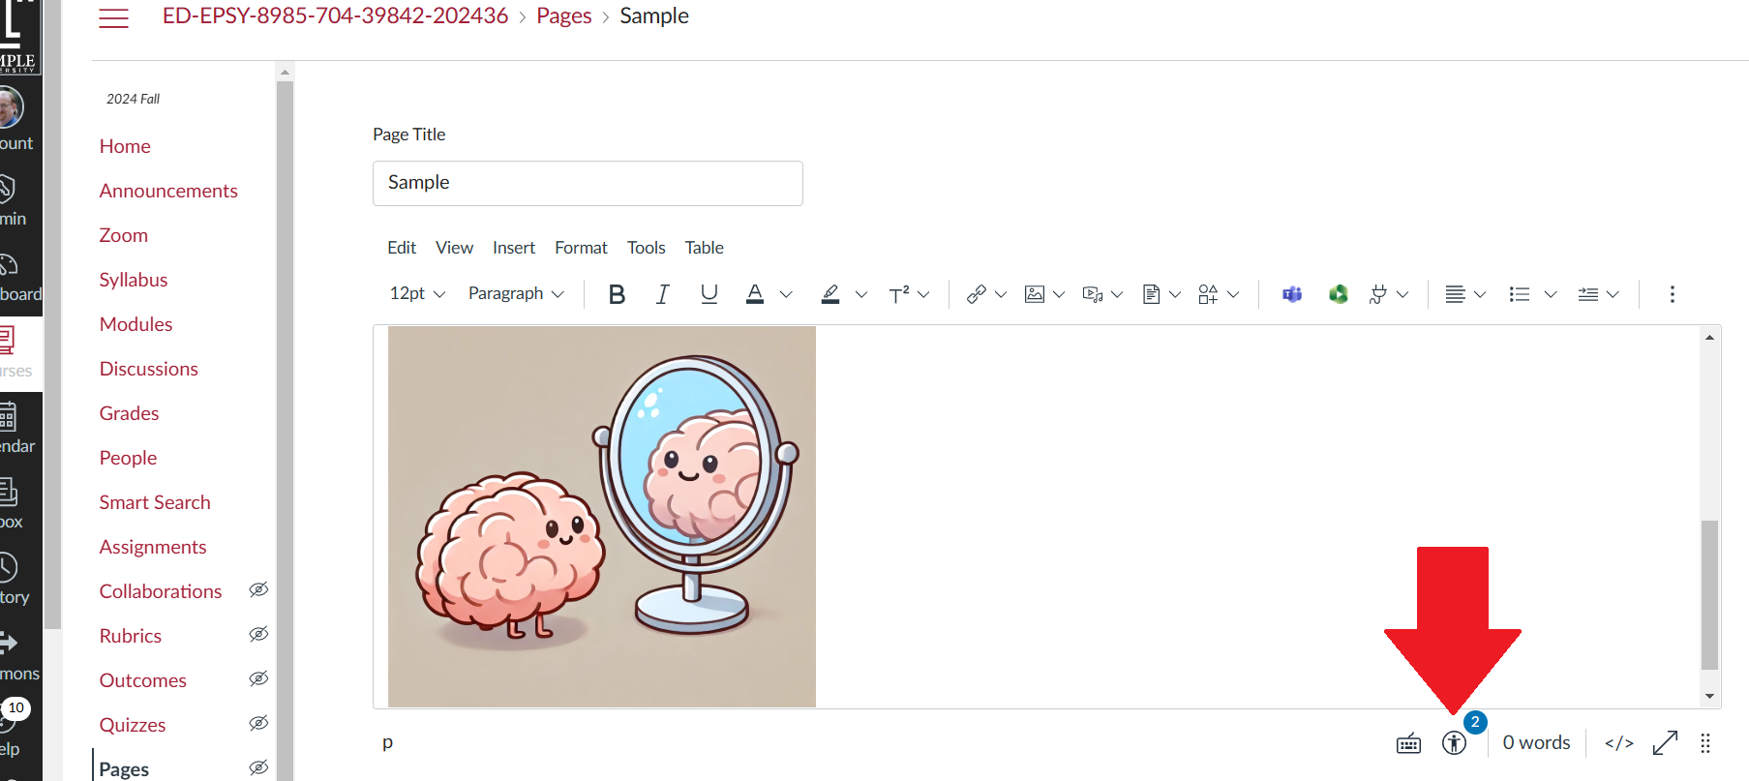

Clicking the Accessibility Checker Icon will launch the check on the right side of the screen.
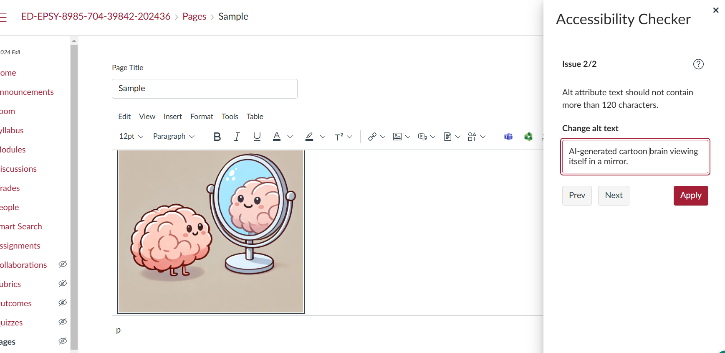
Don’t forget to click the Apply button in the Accessibility Checker and the Save button for the edited content.

Adobe PDFs
Export the document as a Word .docx file and add alt-text there. Then re-export as a PDF or simply save as a Word doc.

HTML
Include alt=”” in the tag. Example <img src=”filename.jpg” alt=”A pig in a cowboy hat taking a bath in a tin wash tub.”>

