

Accessibility How-To:

Creating Accessible Tables in Word

Accessible tables are important because they allow people with disabilities, particularly those using screen readers, to easily navigate and understand the information presented within a table. This ensures equal access to data shared within a document, which is crucial for inclusivity and user experience.
The elements below will help you understand how to build accessible tables. It is important to avoid using layout tables designed to make a page look a certain way, as these tables are often not accessible. Please note that this resource is focused on simple tables. More complex tables will require additional steps.

Creating Your Table
- Create your table by going to the Insert tab and selecting Table.
- Choose your desired number of rows and columns.
- Do NOT use the Draw table option or any other feature to insert your table.
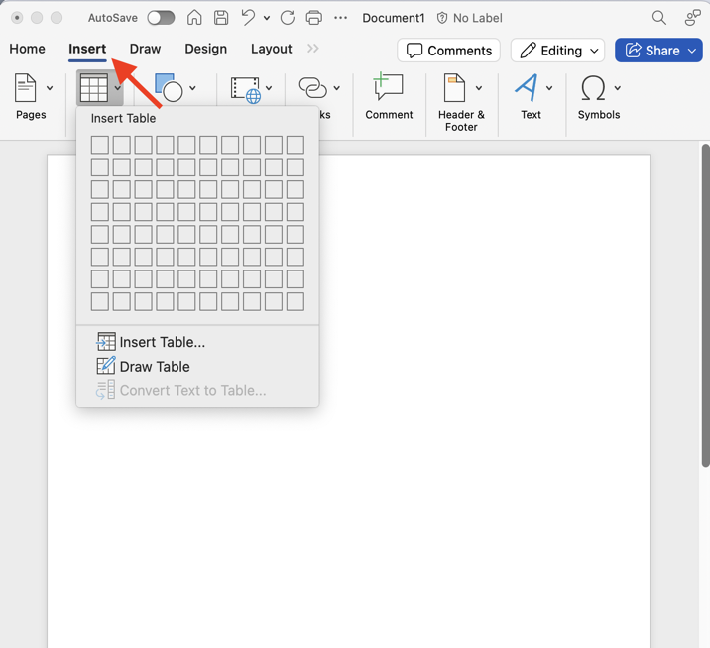

Applying Table Styles
Table styles help improve the readability of your table.
To designate a table style:
- Select your table
- Go to the “Table Design tab”
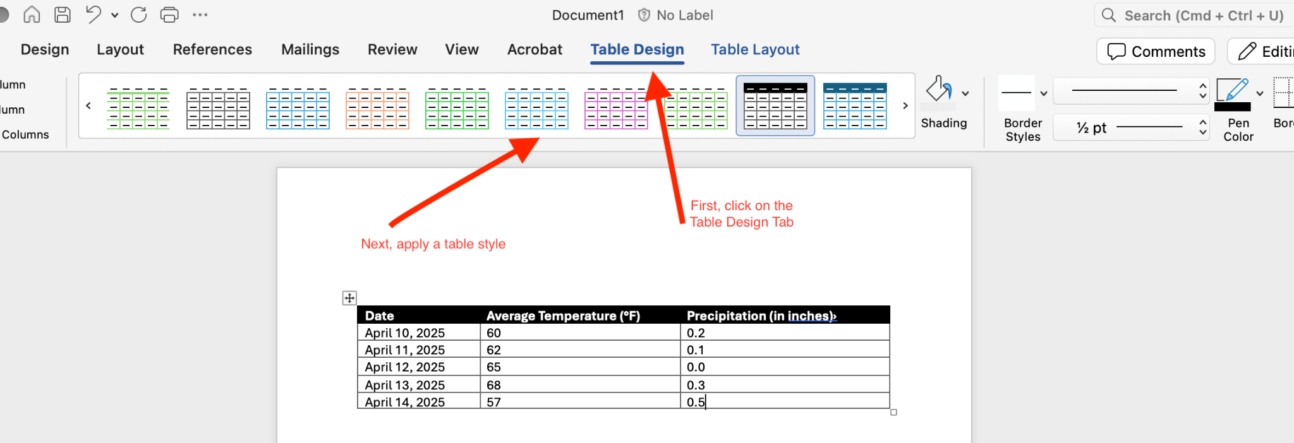
- Apply a table style to distinguish header cells from data cells

Define Header Rows and Columns
A table header is the top row or first column of a data table that acts as a title for the type of information found in each row or column. Creating a table header row or column ensures that screen readers can navigate and read data tables correctly.
- To designate a table header row, go to the “Table Design” tab and check the “Header Row” option.
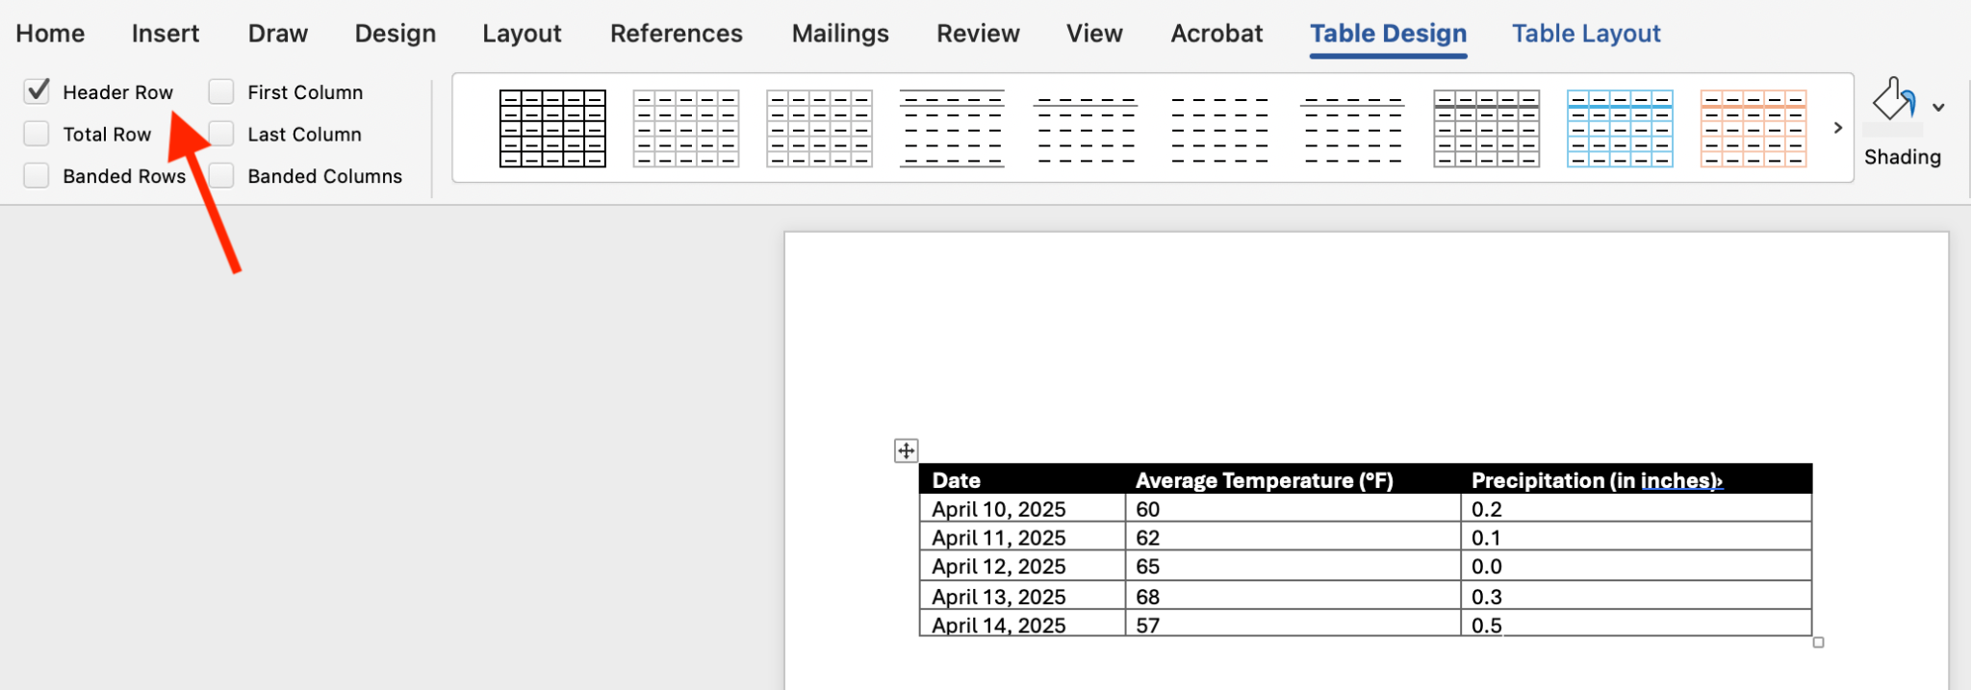
- If your table has descriptive titles in the first column as well as on the top row, select “First Column” and “Header Row” in the “Table Design” tab.
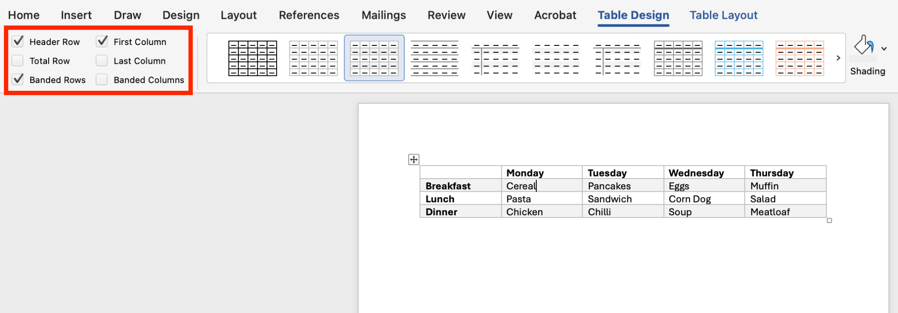

Add Captions and Alt Text to Tables
Accessible tables require a table caption and alt text. A table caption is visible text that appears with the table, usually above or below it. The caption tells everyone what the table is about. It serves as a title or short summary, helping the reader understand the content in the table. Alt text is hidden text, read by screen readers. It describes the meaning or insight of the table for people who can’t see it. It acts as a verbal summary of what the data conveys. Both captions and alt text are needed to ensure your tables are accessible. It is important to note that while the built-in accessibility checker in Word will check for alt text in images, it will not do this for tables.
- To add a caption, select the “References” tab in the home bar of your Word document.
- Next, select “Insert Citation” and write your caption.
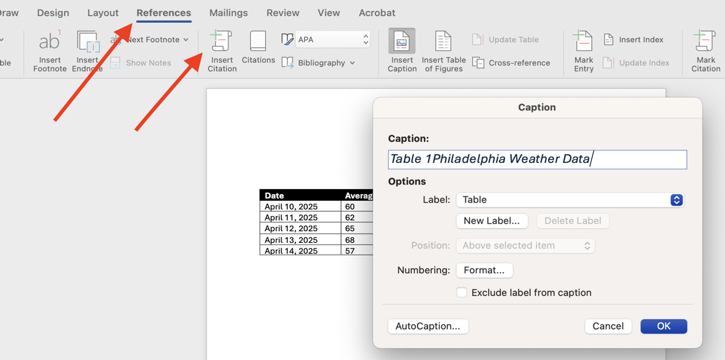
- To add alt text to your table, right-click on your table and select “Table Properties”
- Select the “Alt Text” tab
- Add a title
  - It should be the same as a the caption
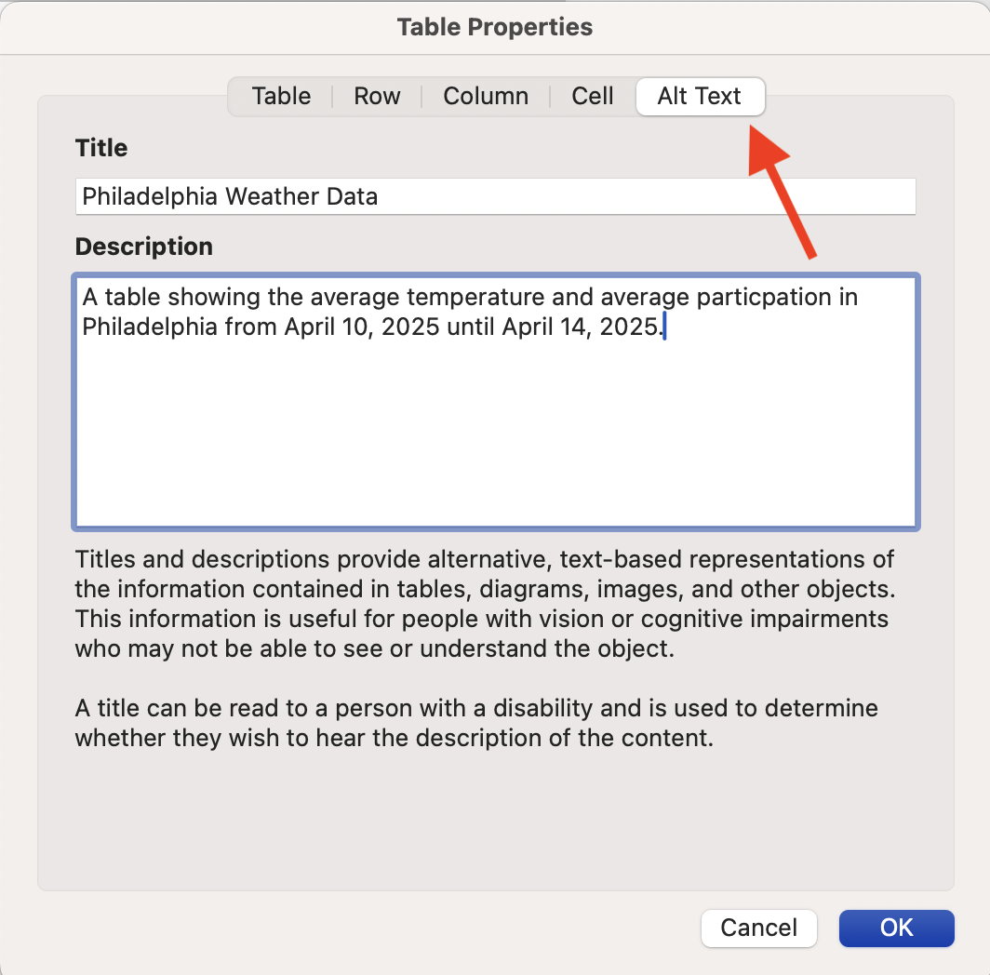
- Add a description that represents the information contained in the table
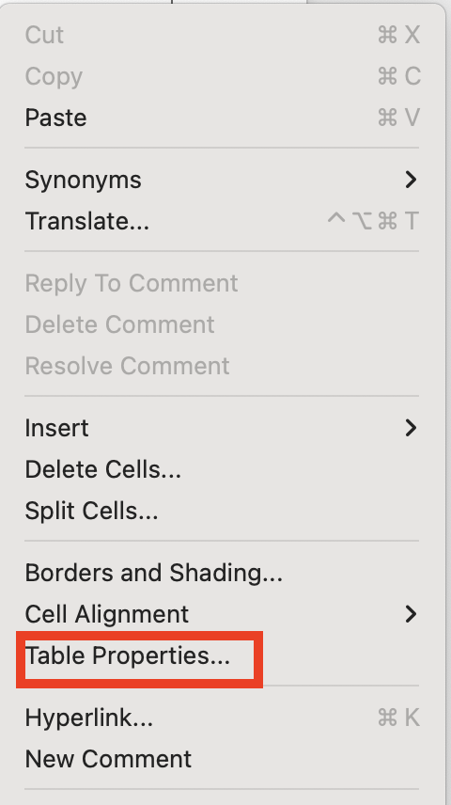

Other Tips for Accessible Tables
- Don’t leave cells empty, especially in the header row or column. If a cell must be left blank, include a placeholder text like “N/A.”
- Don’t merge or split cells.
- The built-in Word Accessibility Checker will not check for alt text in tables.

