Welcome To Temple University!
We have prepared this TA guide to a variety of campus resources that can help you develop professionally and personally and get the most out of your Temple experience. You can also share these resources with your students as needed.

Getting to Know Temple’s Main Campus
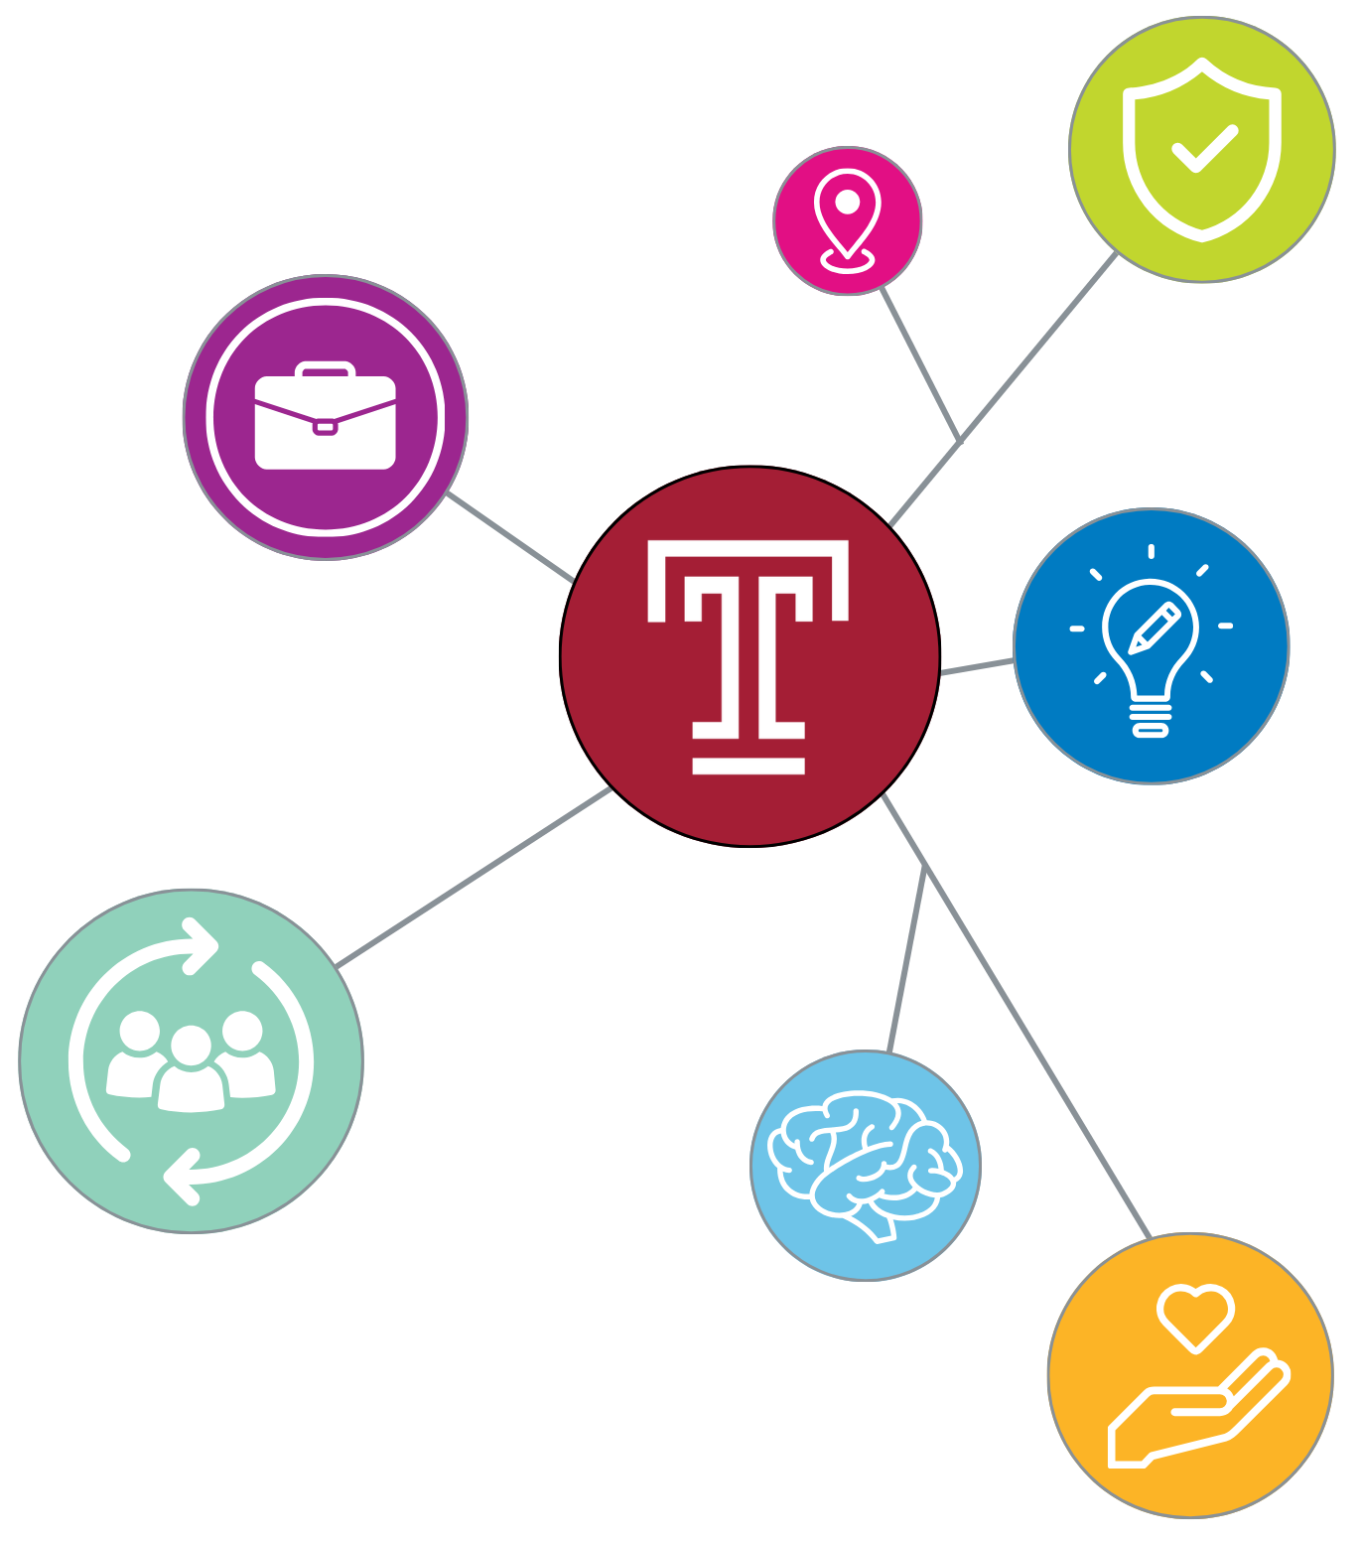
Sign up for a Campus Tour
Campus Food and Dining Options
Food Truck Map
Campus Recreation
OwlSports Event Calendar
Boyer College of Music and Dance Events
School of Theater, Film and Media Arts Events
Tyler School of Art & Architecture Events

Campus Safety
Campus Safety
Request Walking Escort Service

Tuttleman Counseling Services, Health and Wellness
Tuttleman Counseling Services

Disability Resources and Services
Disability Resources and Services

Temple CARE Team (Crisis, Assessment, Response, Education)
CARE Team

Title IX and Mandatory Reporting
Title IX and Mandatory Reporting
Title IX Digital Resources

Accessibility & Inclusivity
Pronoun Use and Gender Identity | Temple University
All Gender Bathroom Locations Interactive Campus Map
Preferred Name Use | Temple University
IDEAL | Temple University Institutional Diversity, Equity, Advocacy and Leadership
Safe Zone Training through IDEAL
Accessible Temple Initiative

Graduate Career Services and Professional Development
Professional Development | Temple University Graduate School

Academic Support
Student Success Center | Temple University

AI in the Classroom- Policies and Guidance
A Faculty Guide to AI | Center for the Advancement of Teaching

