A Self-Directed Guide to Designing Courses for Significant Learning

Dee Fink, PhD
Director, Instructional Development Program University of Oklahoma
Author of:
Creating Significant Learning Experiences:
An Integrated Approach to Designing College Courses
(San Francisco: Jossey-Bass, 2003)
(edited to meet web accessibility standards April 2026)

A Self-Directed Guide to

Designing Courses for Significant Learning
Table of Contents
Introduction 1
An Overview of Integrated Course Design 2
Model 1: The Key Components of Integrated Course Design 2
Designing an Integrated Course 4
Initial Design Phase: Building Strong Primary Components 4
Preview of the Initial Design Phase: Designing Courses that Promote . . . 5
Step 1. Situational Factors 6
Step 2. Learning Goals 8
Step 3. Feedback and Assessment 13
Step 4. Teaching/Learning Activities 16
Active Learning 16
Rich Learning Experiences 19
In-Depth Reflective Dialogue 19
Information and Ideas 21
Step 5. Integration 21
Final Check and Review of Initial Phase 24
Model 2: Criteria for Assessing Course Designs 25
Intermediate Design Phase: Assembling the Components into a Coherent Whole 26
Step 6. Course Structure 26
Step 7. Instructional Strategy 27
Step 8. Creating the Overall Scheme of Learning Activities 28
Final Design Phase: Important Remaining Tasks 31
Step 9. How Are You Going to Grade? 31
Step 10. What Could Go Wrong? 32
Step 11. Let Students Know What You Are Planning 32
Step 12. How Will You Know How the Course Is Going? How It Went? 33
Concluding Counsel 34
Appendices 35

A Self-Directed Guide to Designing Courses for Significant learning

Introduction. When we teach, we engage in two closely related, but distinct, activities. First, we design the course by gathering information and making a number of decisions about the way the course will be taught. Second, we engage in teacher-student interactions as we implement the course we have designed. The concept of Teacher-Student Interaction as used here is a broad one that includes lecturing, leading discussions, running labs, advising, communicating by email, etc. In order to teach well, one must be competent in both course design and teacher-student interactions.
However, of these two activities, our ability to design courses well is usually the most limiting factor. Most of us have had little or no training in how to design courses. In addition during the last two decades, research on college teaching and learning have led to some new ideas about course design that have, in essence, “raised the bar” in terms of what is possible. These include ideas such as active learning, significant learning, and educative assessment.

How can college teachers learn about and take advantage of these ideas? This Self-Directed Guide is intended to introduce a useful and systematic process for designing courses. It is based on the same components found in most models of instructional design, but it assembles these components into a relational, integrated model rather than a linear one. Among other benefits, this model provides clear criteria for determining when a course design is a good design.

This Guide consists of introductory comments, worksheets, and action questions in each of the three major phases of Integrated Course Design:

INITIAL DESIGN PHASE: Build Strong Primary Components
Step 1. Identify important situational factors
Step 2. Identify important learning goals
Step 3. Formulate appropriate feedback and assessment procedures
Step 4. Select effective teaching/learning activities
Step 5. Make sure the primary components are integrated
INTERMEDIATE DESIGN PHASE: Assemble the Components into a Coherent Whole
Step 6. Create a thematic structure for the course
Step 7. Select or create an instructional strategy
Step 8. Integrate the course structure and the instructional strategy to create an overall scheme of learning activities
FINAL DESIGN PHASE: Finish Important Remaining Tasks
Step 9. Develop the grading system Step 10. De-Bug possible problems Step 11. Write the course syllabus
Step 12. Plan an evaluation of the course and of your teaching

Read through the introductory comments in each step, and then complete as much of each worksheet and action item as you can. If you don’t fully understand a particular idea or have difficulty applying it to your own course, do what you can, and then move on. Generally you will be able to come back later and the ideas that you need will be clearer.
One of the benefits of this model is that it allows us to see the importance

In this Guide, I first present an overview of Integrated Course Design and then work through each of the major phases, one at a time.

An Overview of Integrated Course Design

The basic components in this model of Integrated Course Design are the same as those found in other models of instructional design: analyze the situational factors, formulate the learning goals, design the feedback and assessment procedures, and select the teaching/learning activities. What is distinctive about this model is that these components have been put together in a way that reveals and emphasizes their inter-relatedness. (See Model 1 below)

Model 1

The Key Components Of INTEGRATED COURSE DESIGN
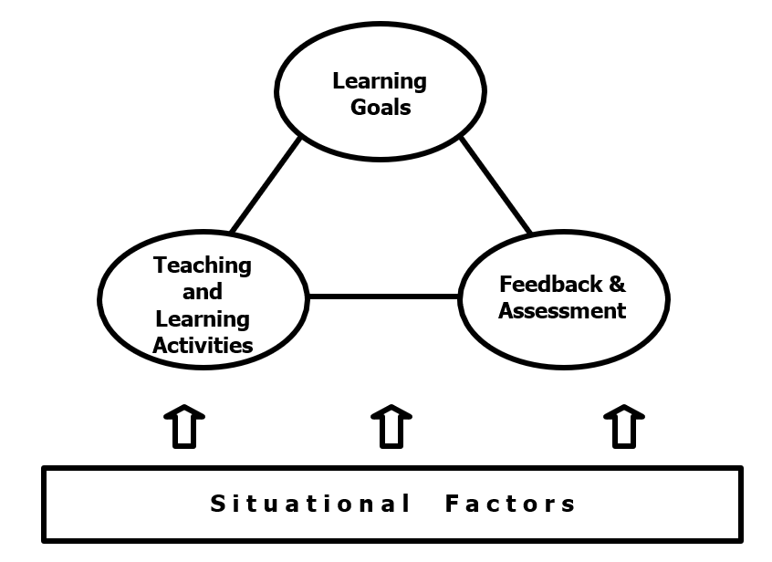

One of the benefits of this model is that it allows us to see the importance of an integrated course and to know when we have one and when we do not. To illustrate this point, let me describe an extreme case of a un-integrated or dis-connected course.

Imagine a course in which the teacher says s/he wants students to (a) “learn all the important content” and (b) “learn how to think critically about the subject.” These are the learning goals. But when you examine what actually happens in class, it is a straight lecture course (this is the “teaching/learning activity”). This creates the first problem: the teaching/learning activities are NOT aligned with the learning goals. The students might be able to learn the content from the lectures, but they definitely are not getting practice and feedback in learning how to think critically.

Now notice the dilemma this teacher faces when s/he attempts to write the mid-term or final exam. S/he can legitimately ask “understand and remember” questions, i.e., content-related questions. But should s/he include thinking questions or not?

If s/he does, the assessment part of the course will be properly connected to the learning goals. But the students will do poorly because they have not had the appropriate learning activities for critical thinking; hence there will also be a disconnect between the learning activities and any assessment on critical thinking. (The diagram below illustrates the situation when the teacher chooses this option.)
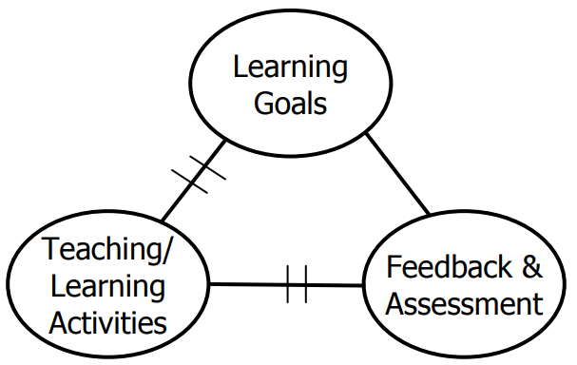

Integration Problem: Example 1

On the other hand, if the teacher chooses not to include thinking questions on the exam, the assessment will be consistent with the teaching/learning activities but not with the learning goals. (This option is shown in the following diagram.)
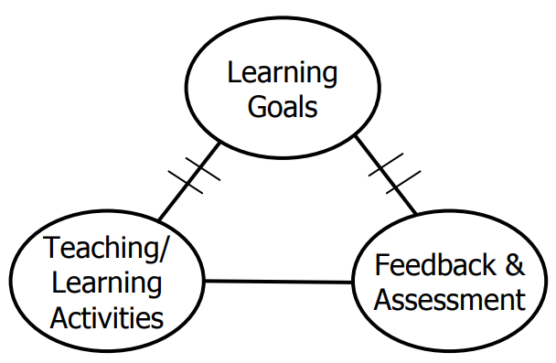

Integration Problem: Example 2

Notice the pattern: If a teacher breaks one of the connections in a course, inevitably another is broken. When two out of three key connections are broken, the course itself is “broken.” This is why it is so important to create an integrated design.

Designing an Integrated Course. In designing a course, we are gathering informa-tion and making decisions about how the course will be taught. We want to engage in both of these activities so that there is a high likelihood that the students will have a significant learning experience. In order to do this, we need to work through the course design process in a systematic way. This means completing each step before going on to the next one. This is important because the later steps build on the earlier ones. For Integrated Course Design (Model 1), start by building strong primary components (INITIAL DESIGN PHASE); then assemble them into a coherent whole (INTER-MEDIATE DESIGN PHASE); and finally, finish several important tasks (FINAL DESIGN PHASE).

INITIAL DESIGN PHASE (Steps 1-5): Building Strong Primary Components
The primary components of Integrated Course Design are shown in Model 1.
The first component in the model is to gather information about the Situational Factors (e.g., how many students are in the course, what kind of prior knowledge are the students bringing to the course about this subject, etc.) [This component is shown as the rectangular box, “Situational Factors” in Model 1.] This information is then used to make the three major decisions about the course (shown as ovals in Model 1).
After you have gathered the information about the situational factors, your first decision is about the Learning Goals, i.e., what you want students to get out of the course. What is important for them to learn and retain, 2-3 years after the course is over? What kind of thinking or application abilities do you want them to develop?
How do you want them to keep on learning after the course is over?

Using the principle of “Backward Design,” we will next turn to decisions about Feedback and Assessment. The basic question here is: What will students do to demon-strate they have achieved the Learning Goals we set for the course? This will usually involve some paper/pencil tests but we will probably need to include other activities as well. The advantage of working on the Feedback and Assessment at this early stage of course development is that when we become clear about what constitutes successful student performance, it is much easier to develop effective teaching/learning activities.
Then we need to formulate the appropriate and necessary Teaching/Learning Activities. If we have significant learning goals and effective assessment procedures, we will most likely need to incorporate some kind of active learning into the course.

And finally we need to check our course design for Integration to make sure all the components are in alignment and support each other. Are the learning activities consistent with all the learning goals? Are the feedback and assessment activities consistent with the learning goals and the learning activities?

Précis of the INITIAL DESIGN PHASE (Steps 1-5)

DESIGNING COURSES THAT PROMOTE SIGNIFICANT LEARNING

If professors want to create courses in which students have “significant learning experiences,” they need to design that quality into their courses. How can they do that? By following the five basic steps of the instructional design process, as laid out below:
Step 1. Give careful consideration to a variety of SITUATIONAL FACTORS
- What is the special instructional challenge of this particular course?
- What is expected of the course by students? By the department, the institution, the profession, society at large?
- How does this course fit into the larger curricular context?
Use the “BACKWARD DESIGN” Process
This process starts at the “end” of the learning process and works “back” toward the beginning. Use information about the Situational Factors (Step 1, above), as you make the following key decisions:
Step 2. Learning Goals What do you want students to learn by the end of the course, that will still be with them several years later?
  - Think expansively, beyond “understand and remember” kinds of learning.
  - Suggestion: Use the taxonomy of “Significant Learning” (Figure 1) as a framework.
Step 3. Feedback & Assessment Procedures What will the students have to do, to demonstrate that they have achieved the learning goals (as identified in Step “A” above)?
- Think about what you can do that will help students learn, as well as give you a basis for issuing a course grade.
- Suggestion: Consider ideas of “Educative Assessment.”
Step 4. Teaching/Learning Activities What would have to happen during the course for students to do well on the Feedback & Assessment activities?
- Think creatively for ways of involving students that will support your more expansive learning goals.
- Suggestion: Use “Active Learning” activities, especially those related to:
  - “Rich Learning Experiences” experiences in which students achieve several kinds of significant learning simultaneously
  - “In-depth Reflective Dialogue” opportunities for students to think and reflect on what they are learning, how they are learning, and the significance of what they are learning.
- Suggestion: Assemble these activities into an effective instructional strategy, i.e., an interdependent sequence of learning activities, and a coherent course structure.
Step 5. Make sure that the Key Components are all INTEGRATED
- Check to ensure that the key components (Steps 1-4) are all consistent with, and support each other.

Step 1. Situational Factors
The first thing to do when designing a course is to size up the situation carefully.
This means reviewing information already known about the teaching and learning situation and, in some cases, gathering additional information. This information will be used to make important decisions about the course.

There are several potentially important situational factors affecting a course.
The general categories I have found useful to consider are the following:
  - Specific Context of the Teaching/Learning Situation
  - General Context of the Learning Situation
  - Nature of the Subject Characteristics of the Learners
  - Characteristics of the Teacher
The specific context factors are always important. The other factors are sometimes important, sometimes not. But it’s always useful to review all of them.

The general categories (and the specific factors associated with each category) are shown in the Step 1 Worksheet. Review each of these factors with regards to your specific course. If you have information about any factor, write it down. If you don’t have information, but think it could be important, write down ideas about how you might obtain it.

Step 1. Worksheet

SITUATIONAL FACTORS TO CONSIDER

Specific Context of the Teaching/Learning Situation
How many students are in the class? Is the course lower division, upper division, or graduate level? How long and frequent are the class meetings? How will the course be delivered: live, online, or in a classroom or lab? What physical elements of the learning environment will affect the class?

General Context of the Learning Situation
What learning expectations are placed on this course or curriculum by: the university, college and/or department? the profession? society?

Nature of the Subject
Is this subject primarily theoretical, practical, or a combination? Is the subject primarily convergent or divergent? Are there important changes or controversies occurring within the field?

Characteristics of the Learners
What is the life situation of the learners (e.g., working, family, professional goals)? What prior knowledge, experiences, and initial feelings do students usually have about this subject? What are their learning goals, expectations, and preferred learning styles?

Characteristics of the Teacher
What beliefs and values does the teacher have about teaching and learning? What is his/her attitude toward: the subject? students? What level of knowledge or familiarity does s/he have with this subject? What are his/her strengths in teaching?

Step 2. Learning Goals
After you have reviewed the situational factors, decide what you want students to get out of the course. Many people take a content-centered approach to this task: “I want students to learn about topic X, topic Y, and topic Z.” This is an easy, natural approach but it generally results in an overemphasis on “understand and remember” kinds of learning. These are important. But when teachers take a learning-centered approach, they usually identify several additional kinds of significant learning.

I recommend that teachers ask themselves: “What would I like the impact of this course to be on students, 2-3 years after the course is over? What would distinguish students who have taken this course from students who have not?”
When students and teachers think about what students can learn that is truly significant, their answers usually include, but do not focus on, “understand and remember” kinds of learning. More often they emphasize such things as critical thinking, learning how to creatively use knowledge from the course, learning to solve real-world problems, changing the way students think about themselves and others, realizing the importance of life-long learning, etc.

After many years of studying people’s responses to the question of what constitutes significant learning, I have proposed a taxonomy of significant learning. It consists of six major types of significant learning, with a number of sub-categories. This taxonomy is shown in Figure 1 (next page). The taxonomy identifies significant kinds of learning that you may want to include as important learning goals for your course.

Figure 1

A TAXONOMY OF SIGNIFICANT LEARNING

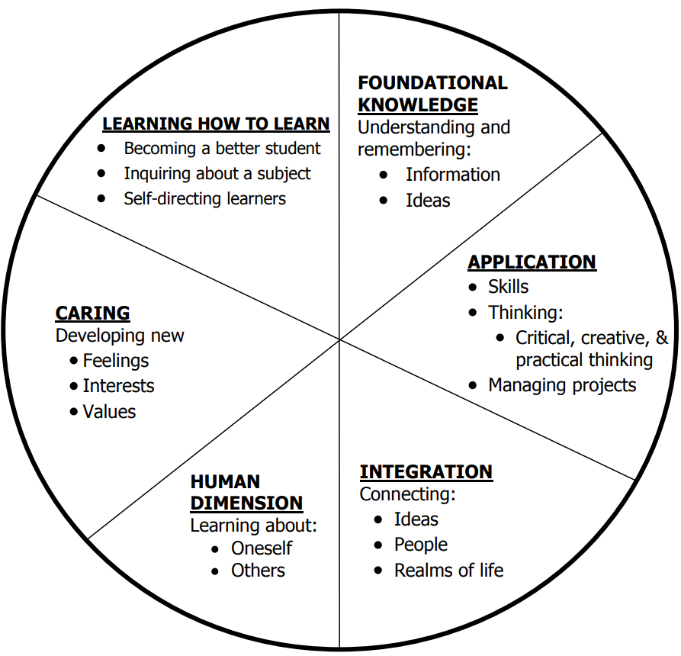

[See Appendix 2 for a long description of this visual.]
One important feature of this particular taxonomy is that each kind of learning is interactive, as illustrated in Figure 2 (next page). This means that each kind of learning can stimulate other kinds of learning. This has major implications for the selection of learning goals for your course. It may seem intimidating to include all six kinds of significant learning. But the more you can realistically include, the more the goals will support each other—and the more valuable will be your students’ learning.

Figure 2

INTERACTIVE NATURE OF SIGNIFICANT LEARNING

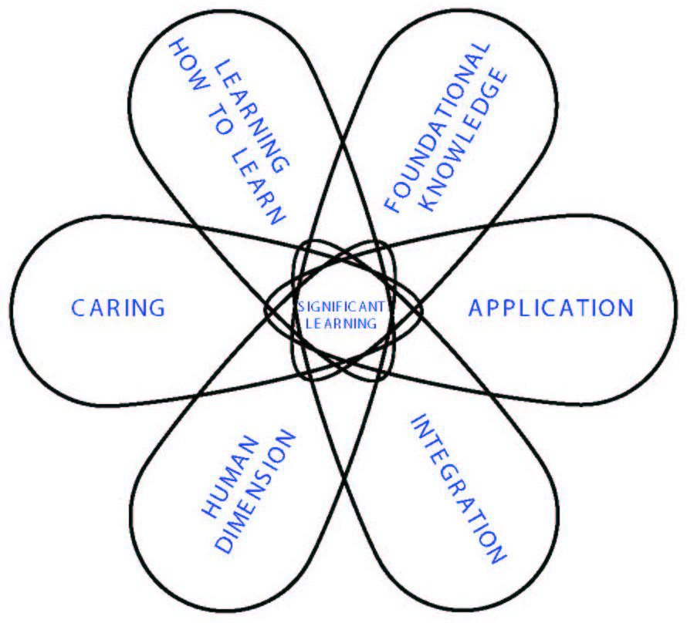

Step 2. Worksheet

Questions for Formulating Significant Learning Goals

"A year (or more) after this course is over, I want and hope that students will .”
Foundational Knowledge
- What key information (e.g., facts, terms, formulae, concepts, principles, relationships, etc.) is/are important for students to understand and remember in the future?
- What key ideas (or perspectives) are important for students to understand in this course?

Application Goals
- What kinds of thinking are important for students to learn?
  - Critical thinking, in which students analyze and evaluate
  - Creative thinking, in which students imagine and create
  - Practical thinking, in which students solve problems and make decisions
- What important skills do students need to gain?
- Do students need to learn how to manage complex projects?

Integration Goals
- What connections (similarities and interactions) should students recognize and make…:
      - Among ideas within this course?
      - Among the information, ideas, and perspectives in this course and those in other courses or areas?
      - Among material in this course and the students' own personal, social, and/or work life?

Human Dimensions Goals
- What could or should students learn about themselves?
- What could or should students learn about understanding others and/or interacting with them?

Caring Goals
- What changes/values do you hope students will adopt?
  - Feelings?
  - Interests?
  - Ideas?

"Learning-How-to-Learn" Goals
- What would you like for students to learn about:
  - how to be good students in a course like this?
  - how to learn about this particular subject?
  - how to become a self-directed learner of this subject, i.e., having a learning agenda of what they need/want to learn, and a plan for learning it?

Step 3: Feedback and Assessment Procedures
In a content-centered course, two mid-terms and a final exam are usually considered sufficient feedback and assessment for the teacher to determine whether the students “got it” or not. But a learning-centered course calls for a more sophisticated approach to this aspect of course design. A set of feedback and assessment procedures collectively known as “educative assessment” is needed to go beyond “audit-ive-type assessment” (that which is designed solely to give the teacher a basis for awarding a grade). Educative assessment actually enhances the quality of student learning. In Figure 3 (next page), the four key components of educative assessment are contrasted with the more traditional audit-ive assessment.

Forward-Looking Assessment incorporates exercises, questions, and/or problems that create a real-life context for a given issue, problem, or decision to be addressed.
To construct this kind of question or problem, the teacher has to “look forward,” beyond the time when the course is over, and ask: “In what kind of situation do I
expect students to need, or to be able to use this knowledge?” Then, create a question or problem that replicates this real-life context as closely as possible. The problem also should be somewhat open-ended and not totally pre-structured. If necessary, certain assumptions or constraints can be given, in order to be able to assess the quality of student responses.

To illustrate this distinction, let me draw from a course I have taught on world geography in which students have studied, for example, a unit on Southeast Asia. A backward-looking assessment would ask students to tell what the differences are in the population and resources of the various countries in that region. In a forward-looking assessment question, I would ask them to imagine that they are working for a company that wants to establish itself in that region; the company wants the students’ opinions on which country has the necessary political stability, purchasing power for their product, prospects for economic growth, etc. This kind of question asks students to imagine a situation where they could actually use what they have learned.
Teachers should explain clearly the criteria and standards that will be used to assess student work. Teachers need to ask themselves, and then share with students: “What are the general traits or characteristics of high quality work in this area?” These are the criteria for evaluation. Then, on each of these criteria, how good does the work have to be, to be acceptably good or exceptionally good? The answers to these questions reveal the teacher’s standards.

It is also important for teachers to create opportunities for students to engage in self-assessment. Later in life, students will need to assess their own performance, and they should start learning how to do that while in the course. You may want the class to do this initially in groups, and later individually. Somewhere along the way, students need to generate—and perhaps discuss—appropriate criteria for evaluating and assessing their own work.

As the students work to learn how to perform well, teachers need to provide feedback. High quality feedback will have the characteristics of “FIDeLity” feedback:
  - Frequent: Give feedback daily, weekly, or as frequently as possible.
  - Immediate: Get the feedback to students as soon as possible.
  - Discriminating: Make clear what the difference is between poor, acceptable, and exceptional work.
  - Loving: Be empathetic in the way you deliver your feedback.
Enhancing Learning with High Quality Feedback
Since the publication of my book, a group of educators in Scotland and England put together a very impressive list of 7 principles for giving feedback in a way that enhances student learning. The 7 principles are listed in the Appendix of this “Guide.”
Note: The full document, the key part of which is only 13 pages long, can be downloaded from a website. The URL for this website is listed in the appendix.

Figure 3

AUDIT-IVE AND EDUCATIVE ASSESSMENT

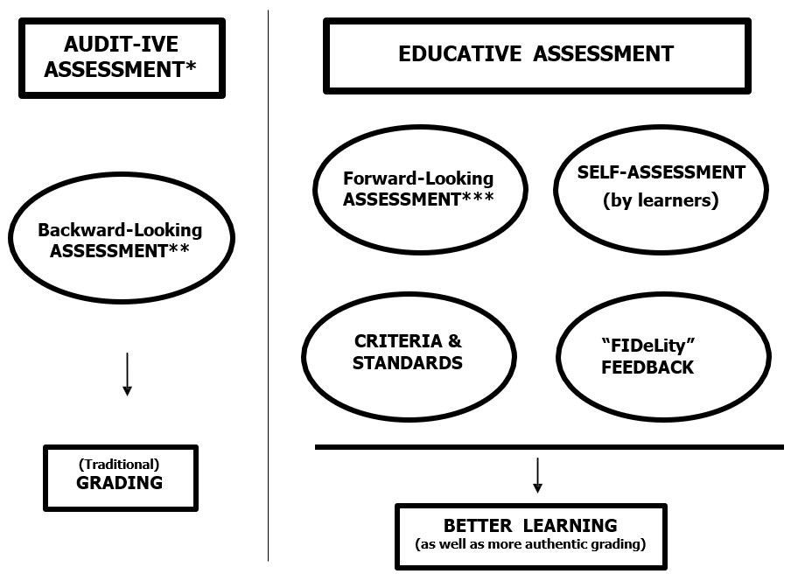

[See Appendix 3 for a long description of this visual.]

Step 3. Worksheet

Procedures for Educative Assessment
- Forward-Looking Assessment Formulate one or two ideas for forward-looking assessment. Identify a situation in which students are likely to use what they have learned, and try to replicate that situation with a question, problem, or issue.

- Criteria & Standards Select one of your main learning goals, and identify at least two criteria that would distinguish exceptional achievement from poor performance. Then write two or three levels of standards for each of these criteria.

- Self-Assessment What opportunities can you create for students to engage in self-assessment of their performance?

- “FIDeLity” Feedback What procedures can you develop that will allow you to give students feedback that is:

Frequent Immediate
Discriminating, i.e., based on clear criteria and standards
Lovingly delivered

Step 4. Teaching/Learning Activities
Often as college teachers thinking about what should happen in a course, we have used the traditional pattern of “lectures and discussions.” Some courses are heavy on lectures; others lean more toward discussion. But to create the kind of significant learning advocated in Step 2, we will need new tools, new kinds of teaching and learning activities. Where can we find these? We need to understand, and then learn, how to incorporate more active learning into our courses.

Active Learning. One of the more powerful ideas to emerge in the literature on col-lege teaching in the last decade or so is the concept of active learning. In essence, the concept of active learning supports research that shows: students learn more and retain their learning longer if they acquire it in an active rather than a passive manner.

What do we mean by “active learning”? Active-learning advocates Bonwell and Eison (1991) describe active learning as “[involving] students in doing things and
thinking about the things they are doing.” By “doing things,” they are referring to activities such as debates, simulations, guided design, small group problem solving, case studies, etc. My way of illustrating that definition is shown in Figure 4. When students listen to a lecture or read a texbook, they are receiving “Information and
Ideas”—an important part of the learning process but also one that is relatively passive. To make the learning more active, we need to learn how to enhance the overall learning experience by adding some kind of experiential learning and opportunities for reflective dialogue.
Figure 4

INITIAL VIEW OF PASSIVE AND ACTIVE LEARNING

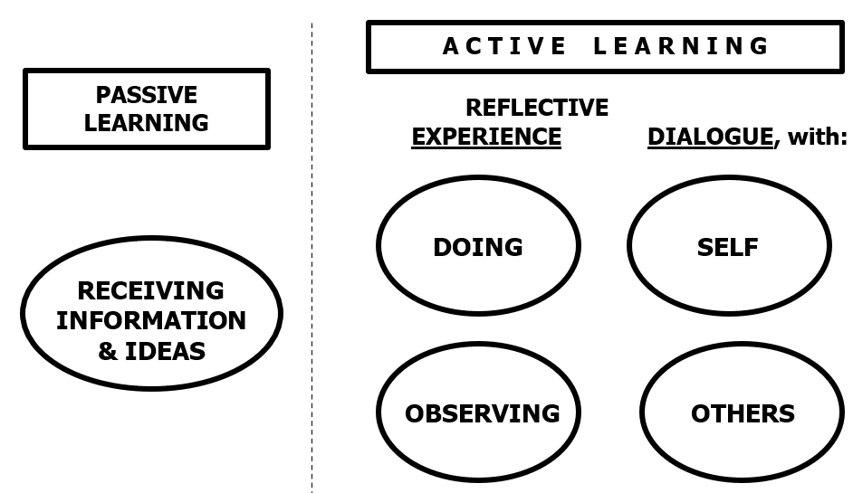
[See Appendix 4 for a long description of this visual.]
An Enlarged View of “Active Learning.” In order to create a complete set of learning activities capable of achieving significant learning, we need an enlarged and more holistic view of active learning—one that includes “getting information and ideas” as well as “experience” and “reflection.” Figure 5 illustrates a new conceptualization of active learning, one that makes all three modes of learning an integral part of a more complete set of learning activities.
Figure 5

A HOLISTIC VIEW OF ACTIVE LEARNING
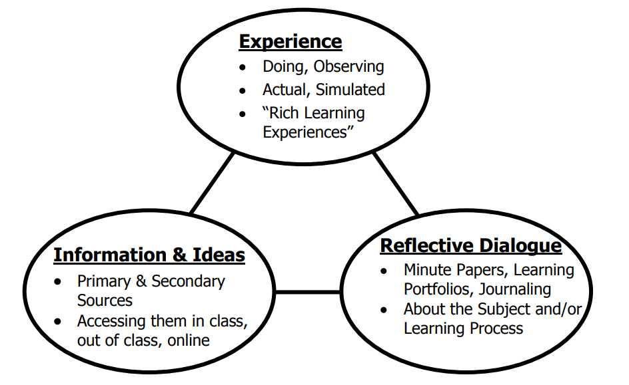
[See Appendix 5 for a long description of this visual.]
Two principles should guide our choice of learning activities. First, an effective set of learning activities is one that includes activities from each of the following three components of active learning: information and ideas, experience, and reflective dia-logue. Second, we should try to find direct kinds of learning activities, whenever pos-sible. Indirect, or vicarious, forms may be necessary in some cases. But when we can find direct ways of providing active learning, the quality of student learning expands.
From my own experience and from reading the literature on what effective teachers actually do in terms of this holistic view of active learning, I have found that good teachers incorporate all three components of active learning in a variety of ways. As shown in Table 1, sometimes teachers provide information and ideas, experience, and reflective dialogue directly; at other times it is done indirectly or even online.

Table 1 - LEARNING ACTIVITIES FOR HOLISTIC, ACTIVE LEARNING
 | GETTING INFORMATION & IDEAS | EXPERIENCE  Doing | EXPERIENCE  "Observing" | Reflective Dialog w/Self | Reflective Dialog w/Others
DIRECT | - Primary data  - Primary sources | “Real Doing,” in authentic settings | Direct observation of phenomena | - Reflective thinking  - Journaling | Dialogue (in or out  of class)
INDIRECT, VICARIOUS | - Secondary data and sources  - Lectures, textbooks | - Case Studies  - Gaming, Simulations  - Role Play | Stories  (can be accessed  via: film, oral history, literature) | - Reflective thinking  - Journaling | Dialogue (in or out  of class)
ONLINE | - Course website  - Internet | - Teacher can assign students to "directly experience .”  - Students can engage in "indirect" kinds of experience online. | - Teacher can assign students to "directly experience .”  - Students can engage in "indirect" kinds of experience online. | Students can reflect and then engage in various kinds of dialogue online. | Students can reflect and then engage in various kinds of dialogue online.

To help you explore ways of developing more powerful learning experiences for your students, I suggest some ideas for each of three components of active learning: Rich Learning Experience, In-Depth Reflective Dialogue, and Information and Ideas.

Rich Learning Experiences. As you try to add an experiential component to the learning experience, look for “Rich Learning Experiences.” Certain learning experiences are “rich” because they allow students to acquire several kinds of significant learning simultaneously. What are some ways this can be done? The list below identifies in-class and out-of-class activities that promote multiple kinds of significant learning—all at the same time.

Table 2 - Rich Learning Experiences
In Class: | Outside of Class:
Debates Role playing  Simulations  Dramatizations | Service learning  Situational observations  Authentic projects
Action: Identify some learning activities to add to your course that will give students a “Doing” or “Observing” Experience. What “Rich Learning Experiences” are appropriate for your course?

In-Depth Reflective Dialogue. Another important ingredient of active learning is giving students time and encouragement to reflect on the meaning of their learn-ing experience. There are various forms of reflective dialogue (See Table 2, next page). One can reflect with oneself (as in writing in a journal or diary) or with others (as in engaging in discussions with a teacher or others). Another key distinction is between substantive writing, in which one writes about a subject (e.g., a typical term paper), and reflective writing, in which one writes about one’s own learning. In reflective writing, students address a different set of questions, such as: What am I learning? What is the value of what I am learning? How am I learning? What else do I need to learn?

Table 2

IN-DEPTH REFLECTIVE DIALOGUE

With Whom?
Oneself (journaling, learning portfolios)
Others (teacher, other students, people outside class)

About What?
- Subject of the Course: (Substantive writing) What is an appropriate and full understanding of this concept or topic?
- Learning Process: (Reflective writing) ۰ What am I learning?
۰ Of what value is this?
۰ How did I learn: best, most comfortably, with difficulty, etc.?
۰ What else do I need to learn?

Written Forms?
One-minute papers Weekly journal writing
Learning portfolios (end-of-course, end-of-program)

The literature on college teaching identifies numerous procedures to promote reflection. In the one-minute paper, the teacher poses a short, but well-focused, question for students to answer once a week or at the end of each class. Sample questions include: “What is the most important thing you learned today? What is the “muddiest point” of this class?” Slightly more ambitious is the practice of having students write weekly learning journals. Ask students to periodically reflect on their learning experience. You may need to guide this effort by providing some questions like the four listed above (or more specific versions of them).
Another excellent practice is for students to put together a learning portfolio at the end of the course. This is an 8-12 page narrative with an appendix of materials to support and illustrate the content of the narrative. In the narrative, students write reflectively about their learning experiences, again addressing questions like the those listed above.
Action: What kinds of Reflective Dialogue can you incorporate into your course?

Information and Ideas. In order to free up some class time for the experiential and reflective activities identified above, you will probably need to explore alternative ways of introducing students to the key information and ideas of the course, i.e., the content. This might involve having them do more reading before they come to class. Or it may mean creating a course-specific website where you put content-related material. Or you can direct students to go to selected websites that have good content related to the course.

Action: Other than lectures, what ways can you identify to cause students to get their initial exposure to subject matter and ideas (preferably outside
of class)?

Step 5. Integration
In this INITIAL DESIGN PHASE (Steps 1-4), you have created strong primary com-ponents for the design of your course. In order to complete this initial phase, you need to check how well these four components are aligned. Step 5 Worksheet gives a de-tailed explanation of how these four components can be integrated with each other.

Step 5: Integrating Steps 1-4

Situational Factors

Assuming you have done a careful, thorough job of reviewing the situational factors, how well are these factors reflected in the decisions you made about learning goals, feedback and assessment, learning activities?

What potential conflicts can you identify that may cause problems?

Are there any disconnects between your beliefs and values, the student characteristics, the specific or general context, or the nature of the subject in relation to the way you propose to run the course?

Learning Goals and Feedback & Assessment

Issues to address include:

How well do your assessment procedures address the full range of learning goals?
Is the feedback giving students information about all the learning goals?

Do the learning goals include helping the students learn how to assess their own performance?

Learning Goals and Teaching/Learning Activities

Do the learning activities effectively support all your learning goals?

Are there extraneous activities that do not serve any major learning goal?

Teaching/Learning Activities and Feedback & Assessment

How well does the feedback loop work to prepare students for understanding the criteria and standards that will be used to assess their performance?

How well do the practice learning activities and the associated feedback opportunities prepare students for the eventual assessment activities?

A good tool for checking on integration, especially on Steps #2-4 above, is to use the Worksheet 1 on the following page. First, fill in a list of your learning goals for the course. If possible, have one for each kind of significant learning in the taxonomy. Second, for each major learning goal, identify how you would know whether students have achieved that kind of learning, i.e., what kind of feedback and assessment can you use? Third, again, for each major learning goal, identify what students will have to do to achieve that kind of learning. You will often find that the assessment and the learning activity are the same or very similar.
But working through this exercise can be very valuable by ensuring that you in fact have specific kinds of assessment and learning activities for each of your learning goals and that you don’t just give “lip service” to them.
After you finish your final check (below), then you can start the process of assembling these several activities into a coherent whole (Phase II, starting on p. 28).

Table 3 - Worksheet for Designing a Course
Learning Goals for Course: | Ways of Assessing This Kind of Learning: | Actual Teaching-Learning Activities: | Helpful Resources:  (e.g., people, things)
1.
2.
3.
4.
5.
6.

Final Check and Review of INITIAL DESIGN PHASE.
A major benefit of this planning model is that it provides specific criteria for assessing the quality of course design.
There are five primary criteria, four of which are illustrated by the highlighted areas of Figure 6 on the next page. It suggests that good course design meets the following criteria.

The basic design for this course is good if it includes…
- In-Depth Analysis of Situational Factors It is based on a systematic review of all the major situational factors, in order to define the situational constraints and opportunities of the course.
- Significant Learning Goals It includes learning goals focused on several kinds of significant learning, not just “understand-and-remember” kinds of learning.
- Educative Feedback and Assessment It includes the components of educative assessment: forward-looking assessment, opportunities for students to engage in self-assessment, clear criteria and standards, and “FIDeLity” feedback. These allow the feedback and assessment to go beyond auditive assessment.
- Active Teaching/Learning Activities It includes learning activities that engage students in active learning by incorporating powerful forms of experiential and reflective learning, as well as ways of getting basic information and ideas.
- Integration/Alignment All the major components of the course are integrated (or aligned). That is, the situational factors, learning goals, feedback and assess-ment, and the teaching/learning activities all reflect and support each other.
If the course design rates “High” on each of these five criteria, then the basic components of good design are in place.

Figure 6

Criteria for Assessing Course Designs
(The major criteria are shown in bold)
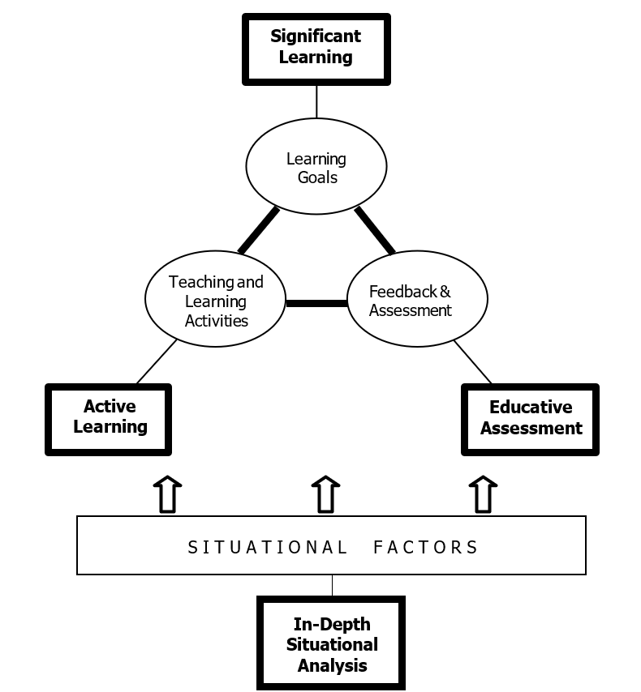
[See Appendix 6 for a long description of this visual.]

Intermediate Phase (Steps 6-8)

Assembling the Components into a Coherent Whole
After you have created the basic components of the course, identify ways of organizing these activities into a powerful and coherent whole. This is done by creating a course structure, selecting or creating an instructional strategy, and then integrating the structure and strategy into an overall scheme of learning activities.

Step 6. Course Structure
Creating a course structure simply means dividing the semester into 4 to 7 seg-ments that focus on the key concepts, issues, or topics that constitute the major foci of the course. Then you arrange these concepts or topics into a logical sequence and decide how many weeks or class sessions to allocate to each one (See Figure 7).
One major value of doing this is seeing more readily how to create questions or assign-ments for students that gradually become more complex and more challenging.

Figure 7

A Structured Sequence for the Content of a Course
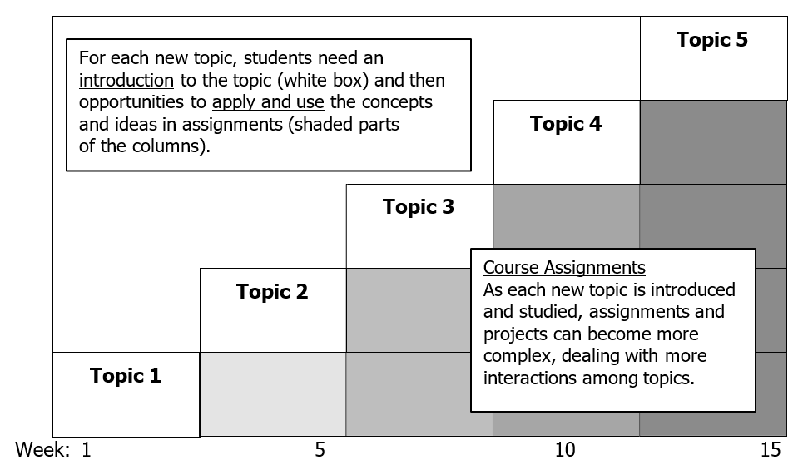
[See Appendix 7 for a long description of this visual.]

Action:

Identify 4 to 7 major concepts, issues, or topics for your course.
What is the appropriate sequence for introducing these to the students? What initial ideas do you have for assignments or problems that would reflect the increasing complexity of the subject as students move from topic to topic?

Step 7. Instructional Strategy
One important conceptual distinction needs to be made between teaching techniques and an instructional strategy. A teaching technique is a discrete, specific teaching activity. Lecturing, leading discussions, setting up small group work all are teaching techniques. An instructional strategy, on the other hand, is a set of learning activities, arranged in a particular sequence so that the energy for learning increases and accumulates as students go through the sequence. This usually requires, among other things, that you set up some activities that (a) get students ready or prepared for later work, (b) give them opportunities to practice—with prompt feedback—doing whatever it is you want them to learn to do, (c) assess the quality of their performance, and (d) allow them to reflect on their learning. To assist in this, the diagram below can help you develop a sequence of in-class and out-of-class activities. I affectionately call this the “Castle Top” diagram (Figure 8). The question marks ask you to identify the learning activity for each in-class and out-of-class block of time. The goal is to create a sequence of activities that build on each other.
Figure 8 - The “Castle Top” Template for Creating an Instructional Strategy
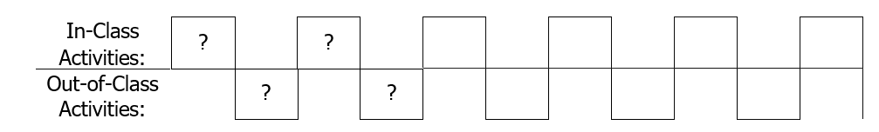
[See Appendix 8 for a long description of this visual.]
Action: Sketch out a sequence of varied activities using some of the learning activities you identified in Phase I.

Step 8. Creating the Overall Scheme of Learning Activities
At this time you need to dynamically integrate the course structure and the instructional strategy for the whole course. It can be helpful to create a diagram of the course structure and the instructional strategy—and then find ways to enhance how these two components work together. Your scheme might look like this:
Figure 9
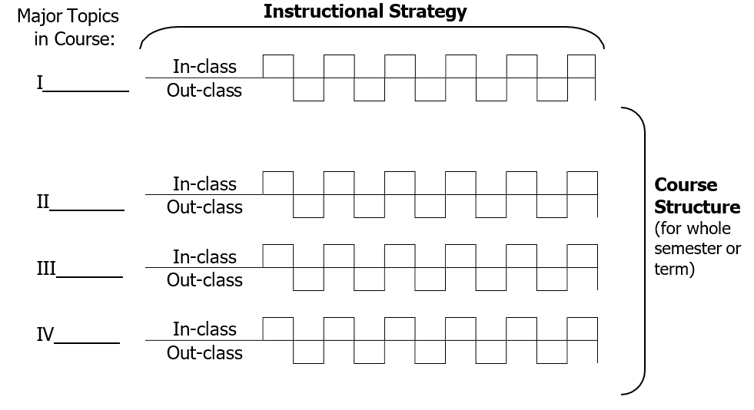
[See Appendix 9 for a long description of this visual.]

Figure 9 above is an example of only one possibility. It would obviously need to be adjusted to fit the circumstances of a given course. This diagram allows us to see one more important principle for good course design: the need for both differentiation and integration of learning activities.

Differentiation can be reflected in these ways:
- Variety in the type of learning activities from day-to-day, within each 1-3 week block of time.
- Development in the complexity and challenge of the learning, from course topics I-IV.
Integration should be reflected both within each topical unit of time and in the
progression through each of the topical units.

At the conclusion of this Step 8, you should be ready to lay out a week-by-week schedule of activities for the whole semester. Worksheet 2 on the following page can be a useful form for creating this schedule. As you do this, consider these questions:
- What activities need to come first, i.e., how should the course begin?
- With what activities do you want to conclude, i.e., how should the course end?
- What sequence of activities will enhance learning in the middle of the course?

Action Using Worksheet 2 (on the following page), pace out the sequence of learning activities for the course. Planning out the schedule concludes the INTERMEDIATE DESIGN PHASE of the course design process.
You now have an integrated set of components assembled into a coherent whole. You are ready for the FINAL DESIGN PHASE, in which there are a few additional tasks to complete.

Worksheet
Table 4 - Sequence of Learning Activities
Week | Class | Between | Class | Between | Class | Between
1
2
3
4
5
6
7
8
9
10
11
12
13
14
15
Final Exam or Project:
FINAL DESIGN PHASE (Steps 9-12): Important Remaining Tasks
Four important remaining tasks need to be undertaken in order to complete the design of your course.

Step 9. How Are You Going To Grade?
At this time, you are ready to develop your grading system. It should reflect the full range of learning goals and activities, but it is also important to remember that you do NOT have to grade everything. In addition, the relative weight of each item as it affects the course grade should reflect the relative importance of that activity.

Action: What are the key components of your grading system?

Action: What will be the relative weight of the grade components? Are you going to determine that yourself, or will you involve the class in this process?

Step 10. What Could Go Wrong?
Now "de-bug" the design by analyzing and assessing your "first draft” of the course. Among other things, this means checking for possible problems. For example:
- Will the students have time to do their out-of-class assignments?
- Will they be able to obtain the necessary resources? (e.g., How many students will be trying to obtain reading material reserved in the library at the same time?)
Action: What problems might arise in the course design as you envision it at this time? What might you do to solve these problems?

Step 11. Let Students Know What You Are Planning (Syllabus)
Now it is the time to write the syllabus. This should include, among other things:
- General management information—instructor, office hours, phone, etc.
- Goals for the course
- Structure and sequence of class activities, including due dates for major assignments/tests/projects
- Text and other required reading material
- Grading procedures
- Course policies: attendance, Honor Code, work turned in late, make-up exams, etc.

Action: What information do you want in the course syllabus?

Action: How do you want to communicate the syllabus to students—on paper, online?

Step 12. How Will You Know How The Course Is Going? How It Went?
It is very important to plan an evaluation of the course itself and of your own teaching. This is the only way you can get the information and insights you need in order to make the course better and to improve your own teaching over time.

As you do this, remember these points:
- You can collect feedback throughout the semester as well as at the end.
- You can use a variety of information sources: ۰ video/audio tape of the class sessions
۰ student ratings of instruction
۰ student interviews and/or questionnaires
۰ outside observers (e.g., colleagues, instructional consultant, Students Consulting on Teaching)
۰ test results

Also consider specific issues:
the degree to which your goals for the course were achieved the effectiveness of particular learning activities
your ability to interact effectively with students
Action: What sources will you use to evaluate the course and your teaching?

Action: What questions are you trying to answer with this evaluation?

Concluding Counsel. Congratulations! You have now finished designing your course. There are two closing caveats for you to consider.
Stay Flexible. The first point to remember is that, although developing a good design or plan for your course is very important, it is only a plan. Like all plans, you need to keep it flexible and subject to change as it is implemented.
1st, 2nd, and 3rd Order Changes. If this is your first attempt at designing a course based on this model, don’t be discouraged if your design does not rate a “10” on all the steps and criteria. It is wise to think of making 1st order, 2nd order, and 3rd order changes. This simply means that on your first attempt to improve the design of your course, focus only on a few changes. But be sure to make some changes in each of the three phases because each affects and reinforces the other. For example, start by making changes to the strong primary components (INITIAL DESIGN PHASE):
Do a somewhat more in-depth analysis of the situational factors;
Add one new kind of significant learning to your list of learning goals; Add one additional kind of educative assessment;
Add one new kind of active learning in which the students engage; and Check to make sure the components are integrated/aligned.
Once you have strong primary components, then you can work on assembling these into a more coherent whole (INTERMEDIATE DESIGN PHASE):
Clarify or simplify the structure of your course;
Create a differentiated set of learning activities (perhaps using the “Castle Top” diagram, Figure 8); and,
Lay out some kind of scheme for the overall set of learning activities.
When you have a coherent scheme of learning activities, you can finish the remaining tasks (FINAL DESIGN PHASE):
Coordinate your grading system with the design of the course; De-bug potential problems;
Put together a syllabus that communicates the design of the course more clearly; and/or
Plan a more thorough evaluation of the course and of your own teaching.
Each time you teach, make an assessment of how well the design worked; then next time, make another, more ambitious set of changes. This way, you can work through 2nd order changes, followed by 3rd order changes, and so forth.

Again, congratulations! When you work seriously on making the kinds of changes described here, you gradually become more and more competent as a course designer. By committing to Designing Courses for Significant Learning, you increase your power and effectiveness as someone responsible for the quality of other peoples’ learning experience!

Appendices

Appendix 1 - 7 Principles of FORMATIVE FEEDBACK

Source: Enhancing Student Learning Through Effective Formative Feedback, by C. Juwah, D. Macfarlane-Dick, B. Matthew, D. Nicol, D. Ross, & B. Smith. Higher Education Academy, York, England. June, 2004.

Facilitate the development of self-assessment (reflection) in learning.
E.g., when students hand in work, ask them what kinds of feedback they would like.

Encourage teacher and peer dialogue around learning.
Use one-minute papers about learning, assignments, and feedback.
Ask students to identify examples of feedback comments they found particularly helpful.

Help clarify what good performance is (the goals, criteria, and standards expected).
Provide better definitions of requirements using carefully constructed criteria sheets and performance level definitions.

Provide opportunities to close the gap between current and desired performance.
Increase the number of opportunities for resubmission of work.

Deliver high quality information to students about their learning.
Relate feedback to predefined criteria. Provide feedback soon after a submission.
Provide corrective advice, not just information on strengths/weaknesses.

Encourage positive motivational beliefs and self-esteem.
Provide opportunities for low-stakes tasks with feedback before giving high-stakes task with grades.
Provide grades on written work only after students have responded to feedback comments.

Provide information to teachers that can be used to help shape the learning.
Have students identify where they are having difficulties when they hand in assessed work.
Use anonymous one-minute papers at end of a class session.

Appendix 2 – Long Description of Figure 1 A Taxonomy of Significant Learning

The taxonomy is represented as a circle divided into six wedges of equal size. Each wedge is labeled with a type of learning goal and some details and/or examples.
- Foundational knowledge: Understanding and remembering information and ideas.
- Application: Skills, thinking (critical, creative, practical), managing projects.
- Integration: Connecting ideas, people, and/or realms of life
- Human dimension: Learning about oneself and/or others
- Caring: Developing new feelings, interests, values
- Learning how to learn: becoming a better student, inquiring about a subject, self-directed learners.

Appendix 3 – Long Description of Figure 3 Auditive and Educative Assessment

The page is divided into two sections by a dotted vertical line.

On the left is a rectangle containing the words “Audit-ive Assessment” followed by an asterisk. Below it is an oval labeled “Backward-Looking Assessment” followed by two asterisks. An arrow points down from this oval to a rectangle containing the words “(Traditional) Grading”.

On the right is rectangle containing the words “Educative Assessment”. Below are four ovals arranged in a 2 by 2 layout. The upper left oval is labeled “Forward-looking Assessment” followed by 3 asterisks. The upper right oval is labeled “Self-assessment (by learners)”. The lower left oval is marked “Criteria & Standards”. The lower right is labeled “FIDeLity Feedback”. FIDeLity is an almost acronym, a mnemonic for Frequent, Immediate, Discriminating, and Loving. Below the four ovals is a horizontal line and an arrow pointing down to a box containing the words “Better Learning (as well as more authentic grading)”.

Appendix 4 – Long Description of Figure 4 Initial View of Passive and Active Learning

The page is divided into two sections by a dotted vertical line.

On the left is a rectangle labeled “Passive Learning” and below it an oval labeled “Receiving Information & Ideas”.

On the right is a rectangle labeled “Active Learning”. Below are the headings “Reflective Experience” and “Dialogue with”. Underneath Reflective Experience are two ovals, the top one labeled “Doing” and the bottom one labeled "Observing”. Under “Dialogue with” are two ovals, the top one labeled “Self” and the bottom one labeled "Others”.

Appendix 5 – Long Description of Figure 5 A Holistic View of Active Learning

Three ovals are connected to each other by lines, making a triangular formation. Each oval has a label followed by some bullet points.

Experience (top oval)
- Doing, Observing
- Actual, Simulated
- “Rich Learning Experiences”

Information and Ideas (bottom left oval)
- Primary & Secondary Sources
- Accessing them in class, out of class, online

Reflective Dialogue (bottom right oval)
- Minute Papers, Learning Portfolios, Journaling
- About the Subject and/or Learning Process

Appendix 6 – Long Description of Figure 6 Criteria for Assessing Course Designs

Fink’s model of integrated course design, depicted as three ovals connect by lines in a triangular formation, under which is a rectangle with arrows pointing up from the rectangle to the ovals.

The top oval is labeled “Learning Goals”, the bottom left oval is labeled “Teaching and Learning Activities”, and the bottom right oval is labeled “Feedback & Assessment.” The rectangle underneath is labeled “Situational Factors.”

A rectangle with heavier weighted lines is connected to each of these four objects by a line. In the topmost rectangle are the bolded words “Significant Learning”, connected to the Learning Goals oval, indicating it is the criteria for assessing Learning Goals. The bottom left rectangle is labeled “Active Learning” in boldface and is connected/is the assessment criteria for Teaching & Learning Activities. The bottom right rectangle is labeled “Educative Assessment” in boldface, the criteria for Assessment & Feedback. At the very bottom of the diagram is a rectangle labeled “In-Depth Situational Analysis” in boldface, which is the criteria for Situational Factors.

Appendix 7 – Long Description of Figure 7 A Structured Sequence for the Content of a Course

A diagram of a box with a label across the bottom showing week 1 of the course on bottom left, week 5 one third of the way along the bottom of the box, week 10 two-thirds of the way along the bottom of the box, and week 15 in the bottom right corner.

Inside the box are five columns of stacked rectangles, each column having one more rectangle than the one to the left of it, forming a staircase shape. The leftmost column has one box; it is labeled Topic 1. The next column has two boxes. The top one is labeled Topic two and the box below it is slightly gray in color. The middle column is three boxes tall. The top box is labeled Topic 3 and the two boxes below it are a slightly darker shade of gray. The next column to the right has four boxes. The top box is labeled Topic 4 and the three boxes below it are an even darker shade of gray. The far-right column has five boxes, the top one labeled Topic 5 and four dark gray boxes below it.

This diagram also contains two text boxes. Near the upper left corner is the label “For each new topic, students need an introduction to the topic (white box) and then opportunities to apply and use the concepts and ideas in assignments (shaded parts of the columns).” The words “introduction” and “apply and use” are underlined for emphasis.

Near the bottom right is a text box that reads “Course Assignments: As each new topic is introduced and studied, assignments and projects can become more complex, dealing with more interactions between topics.”

Appendix 8 – Long Description of Figure 8 The “Castle Top” Template for Creating an Instructional Strategy

A horizontal line divides this diagram into an upper and lower half. The upper half is labeled “In-Class Activities” and the lower half is labeled “Out-of-Class Activities”. A squared off zig-zag wanders above and below the horizontal line, creating six boxes above the line and five boxes below it, offset from each other such that the first box is above the line, the second box below the line, the third above it, etc. The result looks like the battlements of a castle wall, hence the name Castle Top Template. The first four boxes, two upper and two lower, contain question marks.

Appendix 9 – Long Description of Figure 9

The central feature of this diagram is four Castle Top Templates as per Figure 8 (see Appendix 7 above), stacked atop each other. A wide horizontal bracket labeled “Instructional Strategy” is above these four Castle Tops. To the left of this figure is a narrow column labeled “Major Topics in Course”. Below this label are four roman numerals, I through IV, each with a blank space for the particular topic. Each topic is aligned with one of the Castle Tops. To the left of the major topic numerals and the castle tops this is a large bracket labeled “Course Structure (for whole semester or term)”.

