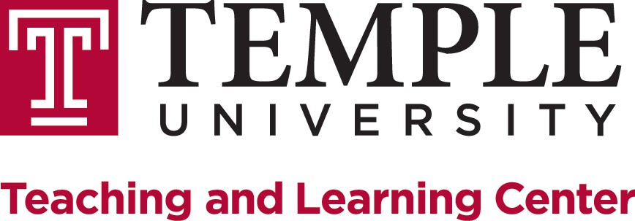

Providing Effective Assessment of Artistic Work

Johanna Inman, MFA, Assistant Director, Teaching & Learning Center

Modes of Assessment
When we hear the term assessment we may think of traditional modes of assessing student learning such as papers, exams, or other structured projects. These traditional modes can be applied to the arts by assessing writing about art, knowledge of the history of a medium, or even knowledge of the craft and process of a medium. However, in some cases applying these forms of assessment to the production of artistic work can be problematic.
Below are some suggestions for other modes of assessing artistic work.

Observations are opportunities for teachers to watch and document students while they participate in a practice, performance, or studio process. Regular observations allow teachers to catch problems with technique, unhealthy studio habits, and monitor students’ progress. Though these are a significant part of the artistic process, they can be neglected when we only assess a final product.
Portfolios are a popular assessment tool across all artistic disciplines. Typically, a portfolio provides examples of the strongest work that a student has accomplished at the completion of a course or program. However, non-traditional process portfolios can also be assigned. This type of portfolio would include documents of the artistic process such as sketches, storyboards, edits and revisions, materials research, and even inspirational imagery.
Self and Peer Assessments in the arts are growing in popularity as useful tools. These are methods that professionals use to improve their own work and can take a variety of forms, including journals, sketchbooks, portfolio reviews, and critiques.

Familiarizing students with these assessment methods and providing them with the criteria and tools for this practice will prepare them for working as professionals within the field.

Assessment Tools
In all assessment activities it is key to develop a set of standards and criteria for evaluation. Research shows that effective and successful assessment takes place when these criteria are aligned to course goals. Below are some tools that can aide faculty in developing and communicating standards and criteria for the assessment of artistic work. These essential grading tools can be created for each of the assessment modes discussed.
Checklists are the simplest form of a scoring guide. These list evaluative criteria for assessing student learning based on the goals for the particular activity or product being assessed. Next to the criteria is a space to indicate whether or not it has been met.
Checklists can provide more specific feedback by allocating a particular set of points or comments to the criteria.
Rubrics are a common assessment tool in all areas of higher education and there’s a reason why. Research shows that rubrics help teachers grade more consistently and provide students clearer, targeted feedback on assignments. When students receive specific feedback on performance criteria and clear descriptions of high, medium, and low quality work associated with these components, they can closely monitor their progress and understanding, as well as target future practice of their medium.
Holistic Rubrics describe high, medium, and low qualities of artistic work. This form of rubric can be useful when it is difficult to separate evaluative criteria in scoring student learning. In some artistic mediums elements could be dependent on one another to be successful and it may be more effective to consider criteria together. In this instance providing a written description and examples of various levels of accomplishment may be more appropriate.
“But I teach Art, why should I use such a structured tool for grading?”
- Communicates speciﬁc criteria, goals, & standards for your course.
- Provides students with criteria and standards to apply during self and peer evaluation.
- Provides students with targeted feedback for future practice and improvement.
- Teaches students’ that art is not exclusively subjective.
- Promotes the idea that assessment is a part of the process of making art and a mode of communication, not just a reward or punishment.

Table 1 - Example Checklist for Instrument Practice
Standard, Skill, Technique | Points | Points | Points
Demonstrated Correct Posture | 1 | 2 | 3
Demonstrated Correct Embouchure | 1 | 2 | 3
Demonstrated Correct Carriage & Hand Positions | 1 | 2 | 3
Demonstrated Correct Breathing Techniques | 1 | 2 | 3
Played with a Full, Characteristic Tone | 1 | 2 | 3
Steady Tempo | 1 | 2 | 3
Correct Rhythms | 1 | 2 | 3
Correct Pitches | 1 | 2 | 3
Began Notes Correctly | 1 | 2 | 3
Released Notes Correctly | 1 | 2 | 3
Played Proper Phrases | 1 | 2 | 3
Played Prescribed Articulations/Dynamics | 1 | 2 | 3
Played with Conﬁdence | 1 | 2 | 3

Table 2 - Example Rubric for Visual Art Assignment
Criteria | Excellent | Meets Expectations | Needs Improvement
Craft | Student demonstrates mastery of technical skills, materials, and tools. | Student demonstrates technical skills and correct use of materials and tools. | Technical skill level is marginal; work is careless or inconsistent.
Personal Vision & Expression | The work communicates powerful and clear ideas and/or emotion through a combination of formal elements, technique, and subject matter. | The work communicates ideas and emotion through formal elements, technique, and subject matter. | The work communicates little through formal elements, techniques, and subject matter.
Effort & Work Time | Student worked with passion, beyond the time expectations during and outside of class and/or tried a wide variety of problem solving approaches. | Student was on task during class, committed the required amount of time outside of class, and tried some problem solving approaches. | Student did not put in the expected effort in class, did not commit the required amount of time outside of class, and did not attempt problem solving.
Assignment Comprehension | Student excelled at demonstrating the assigned parameters and added rich personal contributions. | Student satisfied the assigned parameters and added personal contributions. | Student failed to completely address the assigned parameters.

Table 3 - Example Holistic Rubric for Creative Writing Assignment
Rating | Criteria
Advanced | Student was totally immersed in the character, communicating character’s wants and behaviors, and was propelled by character motivation. The performance had a sense of character-driven improvising and was both believable and congruent with the scene’s style.
Emerging | Student maintained focus, portrayed character’s unique vocal and physical expressions, and responses are natural or believable. The student knows all the lines and meaning of them and engages eyes, ears, and mind within the act.
Novice | Student’s mind seems to wander, is self-conscious of performance, and does not convey unique character expressions. The performance includes physical reactions incongruous with stimuli provoking them and feels rehearsed or reliant on cues.
Beginner | Student’s eyes watch the audience, student misses lines and does not have a full grasp of meaning to the lines recited. The performance lacks unique character expressions, physical reactions, and the students have difficulty staying focused throughout the performance.

